Adding a Header
You can add a header image to make you blog more attractive.
NB different themes may work differently. For example they need different sized images.

Accessing the Header Editor
Either on your blog or the blogs dashboard, hover over the blog name in the Admin bar and choose Header.
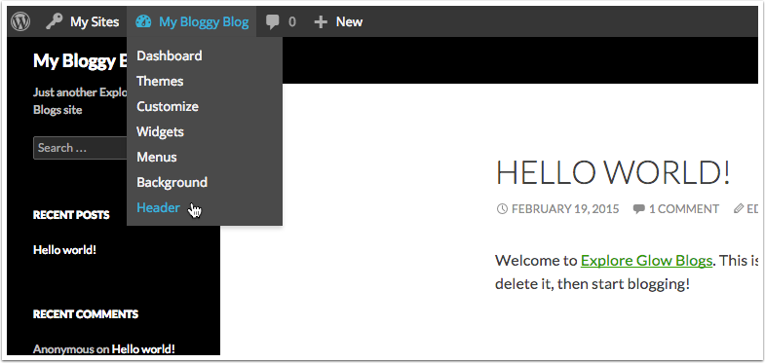

Custom Header Screen
This screen will allow you to either upload a file from your computer [1] or choose one you have already uploaded[2].
Note that you will be provided with information about what image size would be suitable.
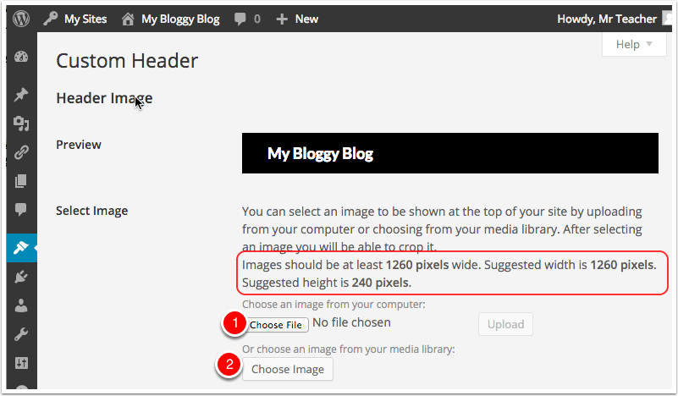

Uploading an image
Here we have clicked Choose file and are selecting an images.
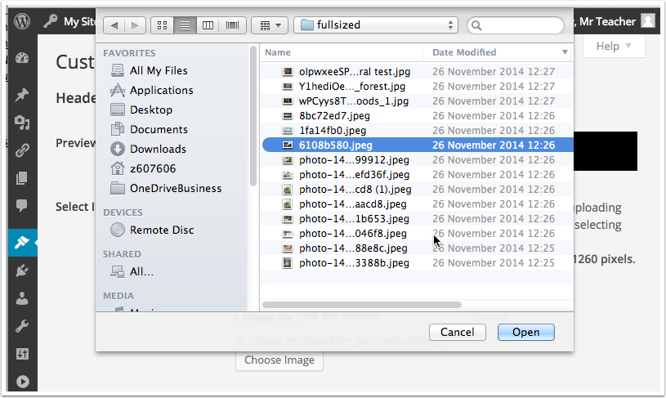

Upload 2
After selecting the image click Upload on the Custom Header screen.
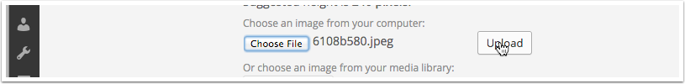

Crop Header
Once the image is uploaded you can crop it if you like.
The suggested crop size usually is a good choice. If you do not crop the image your header may take over the whole screen for visitors.
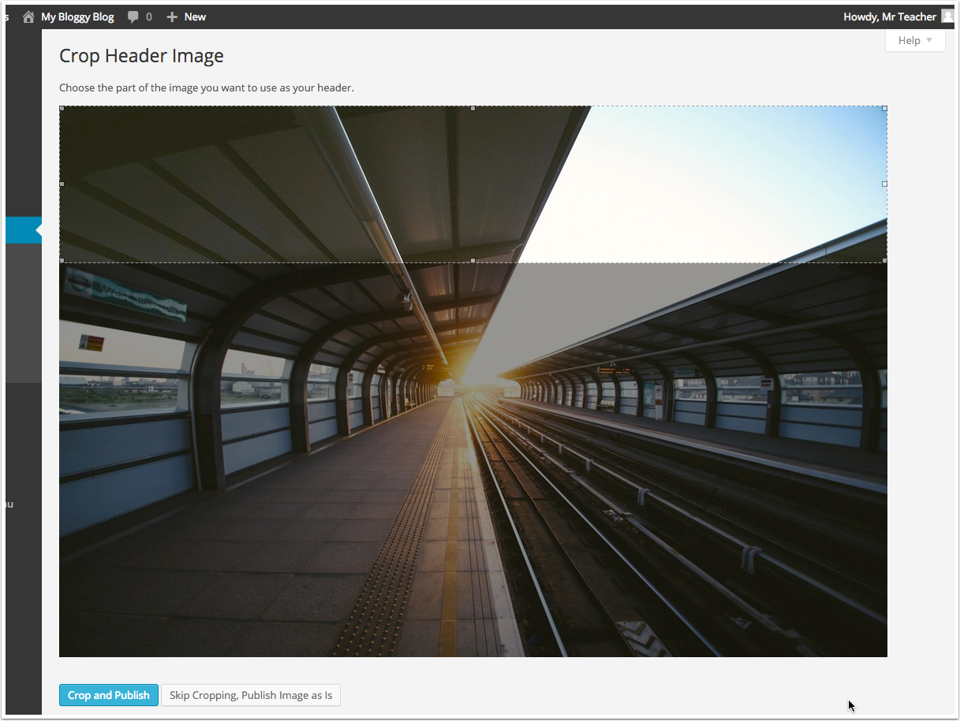

Cropping 2
Here we have moved the selection and are going to click: Crop and Publish [1].
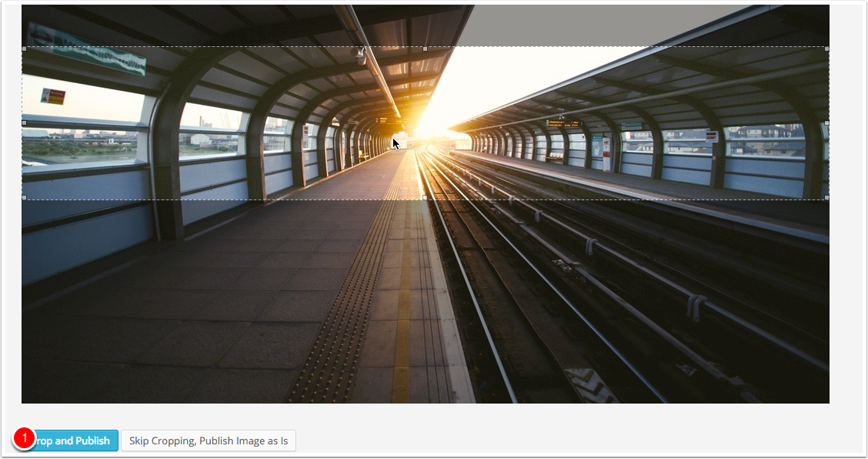

Custom Header Preview
You will return to the Custom Header Screen showing a preview of your blog. There are a few setting shown in the next section...
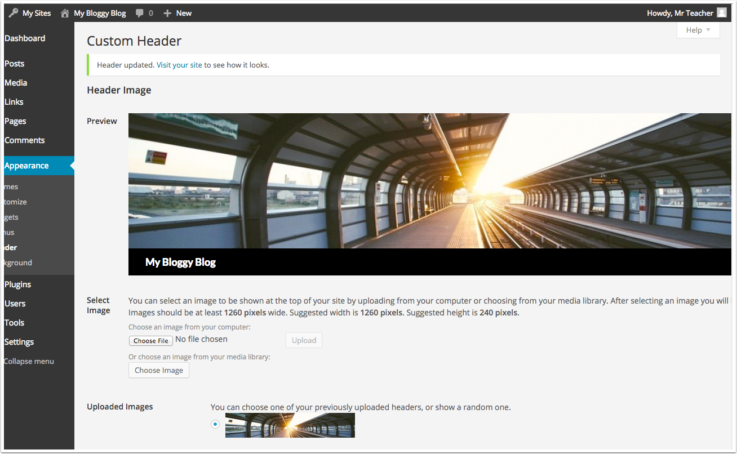

Custom Header Text
At the bottom of the header you can set if the Title of your blogs shows on the header and what colour the test should be.
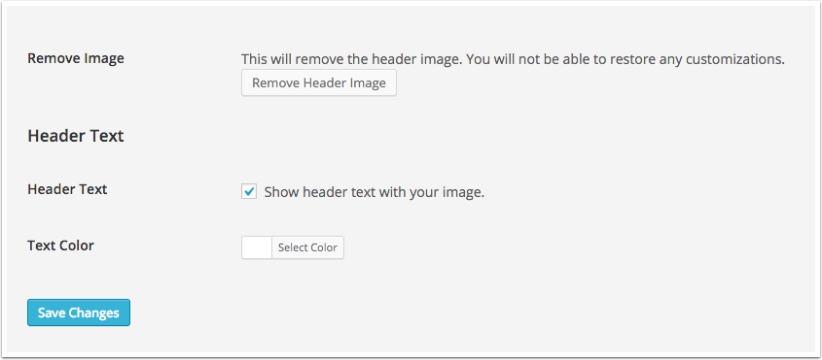

The finished product
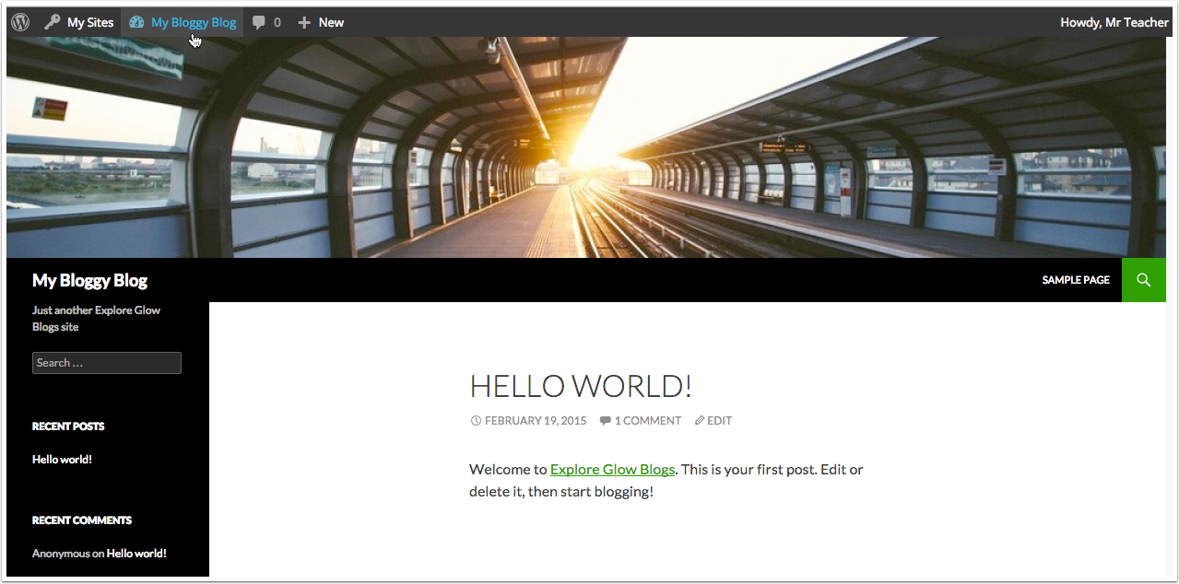

Random images
Back in the Custom Header screen, If you upload more than one header image you can choose between them or set the to show random image.
