Comments

Comments allow your blogs's readers to have a discussion with you and each other.

Comments can be activated on a Page or post. Once you approve a comment, it

appears underneath your content. You can allow comments to appear unmoderated or

moderate them first.

Test Post « pupil admin comments

To comment on a post all you need to do is type in the comment field **[1]** and click

'Submit Comment'**[2]**.

You might have to fill in a name and email if you are not logged into glow **[3]**.

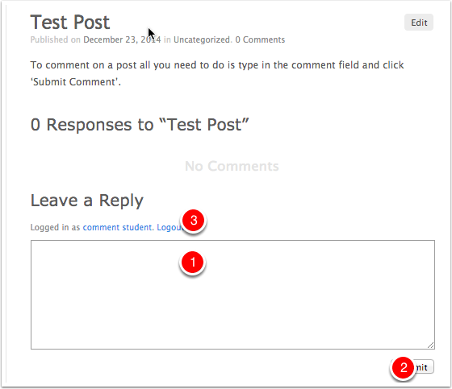

Discussion Settings

The default settings for commenting on posts can be set from the **Discussion** screen of the **Settings** section of the dashboard.

To access this screen click on the **Settings** link in the sidebar **[1]** and then the **Discussions** link**[2]**.

The most important settings are the overall permission to comment **[3]** and the moderation **[4]**. In most cases where you allow comments it is best to check '**An administrator must always approve the comment**'.

After making changes on the setting screen remember to click the '**Save Changes**' button at the foot of the page (not visible in the screenshot below).

**It is important to remember that changes to allow comments will only affect new posts.**

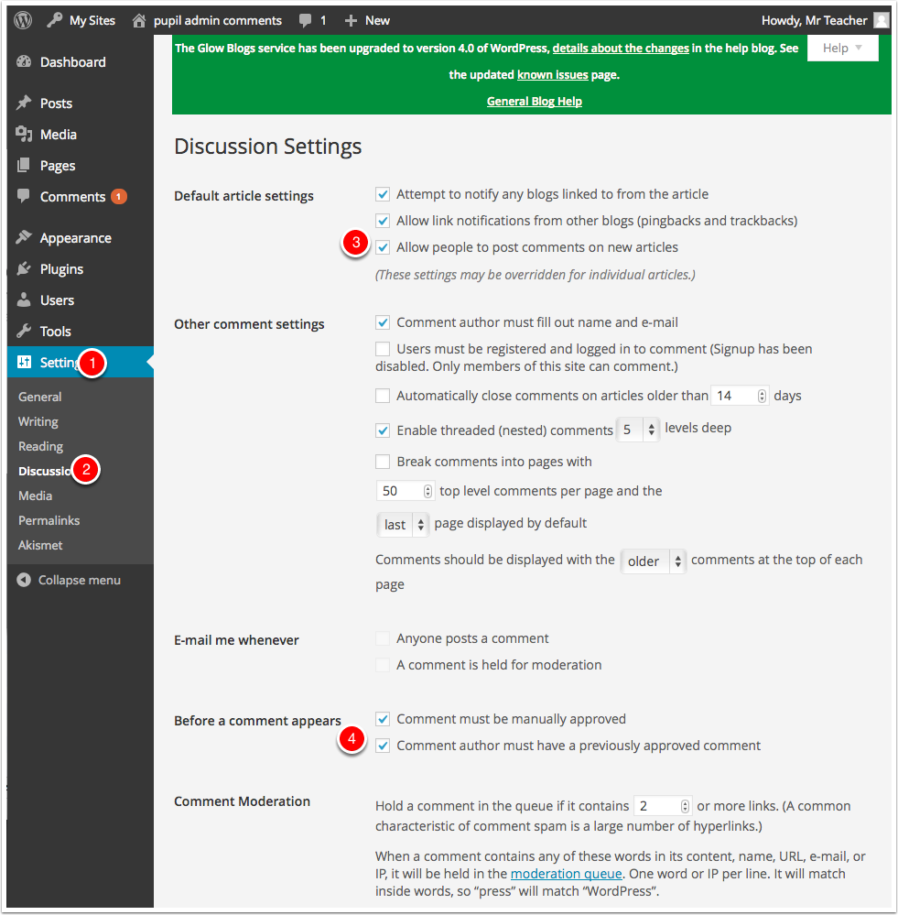

Discussion Settings on Post

You can control the ability of visitors to add comments to your posts and pages on a per post or pager basis.

There is a checkbox at the bottom of the post and page editor.

You can also control trackbacks and pingback for each post. These allow link notifications from other blogs.

The defaults for new posts and pages are controlled in the discussion settings. You may have to show that section by opening the Screen Options **[1]** and ticking discussions **[2]**.

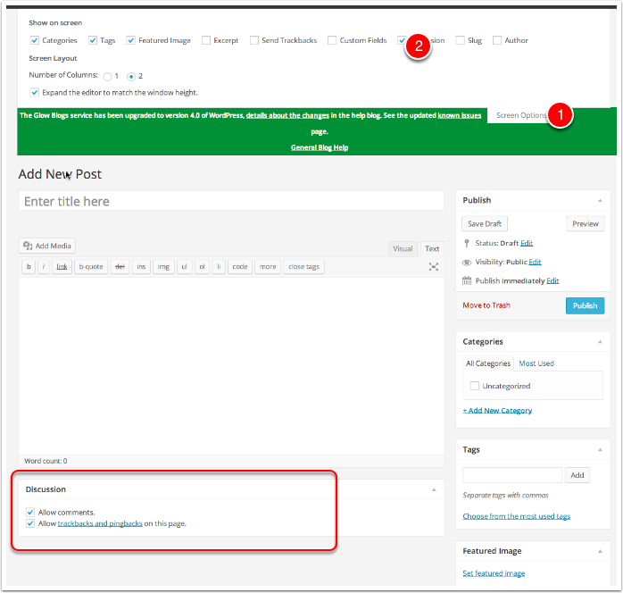

Comment Approval

If you have allowed comments with moderation you need to moderate comments.

Glow blogs differ from standard Wordpress in that Glow users with a pupil role cannot see unmoderated comments on a **public** blog. This is to avoid pupils seeing unsuitable spam comments. On a public blog an Admin who is not a pupil vcan allow pupils to moderate comements if needed.

You can access the comments page in the dashboard by clicking on the link on the left navigation **[1]**.

Comments that have not been approved have a yellow background. Hovering over a comment will show links to **Approve**, **Reply**, **Quick Edit**, **Edit**, **Spam** and **Trash[2]**.

If a comment has already been approve the link will read **Unapprove**.

If a glow user makes a comment on a glow blog while logged into glow the comment will display their display name. Users can change this in their settings. This can be a nick-name so can be used to anomise vunerable pupils. Users with Staff establishment roles will also see the users glow id **[3]**.

