Adding video and audio
Video and audio files can be displayed in players in a blog post or page.
You need to have activated the Anarchy Media player plugin.

Activating the Anarchy Plugin
- On your blog dashboard, click the link to Plugins on the left hand navigation.
- Click Activate under Anarchy Media Player.
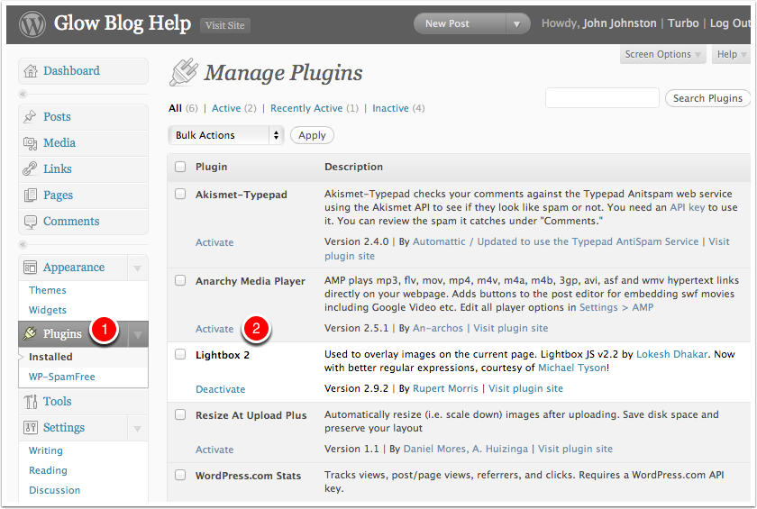

Create a Post or Page
In the normal way create a post.
Place the I-bar where you wish the video to appear and click the Add Video Graphic beside Add Media.
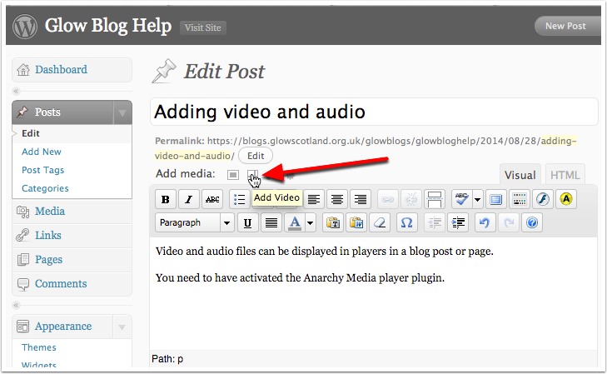

Select Files with the Image picker
You should see a Select Files Button. Click it.
If the Select Files button is not showing you may be using the "Browser uploader" you can use the Choose or Broswe button to selcet a file and then upload it.
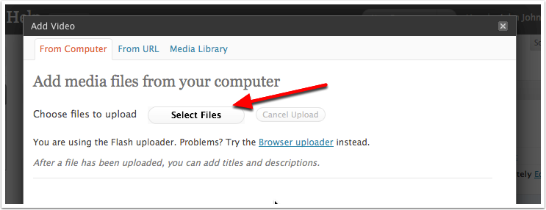

Select file in the standard file browser
Click on a video file and click Open or double click the file.
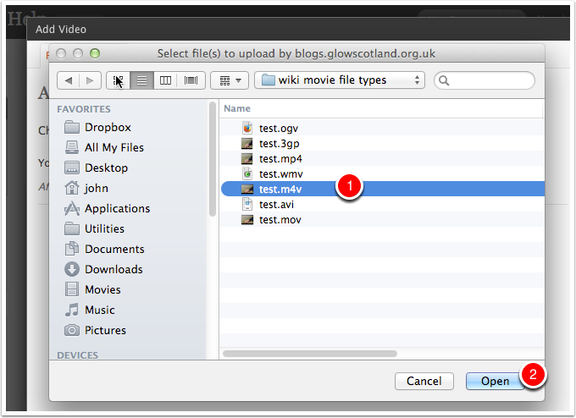

Insert into Post
Once the video is uploaded you will see some information about the file, tyou could add a caption or description if you want.
Click Insert into Post.
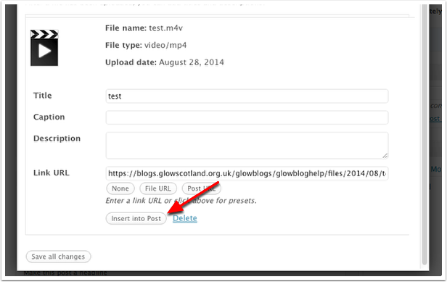

View in Editor and Publish
The inserted video will just look like a link in the editor.
You can publish your post in the usual way by clicking the Publish button.
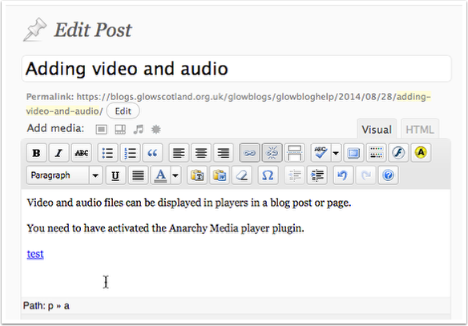

View the post
When you view the post you will see that the link has been replace with a video splash screen.
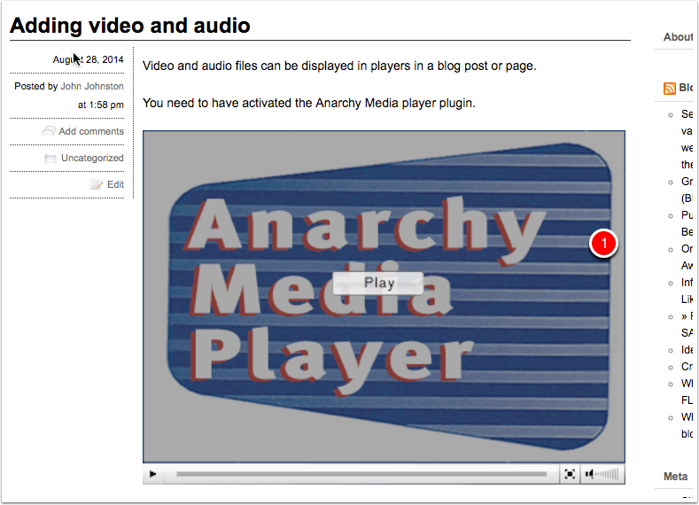

Audio
You can add audio files in exactly the same way.
When the post is published this will insert a flash audio player.
Clicking on the + will change the player to the 2nd view below and play the audio.
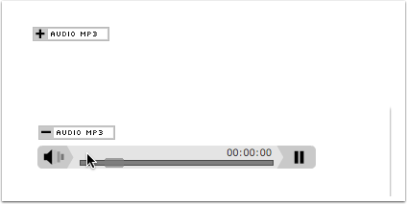

Tips & Factors to note
The playing of audio and video is complex and depends on a matrix of files types and browser capabilities. You may not get the result you expect viewing the media on different browsers.
You can replace the Anarchy media player splash screenshot above with your own. You need to upload a jpg file with the same name as the movie file with the addition of the .jpg extension.
For example if your movie is called myMovie.mp4 you can upload an image myMovie.mp4.jpg. The Anarchy splash screen will be replaced with your image. The image needs to be in the same place on the server so it is best to upload it at the same time as you upload the video.
Remember that you might want to add instructions to the viewer on your splash screen (Click to Play or an arrow).

