An evaluation and implementation analysis of the approach ‘Five to Thrive’

FIONA ELIZABETH ANNE PRIMROSE

University of Dundee

MSc Educational Psychology

Word Count: 18,853

Date of Submission: 29th JULY 2016

CONTENTS

Glossary vii
Acknowledgements viii
Declaration of Authorship ix
Abstract x
1. Introduction 11
1.1 National Context 12
1.2 Local Context 16
1.3 Literature Review 18
1.3.1 Literature Search Methodology 18
1.3.2 Implementation Science 19
1.3.3 Attachment Theory 26
1.4 Summary and Rationale 31
2. Methodology 34
2.1 Participants 34
2.2 Ethics 34
2.3 Epistemological Stance 35
2.4 Method of Data Collection 37
2.5 Procedure 40
2.6 Data Analysis 43
2.6.1 Quantitative data 43
2.6.2 Qualitative Data 44
3. Results 49
3.1 Establishment 1 49
3.1.1 How has FTT been implemented? 49
3.1.2 Why has FTT been implemented this way? 50
3.1.3 Next steps 52
3.1.4 Supporting factors in implementation of ftt 52
3.1.5 Barriers in implementation of ftt 54
3.1.6 what has been the impact of ftt? 55
3.2 ESTABLISHMENT 2 56
3.2.1 How has FTT been implemented? 56
3.2.2 Why has FTT been implemented this way? 58
3.2.3 Next Steps 59
3.2.4 Supporting factors in implementation of FTT 60
3.2.5 Barriers in implementation of ftt 62
3.2.6 what has been the impact of ftt? 62
3.3 ESTABLISHMENT 3 63
3.3.1 How has FTT been implemented? 63
3.3.2 Why has FTT been implemented this way? 65
3.3.3 Next Steps 66
3.3.4 Supporting factors in implementation of ftt 67
3.3.5 Barriers in implementation of ftt 68
3.3.6 what has been the impact of ftt? 68
3.4 ESTABLISHMENT 4 69
3.4.1 How has FTT been implemented? 69
3.4.2 Why has FTT been implemented this way? 71
3.4.3 Next steps 72
3.4.4 Supporting factors in implementation of ftt 73
3.4.5 Barriers in implementation of ftt 74
3.4.6 what has been the impact of FTT? 75
3.5 ESTABLISHMENT 1 76
3.6 ESTABLISHMENT 2 80
3.7 ESTABLISHMENT 3 83
3.8 ESTABLISHMENT 4 86
4. Discussion 90
4.1 Summary of Results 90
4.2 How has FTT been implemented? 91
4.2.1 Verbal communication with parents/carers 91
4.2.2 Visuals across establishments 91
4.2.3 Daily interactions with children 92
4.3 Why has FTT been implemented this way? 93
4.3.1 Links with existing documents 93
4.4 What are the next steps? 94
4.4.1 Share good practice 94
4.5 What are the supporting factors? 95
4.5.1 Management 95
4.6 What are the barriers? 96
4.6.1 Resistance from minority of staff 96
4.6.2 Parental Engagement 97
4.7 What has been the impact of FTT? 98
4.7.2 Establishment and staff 98
4.7.2 Parents/carers understanding 100
4.7.3 Children 102
4.8 Limitations 104
4.9 Implications for Practice and Research 105
4.10 Conclusion 108
References 110
Appendices 115
Appendix 1: Staff Consent Forms 116
Appendix 2: Parent/Carer Consent Forms 119
Appendix 3: Staff Information Sheet 122
Appendix 4: Parents/carers Information Sheet 124
Appendix 5: Parents/carers Interview questions 126
Appendix 6: Staff Questionnaire 128
Appendix 7: Staff Interview/Focus Group questions 131
Appendix 8: Establishment 1 Thematic mind-maps 133
Appendix 9: Establishment 2 Thematic mind-maps 141
Appendix 10: Establishment 3 Thematic mind-maps 147
Appendix 11: Establishment 4 Thematic mind-maps 153

List of FIGURES
Figure 1: Implementation Drivers (Fixsen, Blase, Naoom & Duda, 2015) 21
Figure 2: Continuously reinforced attachment (Adapted from S. Gott (2009)) 27
Figure 3: The Approach of Critical Realism and the relationship with research (adapted from Zachariadis, Scott and Barrett 2013). 37
Figure 4: Establishment 1 – How has FTT been implemented? 49
Figure 5: Establishment 1 – Why has FTT been implemented this way? 51
Figure 7: Establishment 1 – What supports implementation of FTT? 53
Figure 8: Establishment 1 – What are the barriers to implementation of FTT? 54
Figure 9: Establishment 1 – What has been the impact of FTT? 55
Figure 10: Establishment 2 – How has FTT been implemented? 57
Figure 11: Establishment 2 – Why has FTT been implemented this way? 58
Figure 12: Establishment 2 – What are the next steps? 59
Figure 13: Establishment 2 – What supports the implementation of FTT? 61
Figure 14: Establishment 2 – What has been the impact of FTT? 62
Figure 15: Establishment 3 – How has FTT been implemented? 64
Figure 16: Establishment 3 – Why has it been implemented this way? 65
Figure 17: Establishment 3 – What are the next steps? 66
Figure 18: Establishment 3 – What supports implementation of FTT? 67
Figure 19: Establishment 3 – What has been the impact of FTT? 68
Figure 20: Establishment 4– How has FTT been implemented? 70
Figure 21: Establishment 4 – Why has FTT been implemented this way? 71
Figure 22: Establishment 4 – What are the next steps? 72
Figure 23: Establishment 4 – What supports the implementation of FTT? 73
Figure 24: Establishment 4 – What are the barriers 74
Figure 25: Establishment 4 – What is the impact of FTT?. 75
Figure 26: Establishment 1 – Awareness of FTT. 77
Figure 27: Establishment 1 – Impact of FTT. 77
Figure 28: Establishment 1 – Staff initial training attendance. 78
Figure 29: Establishment 1 – When was the initial training attended? 78
Figure 30: Establishment 1 – Perceptions of FTT embedment 79
Figure 31: Establishment 1 – Staff awareness of follow up training sessions. 79
Figure 32: Establishment 2 – Awareness of FTT. 80
Figure 33: Establishment 2 – Impact of FTT. 80
Figure 34: Establishment 2 – Staff initial training attendance. 81
Figure 35: Establishment 2 – When was the initial training attended? 81
Figure 36: Establishment 2 – perceptions of FTT embedment 82
Figure 37: Establishment 2 – Staff awareness of follow up training sessions. 83
Figure 38: Establishment 3 – Awareness of FTT. 83
Figure 39: Establishment 3 – Impact of FTT. 84
Figure 40: Establishment 3 – Staff initial training attendance. 84
Figure 41: Establishment 3 – When was the initial training attended? 85
Figure 42: Establishment 3 – perceptions of FTT embedment 85
Figure 43: Establishment 3 – Staff awareness of follow up training sessions. 86
Figure 44: Establishment 4 – Awareness of FTT. 86
Figure 46: Establishment 4 – Staff initial training attendance. 87
Figure 47: Establishment 4 – When was the initial training attended? 88
Figure 48: Establishment 4 – perceptions of FTT embedment 88
Figure 49: Establishment 4 – Staff awareness of follow up training sessions. 89

List of TABLES
Table 1: Breakdown of Participating staff members and parents/carers from each establishment. 34
Table 2: Breakdown of Participants in Each method of data collection 39
Table 3: Thematic analysis phases (Braun and Clarke, 2006) 45

Glossary
CDO – Child Development Officer
CfE – Curriculum for Excellence
EP – Educational Psychologist
FTT – Five to Thrive
GIRFEC – Getting It Right For Every Child
IS – Implementation Science
KCA – Kate Cairns Associates
QIO – Quality Improvement Officer

Acknowledgements

I would like to express my gratitude first and foremost to the parents/carers and members of staff of the four establishments who participated in the current research, who volunteered their time so as to be involved. I would also like to thank the senior EP and QIO for overseeing this research and making themselves available had I need for any support, as well as my placement supervisor for her continuous guidance. Last but certainly not least, thank you to my University thesis supervisor, who gave consistent and prompt advice from the beginning of the research.

Declaration of Authorship

I declare that I, Fiona Primrose, am the sole author of this thesis. All references cited within the thesis have been consulted. The work undergone, of which this thesis is a record, has been undertaken solely by myself and has not been previously used for a higher degree.

Signed:

Date: 29th July 2016

An evaluation and implementation analysis of the approach ‘Five to Thrive’
Fiona Elizabeth Anne Primrose

Abstract

The current report aims to explore the implementation and effectiveness of an approach, Five to Thrive (FTT), in early years establishments through the perceptions of those involved. Outlined is the national and local context for which the participating early years establishments are based in Local Authority X. Due to the theory and topics underpinning FTT, a literature review of attachment theory and its connections to relationships, emotional regulation and brain development is included. Furthermore and due to the aims of the research, a review of literature regarding Implementation Science is also included. In line with the framework of core components of implementation consideration for participants’ perceptions, the current research is deigned, gathered and analysed within an epistemological stance of critical realism. Thus a multi-method design informs data gathering from parents/carers and members of staff from four early years establishments to provide qualitative data, strengthened by quantitative data. The design of the research facilitates analysis of participants’ perceptions under six broad themes informed by the aims of the research: ‘How FTT has been implemented’, ‘why FTT has been implemented this way’, ‘what the next steps are for implementation of FTT’, ‘what has supported implementation of FTT’, ‘what have been the barriers to implementation of FTT’, and ‘the impact of implementation of FTT’. Sub-themes emerging from analysis of the data within the six over-arching themes are then discussed with regards to the key documents underpinning the national and local context, as well as the theory and topics outlined in the literature review. Whilst exploring implementation and effectiveness of FTT through perceptions fits well within the current epistemological stance, it would have been beneficial to use pre- post- implementation measures to strengthen the data. The information presented in this paper can be used to enlighten next steps in terms of implementation of FTT.

Word Count: 300

1. Introduction
The purpose of this research is to analyse the implementation and impact of an early years approach, Five to Thrive (FTT), within local Authority X. The focus is on the implementation and impact within participating early years establishments with an aim to answer the following research questions:
- What are the perceptions of those linked to early years establishments regarding the implementation of FTT?
- What are the perceptions of those linked to early years establishments regarding the impact of the implementation of FTT?
The national and local context within which the participating early years establishments exist is outlined in the current report, as well as the aims and objectives. The paper provides a critical literature review of legislation, approaches and theory relevant to the current research, namely ‘Attachment Theory’, ‘Attachment and emotional regulation’, ‘Attachment and relationships’, ‘Attachment and brain development’ and ‘Implementation Science (IS)’. The current research is designed, gathered and analysed within an epistemological stance of critical realism. Within this stance the methodology of the current research is outlined as well as a detailed account of the processes involved in analysing the qualitative and quantitative data gathered through means of focus groups, interviews and questionnaires. The analysis allows for themes to be drawn for discussion of ‘How FTT has been implemented’, ‘why FTT has been implemented this way’, ‘what the next steps are for implementation of FTT’, ‘what has supported implementation of FTT’, ‘what have been the barriers to implementation of FTT’, and ‘the impact of implementation of FTT’ with regards to the key documents, approaches and theory outlined in the literature

review. Lastly, the report proposes implications for practice in the implementation of FTT and future research.

1.1 National Context
Across Scotland, a number of documents and legislation have shaped the national context in recent years due to the quantity of research informing of the importance of our earliest years in shaping development for later life, illustrating the importance of the best possible foundations laid in positive early years experiences (Scottish Government, 2007). Thus, Education Scotland endeavours to provide continuous professional development opportunities for practitioners providing a service for the early years to enhance existing skills and abilities to support the best start in life for our children.

The Scottish Government (2007) published fifteen National Outcomes illustrating what should be achieved over the following ten years by “working together to make Scotland a better place to live and a more prosperous and successful country” (Scottish Government, 2007). Particularly pertinent to the delivery of three of the fifteen National Outcomes is the Early Years Framework (EYF) (Scottish Government, 2015). The three outcomes relevant to Early Years are:
- Our children have the best start in life and are ready to succeed.
- We have improved the life chances for children, young people and families at risk.
- Our young people are successful learners, confident individuals, effective contributors and responsible citizens.
(Scottish Government, 2007)

The EYF (Scottish Government, 2015) draws from the aforementioned research and thus provides documentation regarding all children having the best possible start in life, by firstly analysing the experiences that sustain positive outcomes. The framework further includes the steps that should be taken collaboratively by practitioners, partners and the Government to do so, thus ten main elements are illustrated within it:
- A coherent approach.
- Helping children, families and communities to secure outcomes for themselves.
- Breaking cycles of poverty, inequality and poor outcomes in and through early years.
- A focus on engagement and empowerment of children, families and communities.
- Using the strength of universal services to deliver prevention and early intervention.
- Putting quality at the heart of service delivery.
- Services that meet the needs of children and families.
- Improving outcomes and children's quality of life through play.
- Simplifying and streamlining delivery.
- More effective collaboration.
(Scottish Government, 2015)

To move forward in applying the framework to practice (Scottish Government, 2015), the importance of partnership working is highlighted to enable delivery of more support in enhancing parenting skills, as well as implementing a renewed focus on 0-3 as the time of child’s life that is important for later outcomes and a

move towards more integrated and flexible services so as to break down barriers between childcare and education. Further highlighted as important in delivering more support is in improved play opportunities (while considering the barriers to play) and a more consistent access to early years intensive family support services with more consideration for informal support networks. The EYF also illustrates the importance of delivering more support so as to be able to provide a more developed role in family and community learning for nurseries, schools and childcare centres. Furthermore, improvements should be made in adult services such as housing, transport and development planning by focusing more on the needs of children and families and establishing a common value in the workforce, while enhancing existing skills and developing roles. Finally, the EYF highlights the pertinence in delivering an outcome focused and child centred service by building on the work in progress put in place through Getting it Right for Every child (GIRFEC) and the Curriculum for Excellence (CfE).

Further embedded within the national approach for which the local authority exists in is the CfE guidance: the three – eighteen curriculum (Scottish Government, 2010). Its purpose is to demonstrate the range of experiences and outcomes required for children and young people to develop the knowledge, skills and attributes required to achieve positive destinations in learning and in working life. This is across the four capacities with the aim of supporting children and young people to become: successful learners; confident individuals; responsible citizens and effective contributors.

Underpinning both the EYF and the CfE is the national guidance for early years – Pre-birth to three: positive outcomes for Scotland’s children and families (Scottish

Government, 2010). The focus of the guidance is to highlight the importance of pre-birth and brain development, with five over-arching aims to:
- Facilitate effective partnership working for the benefit of every child
- Promote confidence
- Enable practitioners to build in time to 'think' as well as 'do'
- Inform the ways in which staff support children and families
- Improve and enhance evidence-informed practice.
(Scottish Government, 2010)

Thus, the documentation is of importance for all adults working for the health and wellbeing of children as it illustrates core principles in doing so. These include the importance of relationships, responsive care and respect as well as the rights of the child, while demonstrating the impact of these principles of children’s learning and development.

GIRFEC (Scottish Government, 2012) also underpins the approach in Early Years Services across Scotland: improving the Health and Wellbeing of children and young people through a number of means. This is inclusive of putting the best interests of the child at the heart of decision-making whilst taking a holistic approach to the wellbeing of a child. Furthermore, GIRFEC documents the pertinence of working with children, young people and their families on ways to improve wellbeing, whilst advocating preventative work and early intervention to them. Furthermore, it is stated that professionals must work together in the best interests of the child (Scottish Government, 2012). As stated in the Children and Young People (Scotland) Act (2014), the aforementioned key elements of GIRFEC must be enforced by this year (2016).

Alongside the Pre-Birth to Three and CfE is the document Building the Ambition (Scottish Government, 2014) for early years practitioners, providing further national practice guidance by supporting theory into practice. To achieve this, the document illustrates a number of case studies and discussion inducing questions to promote high quality, continuously improving early learning and childcare.

This legislation and policy covered for providing expected standards of early learning and childcare is ever more pertinent within the current national context as children are now entitled to an increased number of hours within early years setting. In 2014 the Scottish Government provided funding for 600 free hours of early learning and childcare for all three and four year olds in Scotland, as stated in The Children and Young People (Scotland) Act 2014. Furthermore, in certain circumstances this funding is also extended to two-year-old children. Thus, the experiences and outcomes expected for children in the early years and childcare services across the nation are increasingly pertinent for their development with the longer periods of time they have access to caring and nurturing settings for which education and care provide.

1.2 Local Context
The current research and the early years establishments participating are based within a large city in Scotland for which a diverse population are located. The city services include one hundred and twelve Early Years establishments, as well as three hundred and forty five voluntary and private childcare providers (inclusive of private nurseries, playgroups and child minders’) for children of ages zero to five (X council website).

In concordance with the national context within which Local Authority X exists, the aforementioned policies and legislation are to be adhered by the early years establishments to support the learning and development of all children attending. Furthermore, the vision held within Local Authority X is of becoming ‘The Nurturing City’, thus the expectation of all establishments placed within it is that all children and young people are cared for and educated in nurturing and inclusive environments (Kearney, Williams and Doherty, 2016). It is therefore pertinent that all practitioners across the authority have knowledge and an understanding of the underpinning principles of nurturing approaches, thus enhancing positive relationships and health and wellbeing.

Further programmes and approaches have been implemented across various early years establishments to promote the positive experiences and outcomes demonstrated as being pertinent to children’s learning and development. The particular focus of the current research is on one of these approaches being implemented by a number of early years establishments within the authority: FTT.

FTT is an approach developed by Kate Cairns Associates (KCA) identifying five activities to establish secure attachment relationships and are required for healthy brain development through mindful co-learning and co-regulation, namely: Respond; Cuddle; Relax; Play and Talk (Kate Cairns Associates, 2014). The approach takes into account recent research illustrating that our brains optimally function when we feel safe, thus the regulation of stress hormones is crucial to our learning and development. The approach further documents that while we encounter experiences that we find challenging, our brains will develop only when we are able to self-regulate. When we are unable to do so we require connections

with others for soothing and co-regulation, to overcome the challenge by stimulating the brain and learning how to do so together. The training and resources focus upon enhancing engagement between caregiver and child to support in developing the child’s emotional regulation. It is further stated that without another to support regulation, particularly in our earliest years, brain development is severely affected.

The approach provides training around the importance of feeling safe and demonstrates, through use of resources provided on the website and at the training sessions, means of promoting and instilling the five aforementioned activities in order to establish secure attachment relationships. Therefore the purpose of the FTT approach is to support services to create an optimal environment, where children feel safe so as to be able to develop and learn to their full potential. The programme also provides a number of resources to support implementation and evaluation of the approach by using the five activities within services. This is inclusive of a number of activities, case studies, as well as a means to evaluate the impact for which the approach has had. A total of one hundred and twenty members of staff working within Local Authority X attended this initial training provided by KCA on 10th February 2015, and have since had full access to all of the resources provided.

1.3 Literature Review

1.3.1 Literature Search Methodology
The preliminary stages of the literature review concerned research into the approach FTT, namely the training and resources provided to the early years establishments participating. This included accessing the main site through local

authority X for which a number of services had undergone training. This site, KCA training, was investigated thoroughly for the researcher to gain a comprehensive understanding of the approach. This further highlighted theory and topics underpinning the approach for further investigation: attachment theory and its connections with emotional regulation, relationships and brain development. As the current research is also concerned with the implementation of the approach, a review of the existing literature regarding IS is included. The researcher conducted searches across a variety of databases to seek out relevant and recent publications pertinent to the current research, inclusive of: Google Scholar; Google Books; PsycArticles and The University of Dundee’s Cross Search facility. The following keywords were used singularly or with one another within the aforementioned databases: ‘early years’, ‘attachment’, ‘brain development’, ‘relationships’, ‘emotional regulation’ and ‘implementation science’. The researcher read through the abstracts of the number of publications yielded for each search, from which literature was selected on the basis of recency in addition to relevancy to the current research.

1.3.2 Implementation Science
The key factors of IS have influence in how successful an intervention is, particularly important to consider in terms of implementing a programme within an establishment: in this case the FTT approach. The definition of IS is stated as “the study of the processes and methods involved in the systematic transfer and uptake of evidence-based practices into routine, everyday practice” (Kelly, 2012, p.4). In the study of the processes involved in implementation of an approach (in this case FTT), where interventions have been successfully embedded within an establishment as well as where barriers have been acknowledged, that core

intervention components of successful implementation are identified (Wolf, Kirigin, Fixsen, Blase, & Braukmann, 1995; Huey, Henggeler, Brondino, & Pickrel, 2000; Korfmacher, O’Brien, Hiatt, & Olds, 1999).
Framework of Core Intervention Components Required For Successful Implementation
A framework of Core Intervention components has been identified in order to collate a comprehensive overview of the existing literature (Blase, Van Dyke, Fixsen, & Bailey, 2012). Inclusive of the core components within this framework is the capacity to include the values and beliefs of those implicated in the implementation of a new approach. This is due to existing literature regarding the importance of social constructs in the implementation of a change (Kelly, 2012). Therefore the framework adopts an epistemology of critical realism, in addition to the data collected evaluating the approach’s impact.
Implementation Drivers
Implementation drivers structure the framework for the purpose of implementation, sustainability and evaluation, illustrated in Figure 1 (Fixsen, Blase, Naoom & Duda, 2015). The drivers are divided between three overarching areas: competency, leadership and organisation drivers. It is expected that the three drivers work together to ensure those involved have the capacity for implementation. Furthermore there should be a ‘champion’ who has appropriate strategies and procedures in place for the maintenance of implementation, thus the ability to overcome any possible barriers.

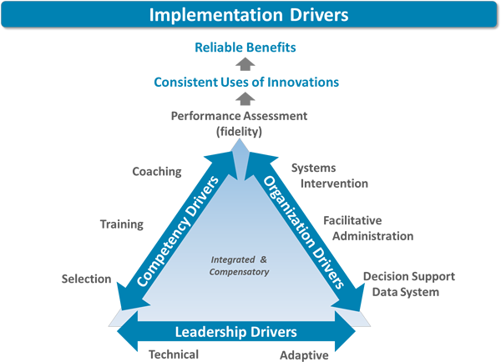
Figure 1: Implementation Drivers (Fixsen, Blase, Naoom & Duda, 2015)

The three over arching drivers and the components within them will be reviewed in the following sections.
Competency Drivers
- Recruitment and Selection of staff
Fixsen et al. (2015) highlight recruitment and selection of staff as the initial component in generating a team who have the appropriate skills, abilities and knowledge to implement evidence based practice. This is with the aim to generate more positive outcomes for clients: in this case the children attending the early years establishments for which they work. Requirements within this component include:

- Skills and abilities required for the sustainability of the implementation reflected in job specification,
- Establishment of processes for recruitment of appropriate members of staff for the sustainability of the intervention,
- Interview procedures, and
- Criteria specifically laid out for insurance of selection of candidates with appropriate skills and abilities for sustainability for the intervention.
As in the current research where implementation of an intervention occurs within an existing team of staff, it is suggested that the requirements are adhered to in consideration of new members joining the team.
- Training
Training in the new approach, as outlined in the framework, also provides a means of supporting implementation. In the current research, the initial training provided by KCA creates a basis for information required for establishments involved. This is so there is an understanding of the new skills and knowledge gained and when, where, how and with whom these are to be applied. Training also provides a means of:
- Offering the knowledge and understanding required concerning the theory, philosophy, value and history of the new approach (FTT),
- Providing practice procedures and rationales for using the new approach, and
- Facilitating experiences to apply newly acquired skills and knowledge within a critically reflective situation.

- Coaching
Whilst the selection and recruitment of staff along with appropriate training in the intervention are important for establishing understanding, knowledge and skills, these are consolidated into practice through on-going consultation and coaching. To implement a new approach such as FTT, a coach needs the ability to encourage and provide experiences to enable this transfer of theory to practice. For successful implementation of an approach across a whole establishment the entire staff (practitioners, administrative and management) must adopt new behaviours required (Fixsen et al. 2015). For this to happen effectively the appropriate training and coaching must be in place for the maintenance and continuous improvement of the approach across the setting.
- Performance Assessment (Fidelity)
The continuous improvement aspect of IS can be evaluated through the degree to which the skills and knowledge learnt in training have been incorporated into practice. Fidelity measures highlight the supports of the implementation of the approach, such as FTT, as well as potential barriers to be overcome to further improve implementation. Using these measures whilst considering that implementation is unique to each establishment due to variations in the previous components, it is the role of each establishment to ensure the approach is being used most effectively when working, in the current context, with parents/carers and children attending.
Organisation Drivers
- Decision Support Data Systems
The next component of the framework considers the use of information to support establishments in next steps regarding implementation of an approach. Steps that can be taken to do so include:

- Deliberate over the key aspects of the establishment’s performance thus far,
- Use collected data to enlighten next steps in terms of implementation, and
- Consistently implement the approach, FTT, whilst ensuring impact for participants involved.
Adopting such measures within this component contributes to reflection on implementation and the supports and barriers that have emerged. In the current research, data collected across establishments could have implications for continuous implementation taking into account the various supports and barriers whilst considering the impact on all those involved. This data could therefore be useful when presented and examined for informing short and long-term targets for all staff involved in implementation (within the playroom as well as at management levels). Alongside the other components of the framework, use of such a system can contribute to the continuous improvement of utilsiing the approach.
- Systems Intervention
Another component of the framework for implementation concerns working together with systems in place externally that can provide supports for an approach. Examples of such supports can include human, organisational and financial means, thus this core component takes into account external factors that can have an influence on the participating establishments’ ability to maintain and progress the approach.
- Facilitative Administrative Supports
A further core component concerns leadership of those involved in implementing the approach, achieved through the utilisation of other components such as the

data systems to inform next steps of implementation. This is in addition to providing coaching and consultation for encouraging staff in ensuring positive outcomes for those involved in the approach, FTT. Utilising these aforementioned components ensures ability to put into place the ethos and structures that flow alongside the needs of the staff involved in implementation.

Crucial in the implementation of an approach are the interactions between all of those affected: in the current paper, the early years practitioners interactions with the parents/carers and children attending the establishment. To enhance these interactions as fully as possible, facilitative administrative supports should include the resources available as part of the approach. Other components and experiences pertinent in implementation (coaching, training, use of data systems) should be utilised with such resources to support all those involved in implementing the approach, FTT, so as the ethos is continuous even when changes occur within staff members, stakeholders and management.
- Leadership Drivers
The final component of the implementation framework constitutes the importance of leadership within the organisation and system levels. Highlighted within the framework is that leadership is not isolated to one individual and is instead distributed ensuring a variety of roles are undertaken in order to implement and establish a new approach sustainably (Fixsen et al., 2015). In the early stages of implementation of an approach it is more likely for leadership roles to be ‘adaptive’, and will continue to be so within the current context given the constantly changing financial and social climate to ensure sustainability of the approach. It may be in time however that leadership takes the form of more

broadly allocated leadership roles. The form in which this takes should be reflective of the current context to enable most effective implementation.

1.3.3 Attachment Theory
The underpinning psychological theory of the current research is attachment theory, due to its base within the FTT approach.

Attachment theory was first outlined by Bowlby (1958), for which he highlighted the connection between babies’ early experiences and how these shape their adult lives and emotional wellbeing. The theory achieves this by focusing on the earliest experiences of emotional security and their importance whilst also suggesting the consequences when such security is not experienced, thus demonstrating the ways in which parenting can influence a child’s social and emotional development (Ainsworth, Blehar, Waters & Wall, 1978).

Attachment is described as the bond that grows from an infant’s innate need for protection, safety and security (Bowlby, 1958). Lorenz’s (1935) research highlighted to Bowlby that this was not simply due to the need for food, and that the ‘imprinting’ demonstrated within this work insinuated another innate drive for children to attach themselves to primary caregivers. Therefore attachment is more than the seeking of food – it is an infant’s need for attention and security for survival. In more recent years, technology in neuroscience has allowed us to see that attention and security are not the only aspects a baby will seek out. Moreover they are instinctively activating sensory stimulation and reactions from others to enable brain development (O’Connor, 2012). For this to happen

effectively, caregivers need to engage with babies as frequently as possible – the underpinnings of the FTT approach.
- Emotional Regulation and Attachment
No baby is born with the innate ability to regulate its own emotions. However babies rapidly learn that when they signal distress an available caregiver can soothe the suffering and support in ‘regulation’ of the feelings associated with distress. When a responsive caregiver engages with the child, the attachment is continuously reinforced, demonstrated in Figure 2.

Figure 2: Continuously reinforced attachment (Adapted from Gott (2009))

This is an obvious short-term benefit, however long term benefits for the child include the neural pathways developing in the baby’s brain when this pattern of distress and caregiver soothing is repetitive. Thus the baby is beginning to internalise the feeling of being secure as they continuously learn how they may soothe themselves in a healthy way (O’Connor, 2012). This is crucial, as highlighted in the FTT training and resources, in supporting children to feel safe.
- Attachment and Relationships
The importance of children feeling safe has an impact on how they experience the world around them – as feeling safe and secure influences how a child explores and experiments (O’Connor, 2012). This is further demonstrated in the FTT resources and training, where the approach seeks to support services to establish an environment through engagement, so that children feel safe thus able to develop and learn to their full potential. The FTT training and resources are therefore based on attachment theory and aim to support practitioners to provide emotionally safe environments (Robinson, 2003).

Therefore relationships are pertinent to a child’s feeling of safety and security. While the primary caregivers are significant in their responses to the child, so too are secondary caregivers, who in the present study can be considered as the early years practitioners. The responses and attunement of those around the child are a significant factor in the building of relationships between the caregivers and child, as they build up memories of what caregivers do when the child is feeling unsure or unsafe (Siegel, 1999). These relationships present a secure base for the child to then further develop their confidence and self-esteem. It is assumed that most caregivers are able to convey feelings of security to their children (O’Connor, 2012), and approaches such as FTT offer support to enhance caregivers’ engagement and relationships with their children.
- Attachment and Brain Development
Since the earliest research into attachment theory there has been a large swell in technology, for which neuroscience has apparently confirmed Bowlby’s theory (1958). As previously mentioned, connections are made in the brain in the form of

neural pathways when caregivers respond and engage with children. Throughout a human’s first three years, rapid structuring and shaping of the brain takes place – with preference made for ‘stronger’ neural pathways – developed over time with repetition (Gerhardt, 2004). The consistency and the way in which caregivers engage with children has a large influence on brain development – particularly in the earliest years of life. While brain structuring and shaping slows down after this three years, human brains will continuously grow new connections – and has been shown to do so most successfully when interacting with other humans (Trevarthen, 1990).

The FTT approach therefore aims to demonstrate the importance of caregiver’s interactions with children in shaping their brains, thus impacting on their life. This is particularly pertinent in considering the effects of stress on the brain, which in its most serious level of toxic stress (trauma) can be experienced by approximately 20% of the population in any given year (Read, 2009). Stress in the form of separation from their parents can be a daily occurrence for children and can be perceived as a threat of abandonment by the primitive brain until the age of five years (Sunderland, 2006). Neural pathways developing the frontal lobes are strengthened through consistent caregiver reassurance and responses, with the intensity of fear of abandonment reducing over time. Given the period of time of which the child undergoes stress during separation from their main caregiver, it is imperative that secondary caregivers in the form of early years practitioners have the skills and knowledge to be able to support children through the distress of separation.

This impact can often be underestimated, however when a child is suffering stress due to separation from their main caregiver the same areas of the brain are activated as when a child is experiencing physical pain (Ladd, Owens & Nemeroff, 1996; Sanchez, Ladd & Plotsky, 2001). The stress hormone, cortisol, is released by adrenal glands and spreads through the brain and body during the periods of time where a child is distressed (Gerhardt, 2004). A caregiver providing the comfort required to the youngster can reduce the level of cortisol produced by the adrenal glands. However if a child does not receive the comfort required by a caregiver then the cortisol levels remain high throughout the brain and body. This can severely impair brain development if this is a frequent and long-term occurrence, causing stress response systems to be oversensitive. In some cases where children are frequently exposed to high levels of stress their stress response systems have been found to produce low amounts of cortisol as an adaptation. Both too much and too little cortisol production have been found to have negative long term implications, and in the case of too little there have been links to a variety of both emotional and physical issues (Gerhardt 2004).

Thus the ability to appropriately respond to children when distressed is crucial for their development. Over time when appropriate engagement has taken place the same experiences begin to reduce in levels of stress as the child learns that somebody is normally there to regulate their emotions (Balbernie, 2007). The availability of a caregiver in a timely response appears to be of importance as well, as it has been described that the ceasing of production of cortisol at the right time so as the child’s brain does not suppress the hormone or become flooded with it is of significance (Gerhardt, 2004). The long-term implications for children

who do not have the availability of a caregiver to support their levels of stress hormone include depression, anxiety disorders, eating and digestive disorders and alcohol and substance misuse (O’Connor, 2012). The ability of the caregiver to support the child is associated with the security of the child’s attachment – having impact upon a child’s ability to regulate their emotions (Gerhardt, 2004).

Further impact of unregulated stress due to lack of a secure attachment to a caregiver includes cell death in the hippocampus: important for memory. Brain scans in children exposed to high levels of unregulated stress have been found to have a similar structure of their hippocampus as an elderly individual (Sunderland, 2006). The implications for impeded brain structure in the hippocampus includes decreased ability in terms of both working memory and verbal reasoning, therefore affecting a child’s learning ability across a range of subjects, in particular in maths (Sunderland, 2006). Links between abnormal levels of cortisol in brain development due to unregulated stress in the early years and the implications for later life has been well researched. Established relationships between this and later physical and mental health include increased risk of major depression and post traumatic stress disorder (Heim, Owens, Plotsky & Nemeroff, 1997) depression (Beatson & Taryon, 2003; Plotsky, Owens & Nemeroff, 1998), and intestinal and digestive function (Alfvén, 2004; Jarrett, Burr, Cain, Hertig, Weisman & Heitkemper, 2003; Stam, Akkermans & Wiegant, 1997;).

1.4 Summary and Rationale
Given the impact demonstrated by the outlined literature of unregulated stress on the developing brain, it is crucial that children are soothed in a timely and appropriate manner. This is well supported by those who have developed a

secure attachment with a child, and for this to take place the child must feel able to trust the caregiver through their attuned and engaged responses with one another.

Considering the length of time that children are now legally entitled to within early years establishments, it is important that those working within such services have the skills necessary to develop secure attachments with children in their care. Secure attachments have been shown in the aforementioned literature to have an impact on a child’s ability to regulate their own emotions. Without this ability, their range of learning experiences can be impinged, as they need to feel safe before being able to fully explore their environment as well as build relationships with others.

FTT seeks to develop and enhance the skills of early years practitioners in terms of engagement with children, as well as enhancing the skills of parents/carers through the establishment with the resources provided. In developing the knowledge of those caring for children in their earliest years, FTT seeks to provide an understanding of why engagement of children and young people is so important for their brain development and the impact this has on adult life. An aim of this project is therefore to seek out the impact that this knowledge and understanding has had: for children, parents/carers and staff.

A review of IS was also conducted to inform methods of how to evaluate the implementation of an approach within various establishments. Consideration of

the core intervention components outlined within the review of the literature has informed the rationale of looking into: How FTT has been implemented; Why it has been implemented this way; Supports and barriers to the implementation of FTT; and the next steps in terms of implementation.

In considering the outlined aims, the research question addressed in this paper is: what are the perceptions of those involved in the study of the implementation of FTT and the impact that this has had? The following chapter will outline the methodology adopted in order to address the aims and research questions of the current research.

2. Methodology

2.1 Participants
This study focuses on the perceptions of the staff of participating establishments and parents/carers of the children attending these establishments. In total, twelve parents and carers participated, while nineteen members of staff participated. In total there were thirty-one participants. A breakdown of the numbers of participating parents/carers and staff from each establishment is detailed in Table 1 below.
Establishment | Number of participating parents/carers | Number of participating members of staff
1 | 3 | 2
2 | 3 | 6
3 | 1 | 3
4 | 5 | 8
Table 1: Breakdown of Participating staff members and parents/carers from each establishment.

2.2 Ethics
At all stages of data collection and analysis, the British Psychological Society code of ethics and conduct (2009) was adhered to. Permission obtained by written consent forms was collected from all staff members and parents/carers participating in either questionnaires and/or interviews/focus groups (see Appendix 1 and 2, respectively). Participant Information sheets were also distributed to staff and parents/carers to ensure participants were fully informed

of the nature of the study (Appendix 3 and 4, respectively). An aspect illustrated both verbally and in the written forms was that participants had a right to withdraw consent at any point throughout the research, whilst being informed that discussion within focus groups was recorded. The participants were also informed that the data gathered and analysed from questionnaires and/or interviews/focus groups would contribute to reports created for both Authority X and the University of Dundee, however anonymity would be maintained in these write ups. Consent forms, focus group records and completed questionnaires remain securely stored in a locked cabinet, within the researcher’s placement local authority office, secured by two locked entry points, in line with the Data Protection Act, 1998. Meanwhile, analysis of the data collected from questionnaires and focus groups has and continues to be stored on an encrypted memory stick for which only the researcher has access to.

For the purpose of this report, maintenance of anonymity for participants and for the local authority is upheld by referring to the local authority as Authority X and collating the data from each early years establishment, named nursery 1, 2, 3 and 4 to prevent individuals from being identified. Participants are identified by role (Parent/carer, or staff) in the analysis but are discussed in groups without identifying individuals.

2.3 Epistemological Stance
In an attempt to understand the epistemological and ontological approach of the researcher, the philosophical system of critical realism can be applied. This stance

was adopted for the current research due to its applicability of beliefs regarding reality and knowledge, in this case stakeholders views of an approach (namely FTT) and the interpretations of these beliefs. Those holding a critical realist stance approach reality as being constructed through tangible events, change inducing structures, and the perspectives of those involved in the event and change (Clark, 2008). Furthermore, a critical realist stance promotes consideration of what is known to be true: in the current study this is the implementation of FTT. The use of qualitative measures, in the current study focus groups and interviews, allows for obtaining perspectives and so a critical approach to how the reality of those involved in the implementation of FTT had been constructed by the differing causalities and aspects associated. Furthermore, the focus groups and interviews allowed for observable events to be recorded, which for the current study was discussion around the implementation of FTT. In analysing the focus groups and interviews, the researcher aimed to uncover underlying casualties and aspects linked to the varying implementation and stage of implementation of the approach. Furthermore, the use of qualitative and quantitative data from questionnaires to triangulate with the qualitative data collected from focus groups and interviews was adopted in order to gather a depth of knowledge around the implementation of FTT in various establishments, for which an inherent link between this mixed methods design and epistemological stance is illustrated below in Figure 3.

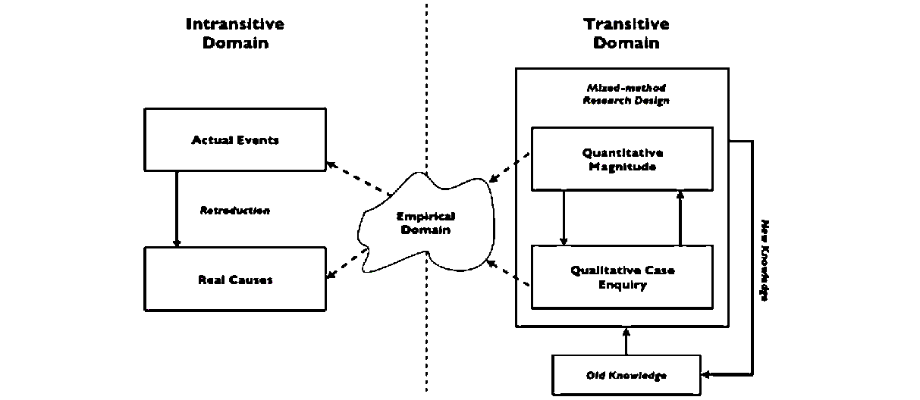
Quantitative Measures
Qualitative Interviews
Critical Realism Research Design

Figure 3: The Approach of Critical Realism and the relationship with research (adapted from Zachariadis, Scott & Barrett 2013).

2.4 Method of Data Collection
A multi-level mixed methods design was adopted for the current research. Purposes for adopting mixed methodologies include: allowing for convergence and triangulation of results; examination of overlapping and different levels of a single phenomenon; discovery of fresh perspectives, contradictions and tightening of emerging results; informing of the use of other methods from another, and broadening the scope of research (Greene, Caracelli, & Graham, 1989). For the aforementioned reasons, the researcher felt that a more thorough evaluation and implementation analysis could be conducted.

Therefore, data collected for this current study was qualitative and quantitative in nature, comprising of questionnaires, interviews and focus groups. As the

majority of data collection methods were qualitative in nature, the current research is more dominantly qualitative with the quantitative methods utilised to broaden the qualitative project.
Semi-structured interviews with parents/carers
To enable the gathering of perspectives of parents/carers on the implementation of FTT, the researcher chose the use of semi-structured interviews to gather information with the flexibility of adapting language according to the parents/carers level of understanding. The questions were framed within a document shared with the early years establishments head teachers to ensure suitability. As positive feedback was received, this structure was used for all interviews with parents/carers across all four participating establishments. The questions are attached as Appendix 5.
Staff questionnaires
Questionnaires for staff were chosen as one method of data collection so as to be able to gather the views of as many practitioners involved as possible. The questionnaire comprised of open, closed and scaling questions, with the aim to gather the perceptions of staff involved in the implementation of FTT in the most practical manner possible, left with each of the establishments’ lead of FTT to be distributed and collected. The questionnaire can be found as Appendix 6.
Staff focus groups/interviews
To gather the perceptions of staff members involved in the implementation of FTT, a further method of data collection was utilised: focus groups. Whilst each focus group consisted of an original framework of four key questions (see Appendix 7), the quantitative and qualitative information from the staff

questionnaire was used to deepen discussion and triangulate information with the staff focus groups for each of the early years establishments. Focus groups were selected as an optimal method of collecting data as a key feature of using them is the use of group interaction to gather perspectives and information that could prove challenging to discover otherwise (Morgan, 1997). The interaction between participants is particularly beneficial due to learning of others perspectives, as well as facilitating participants’ “learning from each other and re-considering or re-evaluating their own understandings and experiences” (Litosselitti, 2003, p.19). Thus, a change and development in the opinions of participants can occur as discussions move forward in the duration of a focus group. The focus groups were facilitated by the researcher within each respective early years establishment.
A breakdown of the role of the participants, as well as the number of participants taking part in each method of data collection, is outlined in Table 2 below.
Establishment | Number of participating parents/carers  (Questionnaires) | Number of participating members of staff  (Questionnaires) | Number of participating members of staff  (Focus Groups/Interviews)
1 | 3 | 2 | 2 (interview)
2 | 3 | 6 | 6 (focus groups)
3 | 1 | 3 | 3 (focus group)
4 | 5 | 8 | 6 (focus groups)
Table 2: Breakdown of Participants in Each method of data collection

It has been established that the size of a focus group should normally involve between four and twelve participants (Krueger & Casey, 2014). However as illustrated in the table above, a number of focus groups were small in size. This therefore poses limitations in the methodology, as discussion may not have been as in depth as it would have if the focus groups were larger. However it was deemed impractical for larger numbers to attend focus groups within the time frame of the current project. These limitations will be further discussed later in the report.

2.5 Procedure
Recruitment Process
In preparing this implementation analysis, it was important to consider key practical issues for the planning stage. The early years establishments approached for the current study had had representation at the KCA FTT training and had previously shown interest in taking part in research concerned with FTT when asked by a Quality Improvement Office (QIO) and Senior Educational Psychologist (EP). Thus a purposive sampling method was adopted. Of the six early years establishments who had originally shown to be interested in taking part, four early years establishments were recruited by telephone and/or email. Those who responded positively were included in the present research.

From there, the four interested establishments were visited by the researcher for an initial meeting, for which the purpose was to fully describe the rationale for the current research and what the early years establishment’s involvement would look like. It was at this stage that parent/carer consent forms, staff consent forms,

parent/carer information sheets and staff information sheets were handed to the link person within each establishment for distribution to members of staff trained, and parents/carers of children who attend the rooms where the members of staff are placed.
Parent/Carer semi-structured interview
To gather the perceptions of the parents/carers of children attending early years establishments with members of staff trained in the FTT approach, the researcher created a set of questions (see Appendix 5) for use in semi-structured interviews after consultation with the Senior EP and the QIO. These include questions regarding the origins of the parents’/carers’ knowledge of the FTT approach and if, in their point of view, this had made a difference for them and their child/children attending the early years establishment. The questions were visually represented for the parents/carers and were one page long of short, clear and simple questions.

The semi-structured interviews were conducted on a one-to-one basis with the researcher only; who asked the questions listed verbally and recorded them whilst the participants were answering. The semi-structured nature of this approach allowed for the same types of questions asked of each parent/carer, with the potential of adaptation if necessary (Robson, 2011). The rationale for this approach was that it was indicated in the planning stage by early years establishments and Psychological services that some parents may face barriers in completing questionnaires due to a number of factors, for example literacy difficulties or English as an Additional Language (EAL). With the flexibility of the semi-structured interview, the researcher was hopeful that this would overcome

any barriers in understanding of any of the questions, therefore increasing participation and encouraging participants to provide more information in their answers. The semi-structured interviews were conducted with the researcher only to encourage participants to be as honest as they could in their responses regarding the early years establishment implementation of the FTT approach.
Staff Questionnaires
In order to gather the views of as many members of staff trained in the FTT approach as possible, a questionnaire was formulated and administered comprising of thirteen questions, in a variety of formats: closed; open-ended and scaling (see Appendix 6). This was conducted for triangulation purposes, as it became apparent in the planning stage for focus groups/interviews that it may be difficult to find time for members of early years establishment staff to be removed from the rooms with children due to the child: staff ratios to be met. Furthermore, questionnaires were administered with a view to gauge key aspects of the early years establishments’ implementation of the approach to feed into later focus group/interview discussion. The researcher created questions that were short, clear and simple to ensure they were easily understood by early years establishment staff (Robson, 2011).
Focus Group/Interview Questions
In the preparation and planning stage of the current study, the researcher developed questions for the staff focus group/interview data collection (Appendix 7). This involved consultation with the Senior EP and the QIO to ensure appropriate questions were developed to gather information of interest from early years establishment staff and parents/carers regarding the FTT approach.

Additionally, the use of open-ended questions allowed participants ‘to respond from any perspective’ and ‘freely share their own views’ (Hennink, 2013, p. 60).

In total, the researcher facilitated six focus groups across three of the four participating early years establishments comprising of members of staff based within their respective nurseries. The members of staff taking part in the focus groups were all, at the time of data gathering for the current study, Child Development Officers (CDOs). In addition, focus groups comprised of CDOs working within the same early years establishments. It is hoped that as the participants in each focus group were in the company of colleagues of the same level and worked with one another on a daily basis, that a comfortable and respectful environment was facilitated.

Within the remaining early years establishment participating in this study, two individual interviews were held due to the numbers being too small for a focus group. Whilst it would have been optimal to conduct a focus group in all establishments, it was not deemed possible due to difficulties in accommodating the child: staff ratio to be maintained at all times in the early years establishment. This limitation will be discussed in a later section.

2.6 Data Analysis

2.6.1 Quantitative data
The quantitative data gathered from the staff questionnaire and the parent/carer semi-structured interviews was collated manually by the researcher, for which descriptive statistics and visuals have been created to illustrate where staff and

parent/carer knowledge of the FTT has come from, how well the FTT approach has been embedded within the establishment from staff member’s perspectives as well as knowledge of follow up training opportunities.

2.6.2 Qualitative Data
For the purpose of analysing the qualitative information from the parent/carer interviews, staff questionnaire and staff focus groups/interviews, thematic analysis has been adopted. The process is deemed by Braun and Clarke (2006) to be a means of “identifying, analysing and reporting patterns (themes) within data”. Thus, the researcher aimed to be “searching across a data set – be that a number of interviews or focus groups, or a range of texts – to find repeated patterns of meaning” (Braun & Clarke, 2006).

For the current study, the six phased thematic analysis constructed by Braun and Clarke (2006) was adapted and utilised by the researcher as a means to apply a broad method in condensing main aspects of the data collected by numerous methods. Deductive analysis was undertaken in that the researcher established the coding of the data and therefore ascertained the themes selected, in an attempt to address the pre-established research questions. The six phased process applied to analyse the data collected in the current study are illustrated in Table 3 below, for which each phase will be expanded upon in the following sections.

Phase of Thematic Analysis | Procedure
Phase 1 | Familiarising self with data
Phase 2 | Generating initial codes
Phase 3 | Searching for themes
Phase 4 | Reviewing themes
Phase 5 | Defining and naming themes
Phase 6 | Produce report
Table 3: Thematic analysis phases (Braun and Clarke, 2006)

Data Analysis Procedure
- Phase 1: Familiarising yourself with the data
The initial phase of thematic analysis involved the researcher becoming ‘immersed’ in the collected data (Braun and Clarke, 2006). Due to the number of focus groups and interviews that the researcher conducted for the project and the time restrictions in place, notes of key discussion points were taken throughout the duration of the focus groups/interviews. Furthermore, the qualitative information gathered from the staff questionnaires was highlighted in preparation of later phases of thematic analysis. Immediately after each focus group or interview was conducted, the researcher checked back with the participants that the notes taken throughout were representative of their perceptions, adding to and amending as appropriate. These notes were then read over and typed up so as the researcher became immersed in the data collected.

- Phase 2: Generating Initial Codes
The second phase of data analysis involved the researcher generating initial codes from the aforementioned recordings of the data collected. Highlighters were adopted for this manual process, where the researcher aimed to provide equal consideration for the complete data set (Braun and Clarke, 2006) in manually colour coding the notes taken from the six staff focus groups, two staff interviews, twelve parent/carer interviews and nineteen staff questionnaires.

Due to the deductive approach employed by the researcher, the research questions were instrumental in generating codes in that items related to the perceptions of the impact of FTT and how it had been implemented, why it was implemented that way, what now in considering implementation, supports and barriers to implementation as well as the impact the approach has had, within the respective establishments were highlighted (Braun and Clarke, 2006). This process produced a number of lists for each strand of research (staff questionnaires, staff focus groups/interviews and parent/carer interviews) for each participating establishment.
- Phase 3: Searching For Themes
Pre-determined themes were adopted for the current research, due to the adopted framework for information gathering regarding the implementation and impact of FTT. The framework structured discussion with the participants across a range of different methods, and so the researcher deemed it appropriate for the same framework to drive the analysis of the data. This therefore allowed for the focus of themes to be on the ‘How’, ‘Why’, ‘What now’ of implementation of FTT, and the impact the approach has had upon the children, the parents and carers

and the members of staff of the establishments involved in the current study. Furthermore, following the framework allowed for identification of the supports and potential barriers of the implementation of the approach. It is hoped that analysing the data within the aforementioned headings therefore makes the research user-friendly for the authority for which the current project has taken place.

Thus, the researcher collated the codes that had been generated within the second phase of thematic analysis within the aforementioned themes (How, Why, What now, supports and barriers of implementation, and impact upon children, parents/carers and members of staff of establishments). Throughout this process sub themes emerged as data was categorised within these headings.
- Phase 4: Reviewing Themes
For establishment 1, please see Appendix 8, establishment 2, Appendix 9, establishment 3, Appendix 10, and establishment 4, Appendix 11.
- Phase 5: Defining And Naming Themes
During the fifth phase of thematic analysis, the researcher further scrutinised the data illustrated within thematic maps created for each establishment to increasingly define themes emerging. In order to do so, the researcher regarded the illustrated data as a single entity and so considered each thematic map produced in line with the research question (Braun and Clarke, 2006). Thus a number of themes were considered and sub theme labels changed to ensure all perceptions were sufficiently represented, and so final thematic maps were

produced illustrating each of the overarching themes for each participating establishment.

These will be presented in the following section for each establishment: 1,2,3 and 4, for which thematic maps have been constructed to outline the perceptions of parents/carers and staff members within the following themes: ‘How has FTT been implemented?’ ‘Why has it been implemented this way?’ ‘What now?’ ‘What has supported implementation of FTT?’ ‘What has been a potential barrier to the implementation of FTT?’ ‘What has been the impact of FTT?’.

3. Results
The data collected from questionnaires, focus groups and interviews for participating establishments are presented individually using the previously outlined headings.

3.1 Establishment 1
For the full thematic maps for each theme please see Appendix 8.

3.1.1 How has FTT been implemented?
Analysis of questionnaires and interviews identified a number of ways FTT has been implemented within the nursery.
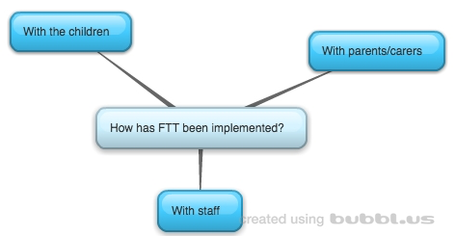
Figure 4: Establishment 1 – How has FTT been implemented?

As can be seen in Figure 4 It has emerged from analysis that FTT has been implemented with staff. A closer look at the data indicates this is through the initial KCA Training of FTT for which specific members of staff from the 0-2 room attended. Since this time, management “saw the good practice used and wanted

to embed FTT in the older rooms”, and so the approach has been filtered through into the other playrooms.

Within the playrooms, staff and parents/carers reported that the FTT approach has been implemented by members of staff “consistently using the five building blocks” in engaging with children, but also with other members of staff and parents/carers, thus modelling the approach with adults in the children’s lives. This modelling is reported to be of particular importance during times of transition - “the child knows and trusts me and can see if I’m cuddling the new adult, they can trust them too”. Thus, the modelling of the approach is used to promote relationships between the children and their new caregiver.

The approach has also been implemented through the engagement of parents/carers. This has taken a number of forms, inclusive of displays of the FTT building blocks alongside photos of the children and adults demonstrating the principles. Furthermore, the staff and parents/carers reported the relationship between the two parties to be “brilliant” which has played a factor in communicating the approach, either through discussion or through the modelling as described above. The FTT booklets have also been reported as being used to communicate the approach with parents/carers.

3.1.2 Why has FTT been implemented this way?
Questionnaires and interviews held within Establishment 1 identified a number of reasons FTT has been implemented the way it has.
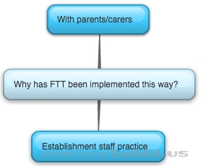

Figure 5: Establishment 1 – Why has FTT been implemented this way?

Analysis of the data illustrated in Figure 5 and Appendix 8 indicates that FTT has been implemented the way it has been illustrated in the previous section so as to be able to “enhance practice with the knowledge of brain development” throughout different playrooms, using an approach, FTT, that the staff deemed to be a “natural progression from what we were doing before” (named within other data gathering methods as Pre-birth to 3 and Promoting Positive Parenting (Triple P)). Furthermore, it was highlighted that this was done after discussion with all of the playroom staff.

Considering why the aforementioned methods were used for engaging parents/carers, the staff in establishment 1 reported the existing good relationships supported implementation through modelling and verbal communication, with the aim to “promote engagement through the five building blocks as early as possible”. Engaging the parents/carers in FTT was done so as to promote consistent working with the children attending, with “everyone using the five blocks consistently”.

3.1.3 Next steps
Questionnaires and interviews held within Establishment 1 identified a number of next steps for the implementation of FTT.
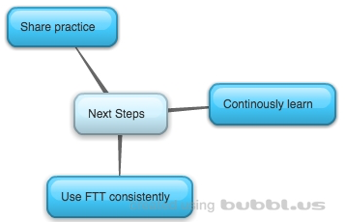
Figure 6: Establishment 1 – What are the next steps?
Figure 6 illustrates themes emerging from analysis of the questionnaire and interview data, for which staff have identified follow up opportunities for FTT implementation as being able to “promote our work to other nurseries at conferences”. It was further established that in terms of implementation within the establishment, FTT needs to be continuously used by “all members of staff and parents so that we can work consistently using the five blocks”. It emerged that in order to do so, members of staff will need to continuously learn and refresh in the approach.

3.1.4 Supporting factors in implementation of ftt
Analysis of questionnaires, interviews and focus groups identified a number of supporting factors for the implementation of FTT within Establishment 1.
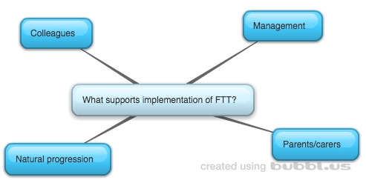

Figure 7: Establishment 1 – What supports implementation of FTT?

Analysis of the data illustrated in Figure 7 and Appendix 8 indicates that supports identified in implementing FTT have included the good relationships held between staff and parents/carers. This has allowed for “good verbal communication about the five blocks” as well as being able to model the principles of interaction for the children.

Furthermore, it was established from staff members that implementation of the approach was supported in the establishment as a whole by the ”majority of staff being on board” as well as the management team being in full support of implementing the approach across numerous playrooms in the establishment.

Lastly, another support of implementation of FTT was identified by staff as being a “natural progression of what we were already doing”, in relation to both the approaches being used within the establishment already (such as Triple P and the pre-birth to three document) and the good practice being used already, which the

FTT approach was enhancing by “raising awareness of the importance of interaction with children”.

3.1.5 Barriers in implementation of ftt
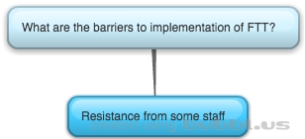
Analysis of questionnaires and interviews identified one potential barrier for the implementation of FTT within Establishment 1 as can be seen in figure 8.

Figure 8: Establishment 1 – What are the barriers to implementation of FTT?

The barrier identified regarding the implementation of FTT, which was that “some members of staff are not as willing to use the approach”. It was noted in discussion that some members of staff were used to more “traditional ways of working” however staff noted the approach was being more readily embedded across play rooms when the benefits of FTT were visible in the children.

3.1.6 what has been the impact of ftt?
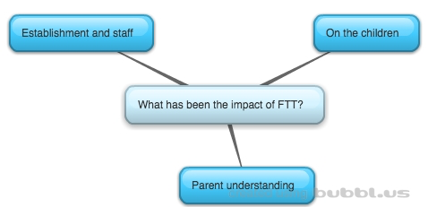
Figure 9: Establishment 1 – What has been the impact of FTT?

Figure 9 and Appendix 8 are illustrations of collated themes drawn from information gathered from staff members and parents/carers of children attending Establishment 1 in relation to the impact of FTT.

With regards to the staff members within the establishment, it was identified by staff that the practice is adapting and improving due to the FTT approach. Further indicators of impact include that staff felt that FTT was different from other approaches as “we can use it visibly in our practice everyday” as well as being more hands on than other approaches in that it promotes cuddling and touch for promoting development. Furthermore, staff noted that the majority of staff were interacting more with the children attending due to the benefits seen from using the approach.

These benefits have been documented in the data gathered from both parents and staff as the children settling into their environment much better since using the approach. Furthermore, members of staff noted that when a change in staff member meant the approach “was not being used, the child’s behaviour was regressing… using the approach again and letting the staff member know the child was much happier and more settled”.

Another indicator of the impact of the implementation of FTT was parent/carers understanding of the approach. It was identified during parent interviews that parents understood FTT as being an approach for promoting healthy relationships and “taking the five blocks forward”. Parents/carers also understood the approach to be a hands-on approach to attachment, for which they felt their own interactions with their children were improved as well as being able to show family members the importance of engaging with the child.

3.2 ESTABLISHMENT 2
For full thematic maps, please see Appendix 9.

3.2.1 How has FTT been implemented?
Analysis of questionnaires and interviews identified a number of ways FTT has been implemented within Establishment 2.

Figure 10: Establishment 2 – How has FTT been implemented?

Figure 10 and Appendix 9 illustrate the collated themes emerging from the data gathered from parents/carers and staff of establishment 2.

It emerged from the data collected that FTT has been implemented with staff either attending the initial KCA training held last year, or through in-house training from the establishment using the FTT resources.

Using this knowledge from either sets of training, staff members from establishment 2 have sought to engage parents/carers through a number of routes. This includes written documentation that has been handed to parents/carers regarding FTT, for which the establishment “focus on one of the blocks at a time for the leaflets and home link sheets to make it more manageable”. Data gathered also indicated an established link between the establishment’s storytelling bags that have gone home with the children from the nursery promoting interaction, as well as a monthly newsletter that is distributed amongst parents/carers. Lastly, all participants made mention of the visuals

within the establishment promoting FTT through a combination of the resources provided and photos of the children attending with parents/carers or staff promoting the principles.

It also emerged from the data that the approach is implemented with the children through the daily interaction they have with staff, who are actively using the approach in the playroom to “enhance our existing skills”.

3.2.2 Why has FTT been implemented this way?
Questionnaires and interviews held within Establishment 2 identified a number of reasons FTT has been implemented the way it has.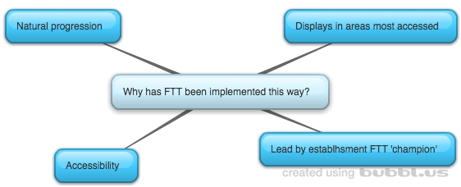
Figure 11: Establishment 2 – Why has FTT been implemented this way?

Figure 11 illustrates staff views regarding why FTT was implemented the way it was. A number of staff members commented that FTT was a natural progression of previous approaches used within the nursery. This is inclusive of parental interactions, such as parents evening, display boards and home link sheets. A number of these existing approaches were therefore selected to promote FTT making use of the “good relationships we have with parents”.

In terms of the display boards, the establishment staff indicated that they endeavoured to promote FTT within the areas most accessed, for example “we put photos and descriptions above the hooks where they put their jackets” so as to be able to make the resources as accessible as possible.

Focusing on one block at a time was established as an appropriate way to implement FTT as it was thought to “be easier to follow for our parents” when giving out leaflets.

The way in which the approach was implemented throughout this establishment was identified by staff members as by the FTT ‘champion’ who sought to embed the approach.

3.2.3 Next Steps
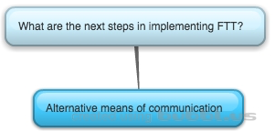
Questionnaires and interviews held within Establishment 2 identified a number of next steps for the implementation of FTT.

Figure 12: Establishment 2 – What are the next steps?

Figure 12 illustrates staff members’ views regarding the next steps of implementation.

The staff at this establishment felt that the newsletters were a good way to get information to parents/carers but “a lot of the time the newsletter ends up in the junk mail folder in the parents’ emails” – and so discussion took place considering other possible means of distributing newsletters.

Furthermore, all participating staff identified that they would like to be able to hand the parents/carers a separate booklet highlighting the importance of interaction and phones: “some need to know how important it is to be talking to your child instead of being on the phone”. All staff participating felt an easily accessible booklet would be beneficial for further promoting engagement.

3.2.4 Supporting factors in implementation of FTT
Analysis of questionnaires, interviews and focus groups identified a number of supporting factors for the implementation of FTT within Establishment 2.

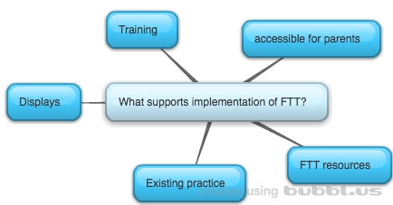
Figure 13: Establishment 2 – What supports the implementation of FTT?

Figure 13 illustrates the collated views of participating staff members during data collection.

Staff members felt that the principles of FTT were being used in the establishment prior to the introduction of the approach, however FTT was enhancing existing practice by helping putting a name to it and “bringing in brain development”.

A number of staff also commented on the usefulness of the FTT resources in terms of promoting engagement from parents/carers. This also has implications for the displays around the establishment as the resources provide visuals.

Further supports identified were that staff felt that the approach was “written in clear and easy-to- follow language for all of our parents to be able to access” thus promoting parent/carer engagement in the approach.

Lastly, the staff members of this establishment commented on the training of the approach, enabling staff members to embed FTT in the establishment.

3.2.5 Barriers in implementation of ftt
Analysis of questionnaires and interviews held within Establishment 2 identified no potential barriers to the implementation of FTT.

3.2.6 what has been the impact of ftt?
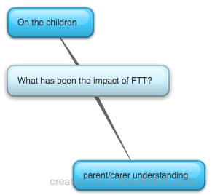

Figure 14: Establishment 2 – What has been the impact of FTT?

Figure 14 and Appendix 9 illustrate the collated views of staff members and parents/carers of establishment 2.

Part of the demonstrated impact in implementing the FTT approach in establishment 2 is the parents/carers understanding of what the FTT is and what the purpose of using it is. Parent/carer understanding included knowledge of what the five blocks were for, for which they identified “using the five blocks supports brain development” “using the blocks from FTT will support them when they have grown up and for later life”, and “that the blocks help children to feel safe and secure”. Furthermore, parents/carers were able to identify that FTT supports nurture, whilst “showing us the importance of interacting with our children from when they are born”. Parents also identified that the approach allows for partnership working with staff as it “means we are using the same approach consistently with our children”.

In terms of the impact of the approach with children, it was identified that participants perceived children to have “got more confident” and are “feeling safe and happy” within the nursery and home environment. One parent also noted there had been improvements in their child’s communication and expression of emotion. Lastly, staff members noted that using the approach was helping in transition between rooms within the nursery, whereby children were settling in more quickly.

3.3 ESTABLISHMENT 3
For full thematic maps please see Appendix 10.

3.3.1 How has FTT been implemented?
Analysis of questionnaires and interviews highlighted various ways FTT has been implemented within Establishment 3.
Figure 15: Establishment 3 – How has FTT been implemented?

As illustrated in Figure 15, staff members reported that FTT had been implemented throughout staff members. This was reported as through attendance at the KCA FTT initial training for some staff, as well as continuous in-house training throughout the year for refresher knowledge.

Furthermore, implementation has included engaging the parents/carers through a number of approaches. These have included homelink sheets containing information regarding FTT, FTT booklets and verbal communication between staff members and parents/carers. Furthermore, the use of visuals has been widely used within the context inclusive of the FTT resources and as visual representation of the five blocks, alongside descriptions of which of these are. These have been

captured in “minimalist displays around the nursery” which include “regularly changed photos of children and adults illustrating the five blocks”.

Finally, with the children in their establishment, staff members discussed the ways in which the approach was being implemented in terms of their development. This included observations of children within the establishment “using the five blocks to see where they are” following on to the beginning of implementation of the five blocks in children’s planning documentation and individual target setting.

3.3.2 Why has FTT been implemented this way?
Questionnaires and interviews held within Establishment 3 identified a number of reasons FTT has been implemented the way it has.
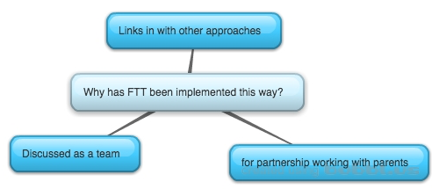

Figure 16: Establishment 3 – Why has it been implemented this way?

Figure 16 and Appendix 10 illustrates the emerging data. Staff members noted that the FTT approach links in with other approaches and legislation utilised within the establishment, inclusive of Building the Ambition and pre-birth to 3.

Furthermore, staff noted the importance in working in partnership with parents by engaging them, using an “easy to understand format for the parents through our displays in the nursery”. In exploring the methods used for the displays during focus group discussion, staff members highlighted that the displays were in the areas where parents/carers were most likely to see them (inclusive of above coats

outside the playrooms), which are “minimalist so that they “pop” out and are more eye catching” and include photos of the children that are regularly changed so as to “keep up the interest in looking at the displays”.

Staff also highlighted that the choice in implementation was discussed amongst the team and agreed upon.

3.3.3 Next Steps
Questionnaires and interviews held within Establishment 3 identified a number of next steps for the implementation of FTT.

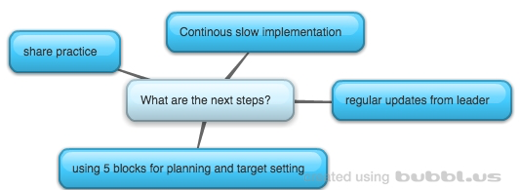
Figure 17: Establishment 3 – What are the next steps?

Figure 17 illustrates the next steps identified by the team, which includes acknowledgement of the upcoming open evening to be held where “nurseries can see how you can use FTT in every day practice”. Furthermore, staff members reported that the implementation of the approach throughout the establishment has been slow “we don’t want to bombard all at once – it needs to be a slow steady process to make sure it flows through the nursery” thus it was acknowledged that implementation would continue to be slow and steady. The identified next stage of the implementation within their establishment was using the five blocks within individual children’s planning and for use of target setting.

In addition, staff had said they would continue to get regular updates from their team leader as the implementation process continues throughout the establishment.

3.3.4 Supporting factors in implementation of ftt
Questionnaires and interviews held within Establishment 3 identified a number of supporting factors for the implementation of FTT.
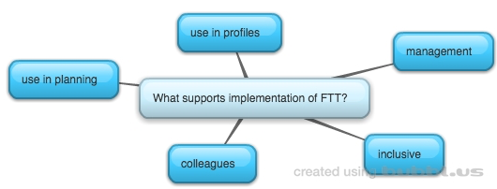
Figure 18: Establishment 3 – What supports implementation of FTT?

Figure 18 illustrates supports in implementation of FTT, inclusive of staff members indicating that the support received from management as well as from colleagues within the establishment helped. Furthermore, the embedding of the approach within planning for the establishment and for individual children helped to “keep FTT at the front of our minds” within everyday practice. This point was further supported by staff members perceptions that the FTT approach is applicable to all children, and supports all children, and that it’s therefore “used in everyday practice”.

3.3.5 Barriers in implementation of ftt
Questionnaires and interviews held within Establishment 3 identified no barriers in implementation of FTT.

3.3.6 what has been the impact of ftt?
Figure 19: Establishment 3 – What has been the impact of FTT?

Figure 19 and Appendix 10 illustrates perceived impact of FTT from the emerging data. In terms of staff practice, participants reported that they felt the environment was “more welcoming” whilst members of staff were more

“enhanced in their practice in terms of their nurture and care with the children who come here”. Staff practice was also impacted upon reportedly due to increased awareness of the importance of the five blacks for engagement with children and the benefits of using them, for which the staff have said they now use while “we follow the child’s lead”.

Impact has also been demonstrated in terms of the parents/carers awareness and understanding of the FTT approach through the establishment, for which they have said that they know the “five blocks help to support the children’s brain development” as well as using the blocks to help their children “feel safe and happy”. In terms of their understanding of what the approach looks like in the establishment, they reported the know “their children are comforted in the nursery”.

This was further demonstrated in terms of impact of the approach on the children, where it was reported by a parent that their “child is comforted more quickly at home and at nursery” as well as reportedly being more safe and happy in general.

3.4 ESTABLISHMENT 4

For full thematic maps please see Appendix 11.

3.4.1 How has FTT been implemented?
Questionnaires and interviews held within Establishment 4 identified a number of ways FTT has been implemented.

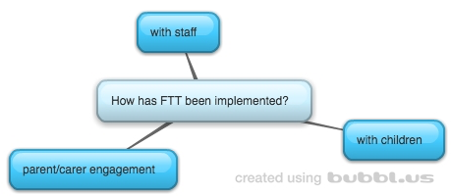
Figure 20: Establishment 4– How has FTT been implemented?

As illustrated in Figure 20 it has emerged from the data that FTT has been implemented through parent/carer engagement with the approach, for which the establishment have adopted a number of different methods. This includes verbal communication with parents/carers as they come into the establishment, creating and distributing monthly handouts for which there is a focus on one block at a time, wall displays throughout the nursery with descriptions and visuals with the FTT resources, and lastly a parent workshop held with the aim to promote the approach.

Amongst staff, it was identified that monthly planning meetings “have FTT on the agenda” and so is a part in the day to day running within the establishment. This is demonstrated in further points made regarding the practice of the staff, for which their “everyday good practice enhanced by FTT” is used with the children attending the establishment.

3.4.2 Why has FTT been implemented this way?
Questionnaires and interviews held within Establishment 4 identified a number of reasons FTT has been implemented the way it has.
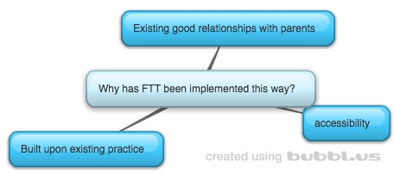
Figure 21: Establishment 4 – Why has FTT been implemented this way?

Figure 21 demonstrates the ways in which the establishment have engaged parents: they have implemented with the aim to make it as easy and accessible for parents to follow. This includes creation of different formats for sharing information (e.g. through workshops and also leaflets), as well as keeping consistency between methods of sharing as they “link the displays on the wall with the leaflets for the block that we’re doing that month”. The reasoning for choosing to focus on a block per month is also to make it more accessible and easy to follow for parents/carers. Utilisation of the existing good relationships with parents and carers has also reportedly informed the choice of implementation.

Furthermore, the staff members identified a number of approaches already being used within the establishment, from which have been built upon for the implementation of FTT. This has included following on from Pre-Birth to three and Triple P, as well as the means previously used to communicate with parents such as newsletters and workshops. It was also reported by staff that “we were already using the principles” and so the approach has enhanced existing good practice.

3.4.3 Next steps
Questionnaires and interviews held within Establishment 4 identified a number of next steps for the implementation of FTT.
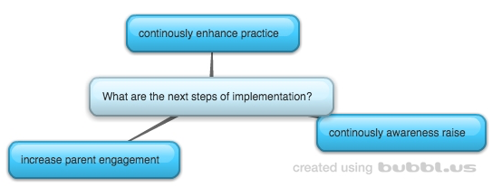
Figure 22: Establishment 4 – What are the next steps?

Figure 22 illustrates that staff members identified that the implementation of FTT was ongoing and that practice was always adapting and improving. Furthermore, staff members felt that engaging parents had been difficult “we held a parent workshop but parents don’t have the time because they are all working” and so that the next step would be looking for ways to increase their awareness and engagement in the approach.

3.4.4 Supporting factors in implementation of ftt
Questionnaires and interviews held within Establishment 4 identified a number of supporting factors for the implementation of FTT within Establishment 4.

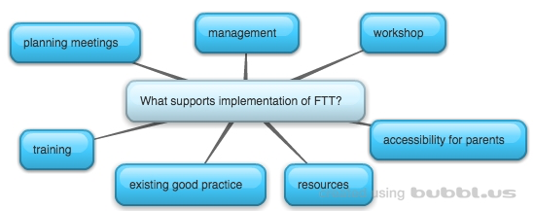
Figure 23: Establishment 4 – What supports the implementation of FTT?

Figure 23 illustrates that staff members highlighted a number of supports for implementation of FTT, namely the amount of support from management for implementation throughout the establishment. This also took the format of in service training and workshops held for parents “using flipchart notes taken from the initial training” and planning meetings for the establishment. Staff members also reported that they felt that the format and language used within the resources for FTT is “good for parents to access – we have lots of parents who are EAL and the language is simple with lots of visuals to help”. Within the establishment, staff also felt that the existing good practice of the CDOs supported the implementation as it enhanced their skills, as well as the consistent approach of staff who are trained in it.

3.4.5 Barriers in implementation of ftt
Analysis of questionnaires and interviews identified one potential barrier for the implementation of FTT, as illustrated in Figure 24.
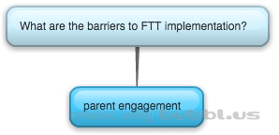

Figure 24: Establishment 4 – What are the barriers

The barrier identified is with regards to parent engagement. As mentioned in a previous section, the staff members perceive this to be difficult and that they need to raise more awareness with parents.

3.4.6 what has been the impact of FTT?

Figure 25: Establishment 4 – What is the impact of FTT?

Figure 25 illustrates emerging data from interviews and questionnaires held within Establishment 4. One way of demonstrating the impact of implementation within the establishment is the understanding of the parents/carers of the FTT approach. Parents/carers shared their knowledge inclusive of the importance of the 5 blocks for “development and later life” as well as the importance of the blocks in terms of brain development. Furthermore, parents/carers are aware that the approach is a reminder of how to engage with children, as well as demonstrating the importance of different ways of interacting with them such as “cuddling” “copying children’s initiatives” and “listening and responding when they are communicating with you”. In terms of existing theory and documentation, parents/carers also reported links between FTT and attachment as well as the CfE.

In terms of staff practice, views gathered regarding impact stated that “our existing good practice has been enhanced” whilst facilitating a “stimulating” and “a more caring and nurturing environment”. From this participants had also acknowledged that relationships with the children had been enhanced.
Other impact on children as perceived by participants is that they have had a “very good settling in period” and are demonstrating that they are keen to go into the establishment. In addition, reports of better behaviour and an increase “in amount of language used” were recorded, alongside portraying to be more happy and cuddly both at home and in the establishment.
QUANTITIAVE DATA
Parent/carer interviews and staff questionnaires gathered information regarding the impact of FTT, the means of awareness of FTT, whether or not the initial training was attended, how long ago this was, how embedded FTT is in the establishment, and whether there was an awareness of any follow up training sessions.

3.5 ESTABLISHMENT 1
Parents/carers were asked if they were made aware of FTT by the establishment their child was attending. 100% (three respondents) confirmed it was Establishment 1 who had made them aware of FTT. This is illustrated in Figure 26.

Figure 26: Establishment 1 – Awareness of FTT.

Parents/carers were asked if FTT had made an impact on them or their child. 100% (three respondents) agreed that there has been an impact. This is illustrated in Figure 27.

Figure 27: Establishment 1 – Impact of FTT.

Staff members of Establishment 1 were asked if they attended the initial training of FTT delivered by KCA. 100% (two respondents) confirmed they had done so. This is illustrated in Figure 28.

Figure 28: Establishment 1 – Staff initial training attendance.

Staff members of Establishment 1 were asked how long ago they attended this initial training. 100% (two respondents) claimed to attend over a year ago. This is illustrated in Figure 29.

Figure 29: Establishment 1 – When was the initial training attended?

Staff members of Establishment 1 were asked a scaling question regarding how embedded FTT is in the establishment, where 1 was not at all and 5 was very much so. 100% (two respondents) rated embedment as 5 (very much so). This is illustrated in Figure 30.

Figure 30: Establishment 1 – Perceptions of FTT embedment

Staff members of Establishment 1 were asked if they were aware of any follow up training session. 100% (two respondents) stated that they were aware of follow-ups. This is illustrated in Figure 31.

Figure 31: Establishment 1 – Staff awareness of follow up training sessions.

3.6 ESTABLISHMENT 2
Parents/carers were asked if they were made aware of FTT by the establishment their child was attending. 100% (three respondents) confirmed it was Establishment 2 who had made them aware of FTT. This is illustrated in Figure 32.

Figure 32: Establishment 2 – Awareness of FTT.

Parents/carers were asked if FTT had made an impact on them or their child. 100% (three respondents) agreed that there has been an impact. This is illustrated in Figure 33.

Figure 33: Establishment 2 – Impact of FTT.

Staff members of Establishment 2 were asked if they attended the initial training of FTT delivered by KCA. 100% (4 respondents) confirmed they had done so. This is illustrated in Figure 34.

Figure 34: Establishment 2 – Staff initial training attendance.

Staff members of Establishment 2 were asked how long ago they attended this initial training. 100% (four respondents) claimed to attend over a year ago. This is illustrated in Figure 35.

Figure 35: Establishment 2 – When was the initial training attended?

Staff members of Establishment 2 were asked a scaling question regarding how embedded FTT is in the establishment, where 1 was not at all and 5 was very much so. 100% (four respondents) rated embedment as 5 (very much so). This is illustrated in Figure 36.

Figure 36: Establishment 2 – perceptions of FTT embedment

Staff members of Establishment 2 were asked if they were aware of any follow up training session. 50% (two respondents) stated that they were aware of follow-ups, while 50% (two respondents) stated they were not. This is illustrated in Figure 37.

Figure 37: Establishment 2 – Staff awareness of follow up training sessions.

3.7 ESTABLISHMENT 3
Parents/carers were asked if they were made aware of FTT by the establishment their child was attending. 100% (one respondent) confirmed it was Establishment 3 who had made them aware of FTT. This is illustrated in Figure 38.

Figure 38: Establishment 3 – Awareness of FTT.

Parents/carers were asked if FTT had made an impact on them or their child. 100% (one respondent) agreed that there has been an impact. This is illustrated in Figure 39.

Figure 39: Establishment 3 – Impact of FTT.

Staff members of Establishment 3 were asked if they attended the initial training of FTT delivered by KCA. 100% (three respondents) confirmed they had done so. This is illustrated in Figure 40.

Figure 40: Establishment 3 – Staff initial training attendance.

Staff members of Establishment 3 were asked how long they attended this initial training. 100% (three respondents) claimed to attend over a year ago. This is illustrated in Figure 41.

Figure 41: Establishment 3 – When was the initial training attended?

Staff members of Establishment 3 were asked a scaling question regarding how embedded FTT is in the establishment, where 1 was not at all and 5 was very much so. 100% (three respondents) rated embedment as 4. This is illustrated in Figure 42.
Figure 42: Establishment 3 – perceptions of FTT embedment

Staff members of Establishment 3 were asked if they were aware of any follow up training session. 100% (three respondents) stated that they were aware of follow-ups. This is illustrated in Figure 43.

Figure 43: Establishment 3 – Staff awareness of follow up training sessions.

3.8 ESTABLISHMENT 4
Parents/carers were asked if they were made aware of FTT by the establishment their child was attending. 100% (five respondents) confirmed it was Establishment 4 who had made them aware of FTT. This is illustrated in Figure 44.

Figure 44: Establishment 4 – Awareness of FTT.

Parents/carers were asked if FTT had made an impact on them or their child. 100% (five respondents) agreed that there has been an impact. This is illustrated in Figure 45.

Figure 45: Establishment 4 – Impact of FTT.
Staff members of Establishment 4 were asked if they attended the initial training of FTT delivered by KCA. 100% (eight respondents) confirmed they had done so. This is illustrated in Figure 46.

Figure 46: Establishment 4 – Staff initial training attendance.

Staff members of Establishment 4 were asked how long they attended this initial training. 100% (eight respondents) claimed to attend over a year ago. This is illustrated in Figure 47.

Figure 47: Establishment 4 – When was the initial training attended?

Staff members of Establishment 4 were asked a scaling question regarding how embedded FTT is in the establishment, where 1 was not at all and 5 was very much so. 87.5% (seven respondents) rated embedment as 5 (very much so), and 12.5% (one respondent) rated embedment as 4. This is illustrated in Figure 48.

Figure 48: Establishment 4 – perceptions of FTT embedment

Staff members of Establishment 4 were asked if they were aware of any follow up training session. 100% (8 respondents) stated that they were not aware of follow-ups. This is illustrated in Figure 49.

Figure 49: Establishment 4 – Staff awareness of follow up training sessions.

4. Discussion

4.1 Summary of Results
Analysis of the data gathered for the current research has shown that the four participating establishments revealed a variety of different sub-themes across the six overarching themes: the how, why and next steps of implementation of FTT, the supports and barriers that have presented and the impact that implementation has had. Strongest themes and comments made across all of the establishments by various participants for ‘how’ FTT has been implemented include: displays/photos/visual, verbal communication with parents/carers, and daily interaction and relationships with children attending the establishments. The strongest theme emerging across all four establishments regarding ‘why’ FTT was implemented the way it was, was the links to and progression from national guidance, while the most common theme amongst establishments regarding next steps was sharing good practice. The consistently emerging strong theme within consideration of supports of the FTT approach was management. Two barriers emerged from analysis of the data, which are resistance from a minority of staff (Establishment 1) and difficulties in terms of parent/carer engagement (Establishment 4).

The impact of the FTT approach documented within establishments will be considered within the literature review sub sections of attachment and brain development, attachment and relationships and attachment and emotional regulation.

Due to the space constraints of this report, only the most strongly emerging themes (demonstrated within the majority of establishments) will be discussed.

4.2 How has FTT been implemented?

4.2.1 Verbal communication with parents/carers
A strong theme emerging from analysis of the results across all establishments was the use of verbal communication with parents/carers for implementing the FTT approach. Both the members of staff and the parents/carers of children attending the establishment reported this. Taking a closer look into the results outlines that it is a variety of individuals across the establishment who communicate the approach with the parents/carers attending.

In considering the literature regarding IS, the interactions between all of those affected by the implementation of a new approach is pertinent (Fixsen et al. 2015). This core component has supported members of staff trained in FTT in successfully communicating the approach with those who have not attended the initial training. Supports can also be put in place to enhance the interactions between those involved in the new approach, Facilitative Administration Supports, which will be expanded upon in the next section.

4.2.2 Visuals across establishments
A form of visuals was documented across all participating establishments as a means of implementing the FTT approach, from the perspectives of both parents/carers and members of staff. Visuals were found to be in the form of wall displays across the nursery, for which all establishments included photos of the children attending with either members of staff or with their parent/carer. Also

included within visuals in the data gathered are resources provided by FTT, such as building blocks and posters, used throughout the establishment. The visuals were recorded by parents as being a key factor as to how they were aware of the approach.

In reference to the previous literature reviewed, it has been deemed crucial by Fixsen et al. (2015) that for successful implementation Facilitative Administrative Supports are in place – in this case the resources provided by the KCA training. The importance of this Implementation Driver is outlined as being a key support in enhancing the interactions between all those involved in the implementation of an approach. Furthermore, making such use of resources can support a continuous flow of an approach whilst changes in staff may occur.

4.2.3 Daily interactions with children
Another theme strongly emerging from the data gathered across all participating establishments is the approach influencing the daily interactions and relationships with the children attending. This was documented as being consistent in the use of the five activities within the playrooms: relax, play, respond, talk and cuddle. In particular one establishment reported the approach being used specifically for modelling during transitions whereby members of staff would model their interactions with one another, to the children, based on the five activities outlined by the FTT approach.

It could therefore be suggested that the competency drivers of IS have been well adhered to across establishments when considering the success of the implementation. The foundations of the FTT approach as documented earlier in this report are that engagement with children is crucial, particularly in the early years. The selection of members of staff within the current research is difficult to document, as there was an existing team of staff within the establishments who were trained in the FTT approach. The initial training has successfully laid the foundations of the knowledge and skills required, as it has been found that the members of staff are using these with the children attending. It could also be suggested that the skills and knowledge acquired through training have been enhanced and embedded by ongoing coaching, another core component of IS. Whilst training has been important for the establishment of skills and knowledge, ongoing coaching and consultation will consolidate theory into practice. The source of this ongoing coaching will be discussed in a later section. Fixsen et al. (2015) states the importance of all staff involved adopting new behaviours to maintain the approach, which is evident in the results that indicate the approach continues to be used one year later and staff perceive the approach to be embedded, as demonstrated in the quantitative data of the results in this report (on average it was reported to be embedded as 4.76 on a scale of one to five).

4.3 Why has FTT been implemented this way?

4.3.1 Links with existing documents
Staff members across all establishments reported that FTT was implemented the way it was due to its natural progression and links with current legislation and documents informing practice and procedures. Documents mentioned include the

‘Pre-Birth to Three’ document (Scottish Government, 2010), ‘Building the Ambition’ (Scottish Government, 2014), and CfE (Scottish Government, 2010).

This was further highlighted within focus groups/interviews, where the good practice already in place within the early years establishments, was highlighted as being formed by the skills and abilities held by individuals and the procedures and policies in place, but were enhanced and refined by the FTT approach.

In considering the literature regarding IS, the national policies and procedures in place for early years establishments could be suggested as forming the basis of the core component ‘systems intervention’. This is due to a number of external factors influencing the establishment’s ability to maintain the implementation – in the current study this is the Government documents’ already in place. Highlighted throughout the documentation is the necessity of continuously improving practice and supports for families informed by evidence (Scottish Government, 2010; Scottish Government, 2010; Scottish Government 2014). Thus, the implementation of FTT approach fits well within the existing national practice guidelines and aims to both support families and improve practice.

4.4 What are the next steps?

4.4.1 Share good practice
All establishments involved identified the next steps of implementing the approach as sharing good practice through a range of means to a variety of individuals. Reported ways of doing so include displays at conferences, open

evenings, through use of additional materials and means of communicating the approach with parents/carers.

The data gathered regarding next steps for implementation fits well with the core component of IS ‘Performance Assessment (Fidelity) (Fixsen et al. 2015). Within this component it is highlighted that the continuous improvement aspect underpinning IS supports implementation of an approach. As implementation is unique to each establishment due to variations in application of previous components, each establishment has the responsibility to ensure the approach is being implemented most effectively with clients. In the current context, it could be suggested therefore that in highlighting next steps as sharing the good practice being used, that establishments are supporting implementation both within and outwith establishments. In the case of open evenings and displaying at conferences, establishments are sharing good practice that could support other establishments overcome potential barriers. In identifying next steps as increasing communication and sharing the good practice (using the five activities with children) with parents/carers, establishments are undertaking their role in ensuring the approach is being used most effectively.

4.5 What are the supporting factors?

4.5.1 Management
Most establishments identified a supporting factor of the implementation of FTT as management being on board, with most establishments reporting the support of a FTT champion throughout discussion in focus group/interviews as well as in questionnaires.

This element of managerial support and/or a ‘champion’ leading the FTT approach within establishments links in well with the ‘leadership’ core component of IS (Fixsen et al. 2015). It is highlighted within the framework and outlined in the literature review of the current report that leadership can be adaptive or technical (Fixsen et al. 2015). In the present study, it could be suggested that roles undertaken are more adaptive as establishments are still in the early stages of implementation, with potential for leadership to be more distributed across members of the team as the approach is implemented more fully across different playrooms. This could be due to the fact that the initial training was targeted to a particular age range, 0-3, in the first instance. If the training were provided more widely to members of staff providing a service across early years in general it would potentially be more likely that team leaders within different playrooms undertake a leadership role. However, as highlighted in Fixsen et al.’s (2015) framework, the form that leadership takes in implementing an approach reflects the current context in which the implementation is taking place. This is evident in the current project where financial constraints have limited the number of those undergoing training.

4.6 What are the barriers?

4.6.1 Resistance from minority of staff
One establishment reported a barrier in implementing the FTT approach as resistance from some members of staff. This highlights the importance of training in a new approach as outlined in Fixsen et al.’s IS framework (2015) as it was reported that those less keen in implementing had not been on the initial training. In the current research, the initial training provides practitioners with the

knowledge and understanding including the theory, philosophy and the value of FTT. It could therefore be suggested that without this core component, barriers can manifest in the implementation of an approach. As mentioned previously, training was not made available to all early years practitioners due to financial constraints of the current context. If further funding is made available for more training, this may support overcoming this barrier. In the meantime using the ‘Decision Support Data Systems’ in place (the current project) could support in enlightening next steps in terms of consistently using the approach, drawing from own strengths in implementation as well the strengths of other establishments involved.

4.6.2 Parental Engagement
One establishment highlighted a barrier of implementing the approach as the parent/carer engagement. This was highlighted during discussion of a workshop held within the establishment, where only one parent attended.

However it can be argued that while the level of attendance at the workshop was not what the establishment was hoping for, analysis of the results from this project has highlighted this may not be as much of a barrier as members of staff believe it to be. For example, this establishment actually had the most parents/carers engage in the data collection for the current project. Within the interviews held with parents/carers, the data gathered highlighted a sound understanding of the FTT approach and the impact that it had had on them and their children.

In considering the ‘Facilitative Administrative Supports’ component of IS (Fixsen et al. 2015), it would appear that the resources available such as those provided by FTT, leaflets created by the establishment and the visuals displayed around the nursery, had enhanced the interactions between the members of staff and parents/carers, thus influencing the parents/carers knowledge regarding the approach. This is backed up by the results found from the data collected in the interviews with the parents/carers, who reported that the knowledge of the approach manifested from the establishment and through verbal communication, visuals around the nursery and leaflets created for them. Whilst parents/carers may not have the ability to attend a workshop (reported by all individuals in the establishment as due to other commitments e.g. work), it could be argued that the establishment have still ensured that the approach has been well communicated through other means. In considering the use of data systems as a core component of IS (Fixsen et al. 2015), the current study can demonstrate the strengths this establishment (and indeed others too) hold in terms of engaging parents enabling continuous growth. Thus, implementing FTT as effectively as possible within the current context.

4.7 What has been the impact of FTT?

4.7.2 Establishment and staff
The impact of FTT on staff members involved and the environment of the establishment within which they work has been recorded through perceptions of those involved in the change. These perceptions will be discussed in relation to the current report’s literature review.

The FTT approach seeks to enhance engagement between caregiver and child to support the development of a child’s emotional regulation by focusing on the importance of five activities. This has been well documented as successful across all participating establishments as seen in the previous results section, for which perceptions of impact included ‘enhanced nurture and care’ across the nursery, with ‘improved practice’ due to the ‘increased awareness of importance of the five activities for engagement’. This has manifested in ‘staff interacting with children more’ as well as using a more ‘hands on approach’ including more cuddles for the children attending.

It could be suggested that the combination of these factors have supported the development of children’s emotional regulation, influencing the development of children’s neural pathways through continuously reinforcing secure attachment when they are engaging with the children through the use of the five activities, teaching children how to soothe themselves in a healthy way (O’Connor, 2012). This would therefore explain the perceptions of a more ‘peaceful environment’ as children are having their needs met either by staff or by themselves.

Furthermore, the continuous reinforcement of this attachment relationship has been outlined in the previous literature as crucial in providing a secure base, thus providing an emotionally safe environment (Robinson, 2003). It could be suggested that this accounts for the more ‘welcoming environment’ that participants perceive to be an impact of FTT. Furthermore, perceptions of a more ‘stimulating environment’ could be due to children feeling more safe and secure

due to enhanced relationships and are thus more likely to explore and experiment with their environment (O’Connor 2012) and therefore experience more learning opportunities.

4.7.2 Parents/carers understanding
Findings of the current study have demonstrated the impact of FTT through the parents/carers understanding of the approach. The initial KCA training aimed to enhance parent/carer understanding of attachment theory and the effects on brain development through a cascade model from trained nursery staff. The resources provided by KCA demonstrating the five activities illustrate a means to establish the secure attachment desired. Therefore the findings of parent/carer understanding of FTT will be compared to its purpose to investigate how effective training early years practitioners and providing resources for implementation has been.

Parents/carers of children attending two different establishments reported that their understanding of the approach was that it was a hands on/easy approach to attachment. It could therefore be suggested that conveying the message of attachment theory has been effective. This is further supported by one establishment’s parents/carers demonstrating an awareness of FTT in supporting healthy relationships, while another stated that using the five activities of FTT supports children to feel safe and happy.

Parents/carers across a range of establishments also demonstrated awareness that the approach was for the use of everyone providing care for children, recorded across a number of participating establishments. Included was parents/carers of one establishment stating that the FTT approach meant that those around the child should model good behaviours. Parents/carers linked to another provision indicated that the FTT approach meant that they knew their children would be comforted when they were upset whilst at nursery. Finally, parents/carers of a further establishment stated that the FTT approach meant that the family and early years provision were working in partnership using a consistent approach to support the wellbeing of the children.

An awareness of what the five activities are was also found during analysis of the interviews with parents/carers. Parents/carers linked to one provision indicated FTT as an approach that reminds and shows different ways of how to engage: important to establish from birth. This was expanded upon in other interviews as listening and responding to children, communicating and talking with them as much as possible, and cuddling with children. Thus it could be suggested that three of the activities: respond, cuddle and talk, have been picked up upon by parents/carers however the two other activities: Play and Relax, have not. However this may be due to limitations in the methodology rather than a lack of parental awareness and will be expanded upon in a later section.

In addition, parents/carers of children attending three of the participating establishments were aware that using the five activities outlined would support brain development of their children. It could therefore be suggested that there is

evidence that knowledge regarding attachment and brain development has been successfully conveyed in some of the provisions. This is further supported by findings of parent/carer knowledge that using the five activities can support the child’s development and therefore later life.

4.7.3 Children
A number of indicators regarding the impact of FTT on children were recorded from both staff members and parents/carers. The impact of FTT will be discussed in reference to the literature regarding attachment theory, brain development, emotional regulation and relationships.

As demonstrated by O’Connor (2012), available and responsive caregivers can support in regulation of feelings associated with distress. In using the FTT approach and engaging with the children when they are distressed, a secure attachment is continuously reinforced. Repetitive and consistent engagement develops the child’s brain as neural pathways are strengthened due to repetition, thus internalising feelings of safety (Gerhardt, 2004). This links in well with the perceptions regarding impact of those involved in the current study. Amongst these are ‘children settling in’ better than they had done before the approach, children appearing to feel both safe and happy (recorded in three different establishments) as well as being comforted more easily than previously.

In considering attachment and relationships, previous literature has demonstrated that both primary and secondary caregivers’ responses and engagement are pertinent in developing a relationship (Siegel, 1999). The FTT approach aims to demonstrate five key activities to support this relationship, which has been reported as successful in the current study as relationships between children and staff are perceived to have been enhanced. Such secure relationships providing secure bases have been illustrated as a key factor in developing confidence, as confirmed in this study. Previous literature has also highlighted the influence of attachment relationships on how children experiment with and explore their environment (Robinson, 2003). It is therefore crucial that children have these safe and secure relationships to enable them to develop and learn to their full potential. Both parents/carers and staff members’ perceptions were that there was an improvement in children’s communication and expression, and increased language acquisition due to FTT.

In considering the literature review regarding brain development, it has been illustrated that in a child’s brain, neural pathways developing the frontal lobes are continuously strengthened through use of consistent caregiver responses and reassurance (Sunderland, 2006). In developing the frontal lobes, the intensity of fear of being abandoned is reduced over time. In the current study participants perceived that the approach has helped the children within transitioning. It could be suggested that this is due to the increased quality and quantity of caregiver response, and so the fear of being abandoned in a different room or in the nursery itself is less intense as the children are learning that predictably someone will be there to regulate their emotions (Balbernie, 2007). As the children have

learned that caregivers are available through this process, it could be suggested that this is why when the FTT approach is not used there have been reports of regression in children’s behaviour as reported by staff members of a participating provision.

4.8 Limitations
Although the researcher endeavoured to conduct the study in as systematic and reliable manner as possible, a number of limitations manifested throughout. These were associated with undertaking research within the real world.

One such limitation is the selection criteria, for which the four participating establishments volunteered to take part in the research. From there, individuals from participating establishments (both staff and parents/carers) were approached by management, rather than being randomly selected. It could therefore be deemed that this method of recruitment was biased.

Furthermore, reduced numbers of participants in some establishments meant the depth of discussion was perhaps limited and indeed led to two separate interviews being undertaken in one provision. This is a limitation of current study, as the same methodology has not been applied within all participating establishments, therefore the benefits of the richness of discussion facilitated within focus groups could perhaps not have been present in the context of a one-to-one interview. However, the researcher felt that this establishment’s staff’s beliefs regarding the FTT approach was important to gather from all participating establishments and so was included in the data analysis.

In addition to this larger numbers of equally spread staff across establishments would perhaps extrapolated the differences in implementation across the provisions.

Whilst investigating the effectiveness of FTT, the researcher employed a number of methods. One of these included short semi-structured interviews with parents/carers. Due to the difficulties in being able to access parents/carers due to the other commitments they have, and in a bid to increase participation, the interview was made as short as possible. However, this could have impacted on the results. In using broad questions rather than specific questions for each of the five activities of FTT, the data gathered may have reduced in depth.

A further limitation concerning the methodology is that the researcher was a single analyst of themes. Therefore, the data produced in this research is “heavily reliant on the multiple judgements of a single analyst” (Altawil, 2008, p.195).

4.9 Implications for Practice and Research
FTT is just one approach being implemented within Local Authority X, one of which undergoes constant change in terms of staff movement and other factors relating to the financial and economic climate. The current research has highlighted a number of indicators of effectiveness for using this particular approach, however this has been based solely on the perceptions of those participating. An implication for research could be suggested as evaluating the approach using a pre and post measure of child/caregiver interactions to evaluate the change over time. In considering a potential limitation of the current research,

this could be done using a random selection to support a more reliable means of data collection.

Another implication stemming from the methodology is the difficulty in facilitating focus groups of an appropriate size. The key factor contributing to this was the inability for practitioners to leave the playroom due to the necessity of the child: staff ratio. Reflecting upon this the researcher has wondered if practitioners are therefore able to spend enough of their working day being able to think and discuss approaches such as FTT with colleagues. One of the aforementioned aims of the Pre-birth to-three document (Scottish Government, 2010) is to “Enable practitioners to build in time to 'think' as well as 'do'”. This methodological limitation could suggest that this may not be the case, and so an implication for research could potentially be to investigate this aspect further.

In using the core components of the IS framework, the researcher was able to pinpoint where establishments fulfil criteria for successful implementation. This also highlighted that while components were adhered to, implementation differed per establishment. An implication for practice for early years establishments and for the EPs supporting implementation would therefore to be mindful that whilst sharing good practice and strengths in implementing FTT may be beneficial, implementation can and will differ according to a number of factors for each early years establishment (for example management structure, the demographics of the establishment, etc.).

Another implication for practice for early years establishments concerns parental engagement. It has been found to be difficult both by the researcher and by establishments to be able to engage with parents/carers on a face-to-face setting. Reflecting on this however, given that the initial training was targeted specifically to early years practitioners working with 0-3 aged children it is more than likely that the vast majority of this particular group of children’s caregivers have other commitments. In sharing good practice amongst establishments, it may be beneficial to build upon strengths in parent/carer engagement that does not require additional time spent on a face-to-face basis. Suggestions could include means of contact through phones, or Internet based via a blog or Twitter account.

In considering the effectiveness of the approach documented in this paper, it would be recommended that the FTT training included more members of staff in early years establishments. The impact of early years experiences on brain development and therefore adult life has been well researched as outlined in the literature review (Alfvén, 2004; Beatson & Taryon, 2003; Gerhardt, 2004, Heim, Owens, Plotsky & Nemeroff, 1997; Jarrett, Burr, Cain, Hertig, Weisman & Heitkemper, 2003; O’Connor, 2012; Plotsky, Owens & Nemeroff, 1998; Stam, Akkermans & Wiegant, 1997; Sunderland, 2006). The importance of sharing this knowledge in an accessible way for all caregivers and providing the resources that support this is therefore crucial. FTT has been shown in this study to do so, and to do so with positive outcomes for children, when implemented according to the core components of IS. Thus, an implication for EP practice would be used the findings of this study to support application for funding for further training for early years practitioners.

4.10 Conclusion
The aims of the current research were to explore the implementation and impact of the FTT approach, with a focus upon answering two research questions:
- What are the perceptions of parents/carers and staff linked to early years establishments regarding the implementation of FTT?
- What are the perceptions of parents/carers and staff linked to early years establishments regarding the impact of the implementation of FTT?
As the underpinnings of FTT are based in attachment theory and its link to relationships, emotional regulation and brain development, a review of the literature related to these areas was undertaken. Furthermore, due to the implementation analysis aspect of the research, relevant literature on IS was also reviewed. As the design of the research was multi-method in nature, semi-structured interviews took place with parents/carers of children attending one of the four participating establishments to gather both qualitative and quantitative data. In addition staff questionnaires were distributed for both qualitative and quantitative data gathering. Prompts for later focus groups/interviews with staff were developed from these questionnaires. The qualitative data gathered was thematically analysed using the following themes: ‘How FTT has been implemented’, ‘why FTT has been implemented this way’, ‘what the next steps are for implementation of FTT’, ‘what has supported implementation of FTT’, ‘what have been the barriers to implementation of FTT’, and ‘the impact of implementation of FTT’. This data was further supported by the quantitative data gathered. The discussion of results mapped the IS literature (Fixsen et al., 2015) with regards to strongly emerging sub themes including: displays/visuals, verbal communication with parents/carers, daily interaction and relationships with children, links to and progression from national guidance and support from management. Barriers to implementation emerged as resistance from a minority

of staff (Establishment 1) and difficulties in terms of parent/carer engagement (Establishment 4). In terms of discussing the impact of FTT, subthemes emerging were discussed with regards to the literature on attachment theory and its link with relationships (O’Connor, 2012; Robinson, 2003; Siegel, 1999), emotional regulation (Gott, 2009; O’Connor, 2012), and brain development (Alfvén, 2004, Beatson & Taryon, 2003; Gerhardt, 2004; Heim, Owens, Plotsky & Nemeroff, 1997; Jarrett, Burr, Cain, Hertig, Weisman & Heitkemper, 2003; Plotsky, Owens & Nemeroff, 1998; Stam, Akkermans & Wiegant, 1997; Sunderland, 2006).

Whilst exploring through perceptions fit well with the critical realism stance of the current research, exploring the impact of the implementation of FTT may have benefited from pre and post measures to strengthen the data regarding the effectiveness of the approach. This limitation and others regarding data collection and procedural methods may have hindered the study, time constraints made these aspects either difficult or impossible to overcome.

The implications for practice and research however will be important for the researcher to disseminate due to the importance emanating of sharing good practice whilst being mindful of national and local contexts.

References
Ainsworth, M.D.S., Blehar, M.C., Waters, E., & Wall, S. (1978). Patterns of attachment: A psychological study of the strange situation. Hillsdale, NJ: Erlbaum.

Altawil, M. A. S. (2008). The effect of chronic traumatic experiences on Palestinian children in the Gaza Strip. (Unpublished doctoral dissertation). University of Hertfordshire, UK.

Alfvén, G. (2004) Plasma oxytocin in children with recurrent abdominal pain, Journal of Pediatric Gastroenterology and Nutrition, 38, 513–517.

Balbernie, R. (2007). Cortisol and the early years. Avaialable at http://www.whataboutthechildren.org.uk/downloads/research-summaries-2006-to-2010/summary_watch_2007_cortisol.pdf (accessed 2nd May 2016).

Beatson J. and Taryon, S. (2003) Predispositions to depression: the role of attachment. Australian and New Zealand Journal of Psychiatry, Apr., 219–225.

Blase, K., Van Dyke, M., Fixsen, D., & Bailey, F. W. (2012). Implementation science: Key concepts, themes and evidence for practitioners in educational psychology. In B. Kelly & D. Perkins (Eds.), Handbook of Implementation Science for Psychology in Education: How to Promote Evidence Based Practice (pp. 13-36). London: Cambridge University Press.

Bowlby, J. (1958). The nature of the child’s tie to his mother. International Journal of Psychoanalysis, 39, 350-371.

Braun, V., & Clarke, V. (2006). Using thematic analysis in psychology. Qualitative Research in Psychology, 3(2), 77-101. doi: 10.1191/1478088706qp063oa

British Psychological Society. (2009). Code of Ethics and Conduct. Leicester: British Psychological Society.

Clark, A. M. (2008). Critical Realism. In L. M. Given (Ed.), The SAGE Encyclopaedia of Qualitative Research Methods (pp. 167-170). London: Sage.

Fixsen, D. L., Blase, K. A., Naoom, S. F., & Duda. A. (2015). Implementation Drivers: Assessing Best Practices. NC: Frank Porter Graham Child Development Institute.

Gerhardt, S. (2004). Why love matters: How affection shapes a baby’s brain. London, UK: Routledge.

Gott, S. (2009). Teach to inspire better behaviour: Strategies for coping with aggressive, disruptive and unpredictable behaviours. London, UK: Optimus Education.

Greene, J. C., Caracelli, V. J., & Graham, W. F. (1989). Toward a conceptual framework for mixed-method evaluation designs. Educational evaluation and policy analysis, 11, 255-274.

Heim, C, Owens, M. J., Plotsky, P. M. & Nemeroff, C. B. (1997) Persistent changes in corticotrophin-releasing factor systems due to early life stress: Relationship to the pathophysiology of major depression and post-traumatic stress disorder. Psychopharmacology Bulletin, 33, 185–192.

Hennink, M. M. (2013). Understanding focus group discussions. NY: Oxford University Press.

Huey, S. J., Henggeler, S. W., Brondino, M. J., & Pickrel, S. G. (2000). Mechanisms of change in multisystemic therapy: Reducing delinquent behavior through therapist adherence and improved family and peer functioning. Journal of Consulting and Clinical Psychology, 68(3), 451-467. doi: 10.1037/0022-006X.68.3.451

Jarrett, M. E., Burr, R. L, Cain, K. C., Hertig, V., Weisman, P. & Heitkemper, M. M. (2003) Anxiety and depression are related to autonomic nervous system function in women with irritable bowel syndrome. Digestive Diseases and Sciences, 48, 386–394.

Kate Cairns Associates (2014). Five to Thrive. Retrieved from: http://www.fivetothrive.org.uk/

Kearney, M., Williams, F. & Doherty, F. (2016). Towards a nurturing city: Promoting positive relations across agencies. Journal of Educational and Child Psychology, 33 (2), 45-56.

Kelly, B. (2012). Implementation science for Psychology in Education. In B. Kelly & D. Perkins (Eds.), Handbook of Implementation Science for Psychology in Education: How to Promote Evidence Based Practice (pp. 4-12). London: Cambridge University Press.

Korfmacher, J., O’Brien, R., Hiatt, S., & Olds, D. (1999). Differences in program implementation between nurses and paraprofessionals providing home visits during pregnancy and infancy: A randomized trial. American Journal of Public Health, 89, 1847-1851.

Krueger, R. A., & Casey, M. A. (2014). Focus groups: A practical guide for applied research. LA: SAGE.

Ladd, C.O., Owens, M.J., & Nemeroff, C.B. (1996). Persistent changes in corticotrophin-releasing factor neuronal systems induced by maternal deprivation. Endocrinology, 137, 1212-1218.

Litosseliti, L. (2003). Using focus groups in research. Cornwall: Continuum.

Lorenz, K. (1935). Der Kumpan in der Umwelt des Vogels. Der Artgenosse als auslösendes Moment sozialer Verhaltensweisen. Journal für Ornithologie, 83, 137–215, 289–413.

Morgan, D. L. (1997). Focus groups as qualitative research. LA: SAGE

O’Connor, A. (2012). Understanding transition in the early years. Abingdon, Oxon: Routledge.

Plotsky P. M., Owens, M. J. & Nemeroff, C. B. (1998) Psychoneuro - endocrin ology of depression: Hypothalamic–pituitary–adrenal axis. Psychiatric Clinics of North America, 21, 293–307.

Read, V. (2009). Developing Attachment in Early Years Settings: Nurturing Secure Relationships from Birth to Five Years. London, UK: Routledge.

Robinson, M. (2003). From birth to one: The year of opportunity. Buckingham, UK: Open University Press.

Robson, C. (2011). Real World Research (3rd Ed). Wiley: UK.

Sanchez, M. M., Ladd, C. O., & Plotsky, P. M. (2001). Early adverse experience as a developmental risk factor for later psychopathology: Evidence from rodent and primate models. Development and Psychopathology, 13, 419-449.

Scottish Government (2007). National Outcomes. Edinburgh: Scottish Government.

Scottish Government (2010). The Curriculum for Excellence. Edinburgh: Scottish Government.

Scottish Government (2010). Pre -birth to three: positive outcomes for Scotland’s children and families. Edinburgh: Scottish Government.

Scottish Government (2012). Getting It Right For Every Child. Edinburgh: Scottish Government.

Scottish Government (2014). Building the Ambition. Edinburgh: Scottish Government.

Scottish Government (2014). Children and Young People (Scotland) Act. Edinburgh: Scottish Government.

Scottish Government (2015). The Early Years Framework – Delivery. Edinburgh: Scottish Government.

Siegel, D.J. (1999). The Developing Mind. How Relationships and the Brain Interact to Shape Who We Are. London, UK: Guildford Press

Stam, R., Akkermans, L. M & Wiegant, V. M. (1997) Trauma and the gut: Interactions between stressful experience and intestinal function. Gut, 40, 704–709.

Sunderland, M. (2006). The science of parenting. London, UK: Dorling-Kindersley.

Trevarthen, C. (1990). Growth and education of the hemispheres. In: C. Trevarthen (Ed.), Brain Circuits and Functions of the Mind (pp.334–363). Cambridge: Cambridge University Press.

Wolf , M. M., Kirigin, K. A., Fixsen, D. L., Blase, K. A., & Braukmann, C. J. (1995). The teaching-family model: A case study in data-based program development and refinement (and dragon wrestling). Journal of Organizational Behavior Management, 15(1-2), 11-68. doi: 10.1300/J075v15n01_04

X Council Website

Zachariadis, M., Scott, S., & Barrett, M. (2013). Methodological implcations of critical realism for mixed-methods research. MIS Quarterly , 37(3), 855-879.

Appendices

Appendix 1: Staff Consent Forms

CONSENT FORM - STAFF

An evaluation of the ‘Five to Thrive’ approach

This study will investigate how effective training, resources and tools have been from the ‘Five to thrive’ approach within the early years service that you are currently working for.

CONSENT
There are no known risks associated with this study; however your participation is voluntary. You may withdraw at any time. You may decide to stop being a part of the research study at any time without explanation and without penalty.

ANONYMITY
No one will be able to link the data to your identity and name, as all information included in the write up of this project will be anonymised by the researcher – even the authority will be written as ‘Authority X’ in the report.

DATA COLLECTION
The Researchers will observe the establishment at least once during this project. These observations will be anonymised in a way that only the researcher can interpret (e.g. Service A, Service B, etc).
Should you choose to be part of a focus group discussing the ways in which the ‘Five to thrive’ approach has been embedded within your service, any discussion that takes place will also be anonymised in a way that only the researcher can interpret.

DATA HANDLING
The data, questionnaires, focus group transcripts and consent forms will be kept in a secure area for 3 years after which time the files will be destroyed (In line with the Data Protection Act).

PLEASE TURN OVER

Please tick one of the following boxes to indicate if you would be interested to take part in a focus group (this will take place within your establishment and will last approximately half an hour)

Yes I will take part in a focus group

No I will not take part in a focus group

By signing below you are indicating that you have read and understood the Participant Information Sheet and that you agree to take part in this research study.

_________________________________ _________________
Participant’s signature Date

_________________________________
Participant’s name

_________________________________ _________________
Signature of person obtaining consent Date

_______________________________
Name of person obtaining consent

Appendix 2: Parent/Carer Consent Forms

CONSENT FORM – PARENTS/CARERS

An evaluation of the ‘Five to Thrive’ approach

This study will investigate how effective training, resources and tools have been from the ‘Five to thrive’ approach within the early years service that your child attends.

CONSENT
There are no known risks associated with this study; however your participation is voluntary. You and your child may withdraw at any time. You and/or your child may decide to stop being a part of the research study at any time without explanation and without penalty.
ANONYMITY
No one will be able to link the data to you or your child’s identity and name, as all information included in the write up of this project will be anonymised by the researchers – even the authority will be written as ‘Authority X’ in the report.
DATA COLLECTION
Any information gathered from you or the service you attend will not have you or your child’s name on it
DATA HANDLING
The data, questionnaires and consent forms will be kept in a secure area for 3 years after which time the files will be destroyed (In line with the Data Protection Act).

PLEASE TURN OVER

By signing below you are indicating that you have read and understood the Participant Information Sheet and that you agree to take part in this research study.

_________________________________ _________________
Participant’s signature Date

_________________________________
Participant’s name

_________________________________ _________________
Signature of person obtaining consent Date

Fiona Primrose
_______________________________
Name of person obtaining consent

Appendix 3: Staff Information Sheet

An evaluation of the ‘Five to thrive’ approach

Introduction
You are being asked to take part in a research study with the purpose of evaluating how effective the ‘Five to thrive’ approach is. I am a 2nd year student of MSc Educational Psychology at the University of Dundee, and will be supervised by one of the members of staff within our department.

This study will look at the benefits of providing training, tools and resources for the ‘Five to thrive’ approach and how these are shown within your service.

Method
If you consent to take part in this research project, you will be asked to complete a short questionnaire regarding what was used within your service before the ‘Five to thrive’ approach for promoting positive interactions and how this approach is different from others. You will also be asked if you would like to take part in a focus group, where I will ask questions about how the ‘Five to thrive approach’ is being used in your service. Shortly after this time I will be visiting the service to observe the establishment where I will be looking for evidence of learning from the ‘Five to thrive’ input within practice.
There are no known risks associated with this study; however your participation is voluntary. You may withdraw at any time, and you can decide to stop being a part of the research study at any time without explanation and without penalty.

CONFIDENTIALITY/ANONYMITY
No one will be able to link the data you provided to your identity and name, as all information will be anonymised by the researcher – even the authority will be written as ‘Authority X’ in the report.
The data, questionnaires and consent forms will be kept in a secure area for 3 years after which time the files will be destroyed.

FOR FURTHER INFORMATION ABOUT THIS RESEARCH STUDY
Fiona Primrose (Educational Psychologist in training) will be glad to answer your questions about this study at any time. You may contact me at f.e.a.primrose@dundee.ac.uk or by phone: xxx

Appendix 4: Parents/carers Information Sheet

An evaluation of the ‘Five to thrive’ approach

Introduction
You are being asked to take part in a research study with the purpose of evaluating how effective the ‘Five to thrive’ approach is. I am a 2nd year student of MSc Educational Psychology at the University of Dundee, and will be supervised by one of the members of staff within our department.
You may be aware that the centre where you and/or your child attends has recently been at a training course about the ‘Five to thrive’ approach. The training includes information about children’s brains growing better when five building blocks for healthy development are used:

Respond Cuddle Relax Play Talk

This study will look at the benefits of providing training, tools and resources for the ‘Five to thrive’ approach and how these are shown within the service that your child attends.

Method
If you consent to take part in this research project, you will be asked to complete a short interview regarding the use of ‘Five to thrive’ in the nursery your child attends.
There are no known risks associated with this study; however your participation is voluntary. You may withdraw at any time. You may decide to stop being a part of the research study at any time without explanation and without penalty.

CONFIDENTIALITY/ANONYMITY
No one will be able to link the data you provided to your identity and name, as all information will be anonymised by the researcher – even the authority will be written as ‘Authority X’ in the report.
The data, questionnaires and consent forms will be kept in a secure area for 3 years after which time the files will be destroyed.
FOR FURTHER INFORMATION ABOUT THIS RESEARCH STUDY
Fiona Primrose (Educational Psychologist in training) will be glad to answer your questions about this study at any time. You may contact me at f.e.a.primrose@dundee.ac.uk or on xxx.

Appendix 5: Parents/carers Interview questions

Questionnaire for parents

The following questions provide you with some statements and ask you to agree or disagree. Some of the questions will ask you for more information.

RESPOND – ENGAGE – RELAX – PLAY – TALK

These are your child’s daily ‘five to thrive’ – the building blocks for a healthy brain. The place you and/or your child attend has recently been trained in this program.

1) Have you heard of the Five to Thrive approach? YES NO
2) If yes, did you hear of the Five to Thrive approach in this setting? YES NO

3) If yes, how did this setting let you know about Five to Thrive?

4) What is your understanding of the Five to Thrive approach?

5) Has the Five to Thrive approach made any difference to you and your child? YES NO

6) If yes could you please give more detail about differences made to you and your child?

Date of completion:
Which service/centre/establishment do you attend:

Thank you for your time, it is greatly appreciated.

Appendix 6: Staff Questionnaire

In order to support the evaluation of Five to thrive, we are asking all professionals whose service was represented at the Five to Thrive initial training to complete a short questionnaire to gather their thoughts about the areas below. Completion of this questionnaire is voluntary and there is no obligation to answer any questions that you do not want to answer.
If you have any queries please contact me at f.e.a.primrose@dundee.ac.uk or on xxxx.
Thank you for your time.
- Did you attend the initial training of the Five to Thrive approach? YES NO
If yes – please continue to question 3.
If no - please continue to question 2

- (A) Has a member of staff who attended the initial training passed on the information and resources from this training to you?

(B) How has this been passed on to you?

(C) How long ago did this happen?

0-5 months 6 months – 1 year more than 1 year

- On the following scale where 1 is not at all and 5 is very much so, how much do you feel the Five to Thrive approach has been used within your establishment/centre/service? (Please circle the appropriate number).
1 2 3 4 5

- What was used before you implemented the Five to Thrive approach within your service/establishment/centre?

- What work was done before with parents to help promote positive interaction?

- What is different about this approach? (i.e. does it involve the more difficult to reach parents? Is the language within it more parent friendly? Is it easy to see within the nursery?)

- What does this approach look like in practice?

- What has supported the approach you have put in place?

- Have there been any issues in adopting this approach?

- What support have you had in using the approach? (colleague, management)

- Are you aware of any follow up opportunities to share with others how the approach has been implemented within your service? If yes please give more information. YES NO

Appendix 7: Staff Interview/Focus Group questions

- How has this approach been implemented within your service/centre/establishment?

- Why has it been done this way? (eg was this the most appropriate for your demographic, was there discussion around it? If so – who was involved in the discussion)

- What reflections have you had surrounding the implementation? Would you use the same approach again? (if not, what would you change and why?)

- How would the children attending your service/centre/establishment know that this approach is being used?

Appendix 8: Establishment 1 Thematic mind-maps

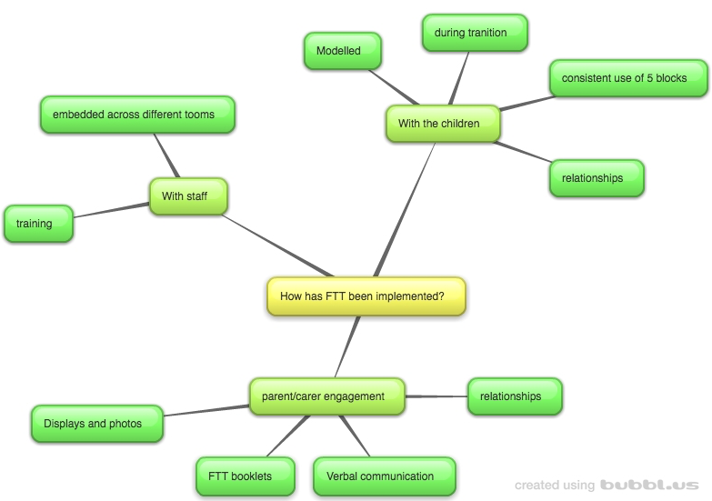

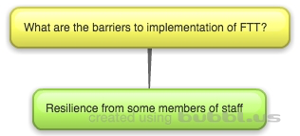

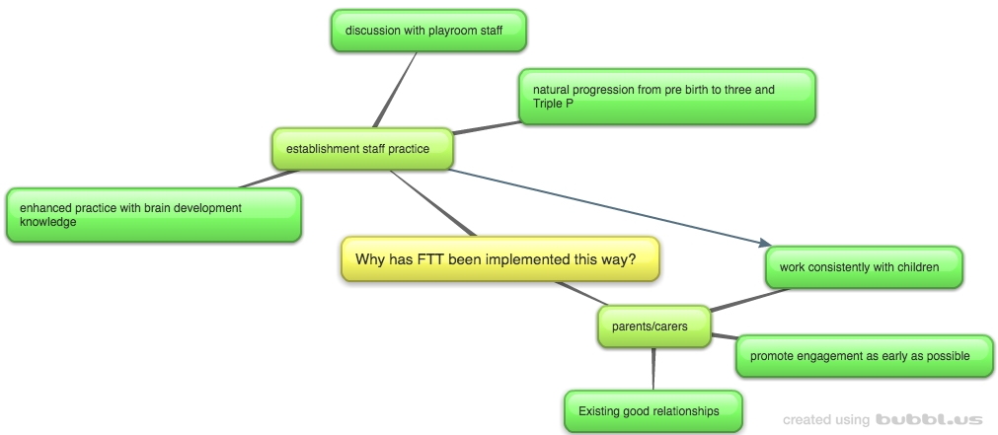

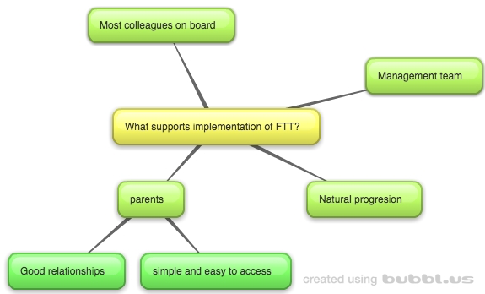
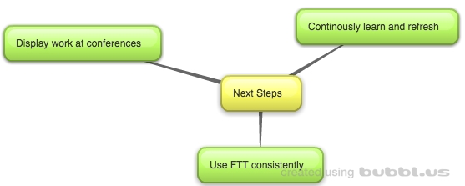

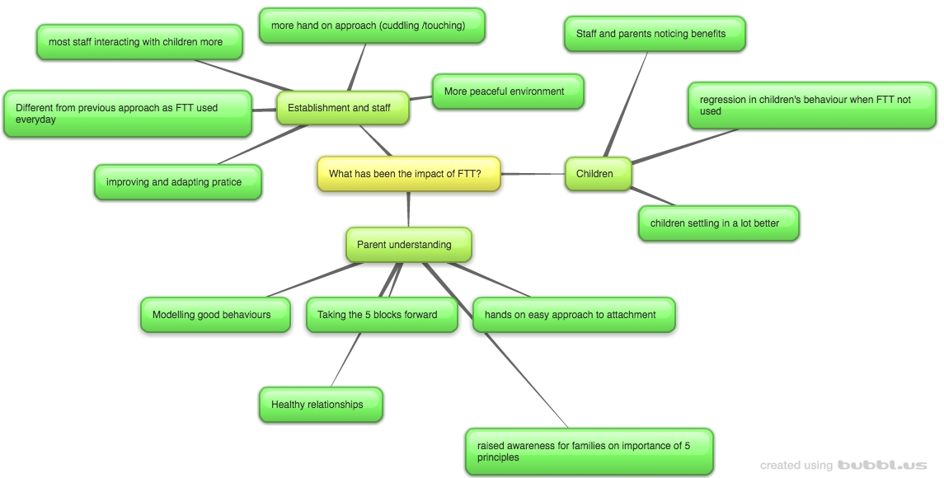

Appendix 9: Establishment 2 Thematic mind-maps

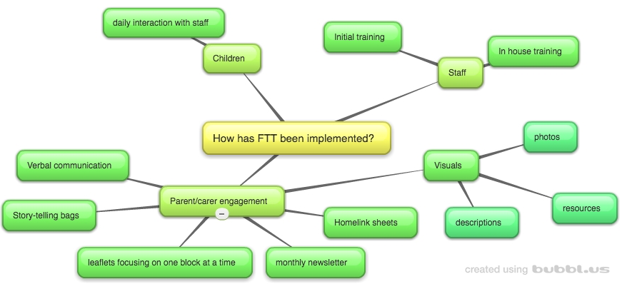

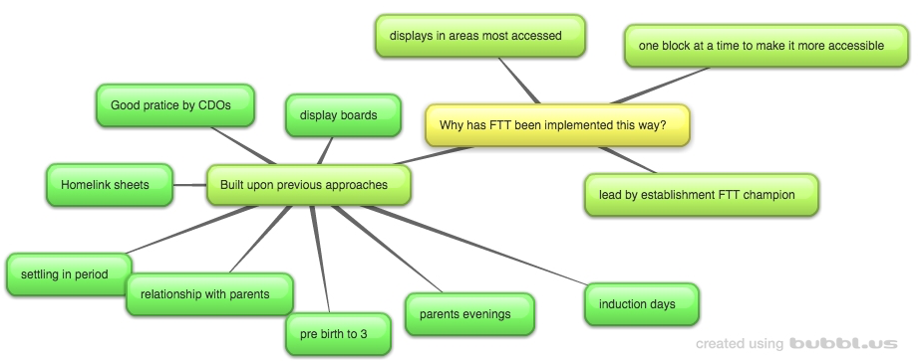

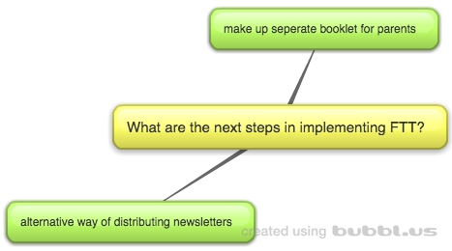

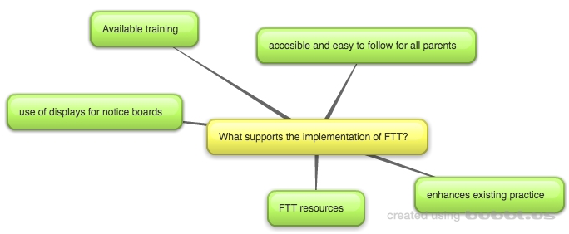

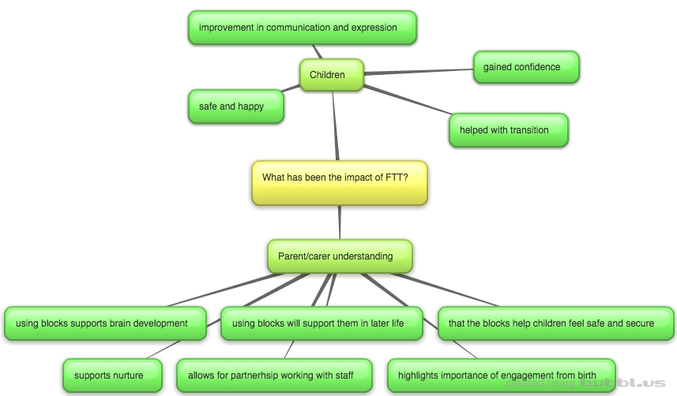

Appendix 10: Establishment 3 Thematic mind-maps
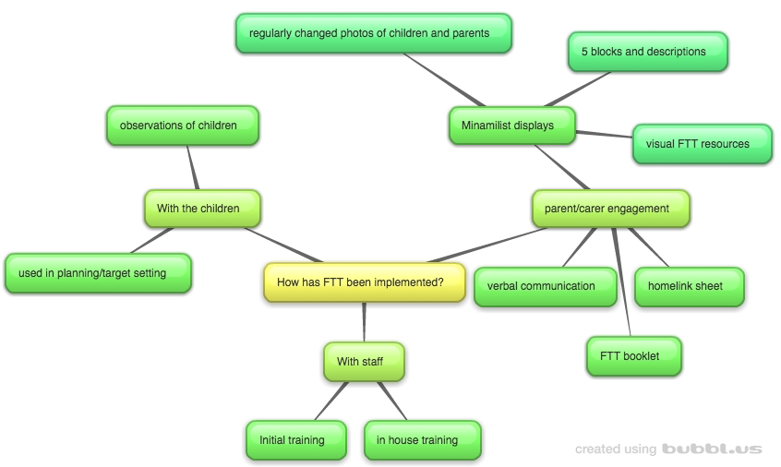

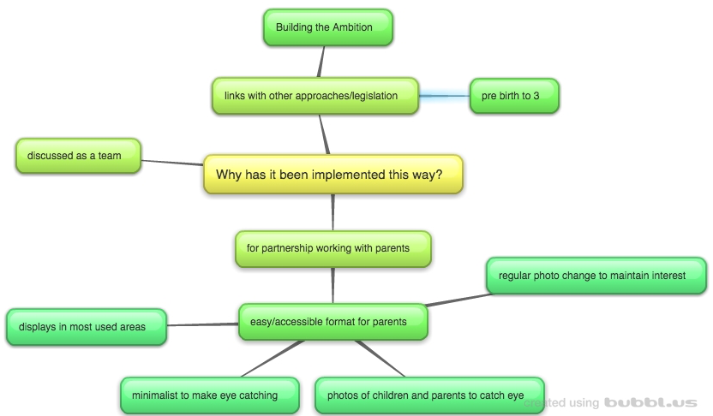

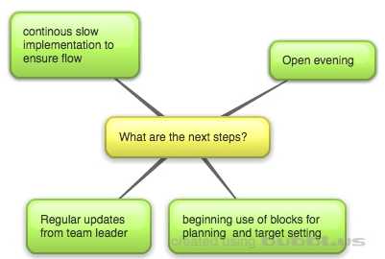

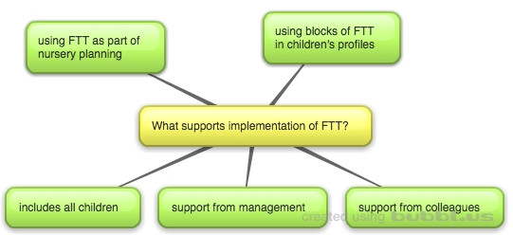
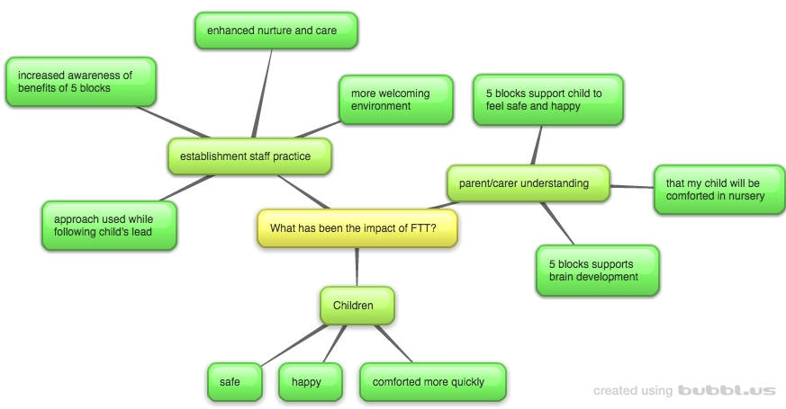

Appendix 11: Establishment 4 Thematic mind-maps
