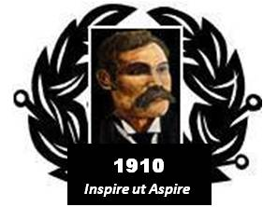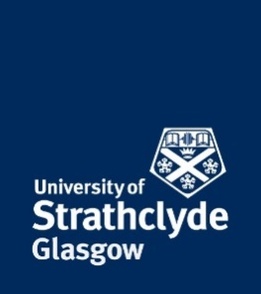
Baird of Bute Society
Lord Smith of Kelvin Lecture 2017

Thursday 7 September 2017
University of Strathclyde, McCance Building

“SCOTTISH FLIGHT – “From Theory to Space”

“Scotland’s William Leitch: Space Rocket Scientist”

Dr Eleanor Campbell FRSC FinstP FRSE FRS
Chair of Chemistry, University of Edinburgh
______________________________________________

“Scotland’s Contribution to Aviation and Aerospace”

Dr Iain Gray CBE FRSE FREng
Director Aerospace, Cranfield University
Vice President, Royal Society of Edinburgh

5.30pm Registration and Refreshments
6.00pm Presentations
7.15pm Networking Reception
8.00pm Event Close

Lord Smith of Kelvin Lecture is an annual lecture with a Scottish perspective on aviation and innovation topics delivered at the University of Strathclyde by noted Scots who have previously been the recipient of a Baird of Bute Society Scottish Award. It was established by the Society and the University to honour Lord Smith of Kelvin who is both Patron of the Society and Chancellor of the University.
Baird of Bute Society Trust recognises the achievements of Bute blacksmith, Andrew Blain Baird who, in 1910 recorded the “first attempted all Scottish heavier-than-air powered flight” in an aircraft of his own manufacture. The Society employs his example to inspire the youth of Scotland to aspire to achievement in their lives through awards and recognitions, school programmes, scholarships and the support of educational activities.

Please register here not later than Friday 1 September 2017:

Enquiries to corporate-events@strath.ac.uk or 0141 548 2245

