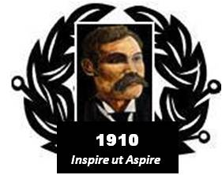

BAIRD of BUTE SOCIETY
Lord Smith of Kelvin KT, Patron

Canadian Science Scholarship
Toronto Canada, July 2016

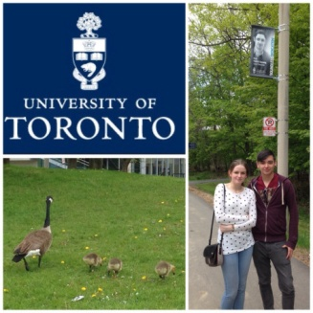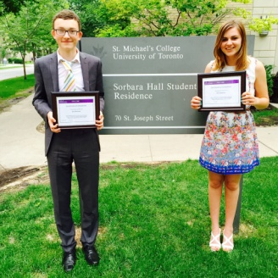
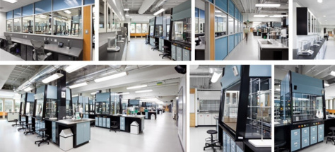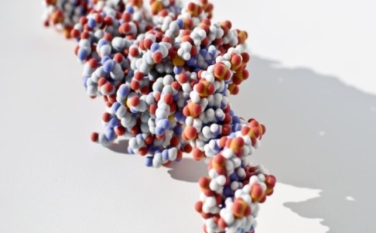

The Canadian Science Scholarship provides two Scottish school leavers the opportunity to acquire unique international experiences and skills to allow each to better succeed in their upcoming university bio-science or related studies. The participants spend no less than two weeks in the Baird of Bute Society’s “Bench to Bedside” programme at a number of Toronto based participating institutions. It all begins at the Ontario Science Centre - then Dr Patrick Gunning’s University of Toronto cancer research facilities provide the “bench” component. With Dr Hazel Markwell they will experience the “bedside” by being immersed in several healthcare facilities and completing a tailored laboratory programme in the world-renowned Li Ka Shing Knowledge Institute.
Where: In and around Toronto Canada
When: July 2016
Who: The Baird of Bute Society welcomes high-quality nominations from school leavers who are 18 years of age by 1 June 2016 and have secured an unconditional offer for a university place and who meet the essential criteria
How: Ask your school contact for more information and an application form

School contact:
_________________________________________________
Proud to help enrich the community and inspire generations

