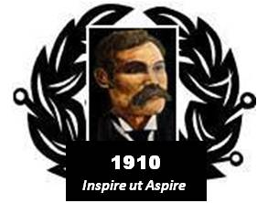

BAIRD of BUTE SOCIETY
Lord Smith of Kelvin KT, Patron

Canadian Science Scholarship

Programme briefing

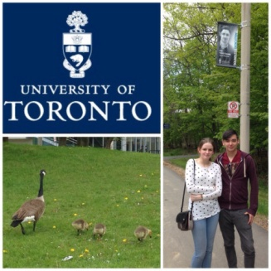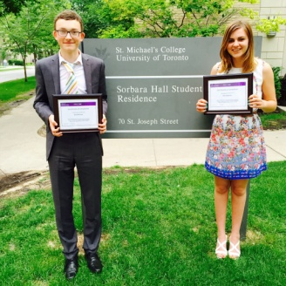

2016

BAIRD OF BUTE SOCIETY CANADIAN SCIENCE SCHOLARSHIP – 2016

- General
The Baird of Bute Society has since 2014 offered a Canadian Science Scholarship and invites applications for each of the two places in the 2016 Programme.
The Scholarship is offered in July 2016.

- Background
The Society
The Scholarship has been developed by the Baird of Bute Society which offers programmes to young people across Scotland. The Society was established to honour Andrew Blain Baird a humble Bute blacksmith who in 1910 achieved the First Attempted All-Scottish Heavier than Air Powered Flight in an aircraft of his own design and manufacture.
The Society employs Baird’s example to Inspire the youth of Scotland to Aspire to greatness in their lives.

Purpose
The purpose of the Canadian Science Scholarship is to provide two young people the opportunity to acquire experiences and skills to allow each to better succeed in their upcoming university studies.
The Scholarship participants spend between two and three weeks participating in the Baird of Bute Society’s “Bench to Bedside” programme in a number of Toronto-based institutions and organisations. Dr Patrick Gunning’s University of Toronto research facilities provide the “bench” component while with Dr Markwell, they will be immersed in several healthcare facilities and complete a tailored laboratory programme in the world-renowned Li Ka Shing Knowledge Institute.
Through these opportunities, the participants will enhance their science knowledge and skill and will have numerous opportunities for multi-disciplinary networking, continuing education, and access to a wide range of life science expertise in a variety of health care settings. The Baird of Bute Society Canadian Science Scholarship provides a unique opportunity for the participants to broaden and deepen their interest in and understanding of science.
- The Scholarship Programme
The Scholarship Programme is entitled “From Bench to Bedside” and follows life science from the genesis of an idea, to research, development, testing, clinical and human trials and ethical issues all the way to its introduction at the bedside.

Faculty and Facilities (Timing and locations subject to modification)
As an introduction to the breadth and depth of science the programme begins at the Ontario Science Centre.
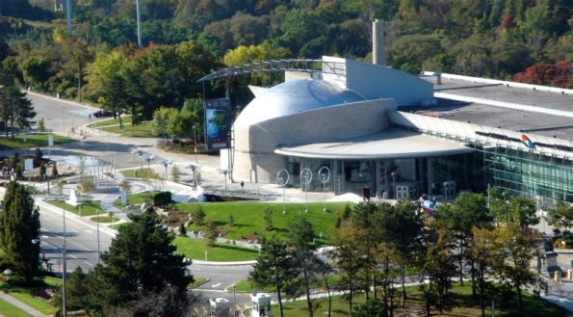

- Ontario Science Centre – Toronto (2.0 to 2.5 days)
The Ontario Science Centre delights, informs and challenges, enriching people’s lives and understanding through engagement with science of local, national and global relevance. Since 1969, the Ontario Science Centre has welcomed more than 48 million visitors, with an interactive approach that was the model for Science Centres around the world. It is the public centre for innovative thinking and provocative dialogue in science and technology, aiming to inspire a lifelong journey of curiosity, discovery and action to create a better future for the planet.
__________________

Prof. Dr Patrick Gunning hosts the participants for the “Bench” portion of the programme at the University of Toronto Mississauga Campus.
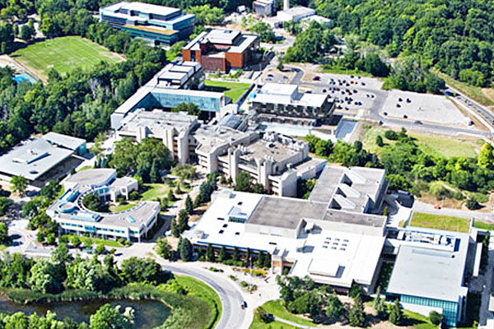
- University of Toronto – Mississauga (4.5 - 5.0 days)
The UofT Mississauga is the home of the Gunning Group, one of the World’s most celebrated bio-chemistry research teams currently working on a drug which is aimed at treating three forms of cancer. Here the participants experience hands on experience at all stages of this research.
_____________________________

Prof. Dr Markwell, through the Centre for Clinical Ethics, hosts the students for their trip through all the steps to move science from the Bench to the Bedside at a number of University of Toronto associated research and healthcare facilities.
- Li Ka Shing Knowledge Institute
This unique and world-class facility creates knowledge and narrows the gap between insight and impact. Their team of researchers, educators, and front-line clinicians come together in a hospital setting to create, instill, and quickly translate health science knowledge. Here the participants enjoy a wide variety of scientific experiences.

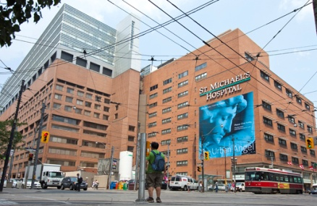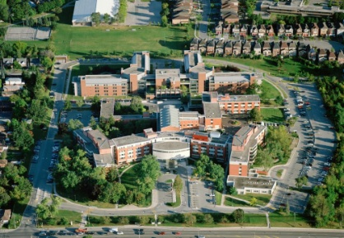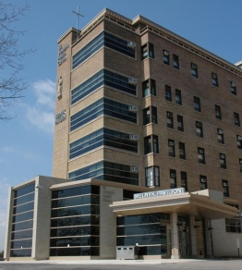

- Toronto Hospitals
The Scholarship programme is supported by three of Toronto’s largest hospitals - St Michael’s Hospital, Providence Healthcare and St Joseph’s Health Centre - affording scholarship participants the opportunity to understand the connection between research and patient care.

- The Mentors in Canada
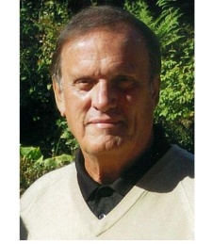
Mr. Christopher Markwell - Scholarship Host and Chair of the Baird of Bute Society
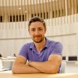
Dr. Patrick Gunning PhD - Assistant Professor and Head of the Gunning Group
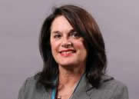
Dr. Hazel Markwell PhD - Associate Professor and Executive Director the Centre for Clinical Ethics

- Eligibility Requirements
The Baird of Bute Society welcomes high-quality nominations from young people who have secured an unconditional offer for a university place and who meet the essential criteria:

Personal

- High academic achievement
- Good character
- Can use the experience to have positive impact on others
- Citizen or permanent resident of Scotland
- Possess a passport valid until at least December of 2016
- Meets Canadian Government Visitor admission requirements
- 18 years of age by 1 June 2016
- Unconditionally accepted to a Scottish University in a life science or related programme
- No criminal record
- Record of community involvement
- Team player
- Prepared to maintain daily blog with other participants
- Prepared to complete weekly blog during 1st year of university
- Able to be insured for Visitors to Canada health insurance coverage
- Submit a personal Letter of Application
- Agree to be interviewed, as required, for selection (in person or on-line)
- Possess immunisation as may be required by participating institutions
Local

- Proposed, endorsed and supported by their school
- Prepared to undertake fundraising, where required, to cover personal incidentals and travel to/from Glasgow airport

- How to apply
Secondary schools in Scotland are invited to promote the opportunity to potential participants – supported by posters, videos and printed materials.
Each secondary school is able to present one nominated candidate for review and consideration by the Baird of Bute Society.
The nomination (including the completed application, the applicant’s letter of interest and the school’s letter for support) must be e-mailed to bairdstudent@gmail.com no later than Monday 23rd May 2016.
By June 1, 2016 selected candidates will be contacted for an interview to be conducted by phone or on-line.
By June 15, 2016 the two successful participants will be advised of their selection and the dates and agenda of the Scholarship programme.
Note: The Scholarship programme will commence and terminate at Glasgow Airport, it being the responsibility of the participant (perhaps locally funded) to provide required transportation. However, the selected candidate may, if required, request assistance with these expenses from the Baird of Bute Society.

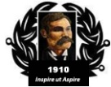
BAIRD of BUTE SOCIETY

Proud to help enrich the community and inspire generations

www.bairdofbutesociety.com www.bairdofbute.com

