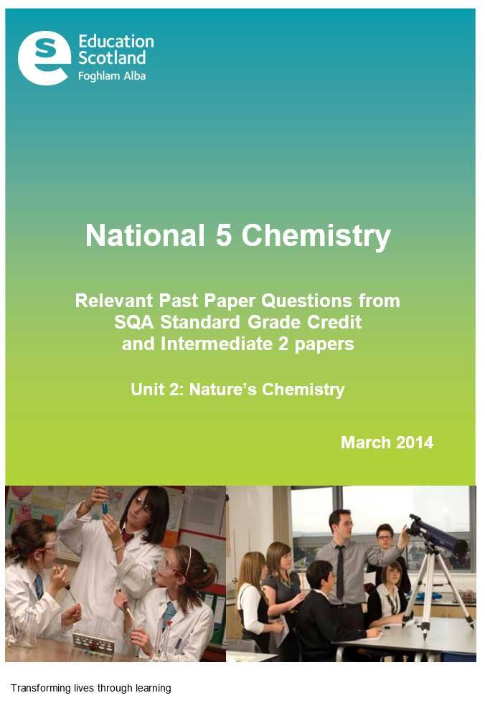

**N5 Chemistry Past Paper Questions**

This resource has been produced in response to the requests from practitioners who attended the National Qualifications Sciences events at Hampden Stadium in December 2013 which Education Scotland organised in partnership with the SQA.

The questions in this resource relate to the Nature’s Chemistry Unit for National 5 Chemistry and have been taken from the 2011, 2012 and 2013 Standard Grade and Intermediate 2 Past Papers.

For Nature’s Chemistry (Unit 2), the mandatory course key areas are as follows:

* Homologous series
* Everyday consumer products
* Energy from fuels

In cases where the questions relate to more than one of the National 5 Units, the constituent parts of the question have been separated into their respective key areas. The stem of the question has been retained to give the context of the question. If practitioners require the full integrated question, they should refer to the original past paper on the [SQA website](http://www.sqa.org.uk/pastpapers/findpastpaper.htm?subject=Chemistry&level=).

Past paper questions for the other two National 5 Units, Chemical Changes and Structure and Chemistry in Society, are also available from Education Scotland’s National Qualifications Glow portal: <http://www.educationscotland.gov.uk/nqcoursematerials/> (cut and paste link into your browser).

Education Scotland would like to acknowledge the support of the SQA in helping us produce this resource. We hope it proves helpful to practitioners across Scotland and assists with the implementation of the national qualifications.

Homologous series

|  |  |  |  |  |
| --- | --- | --- | --- | --- |
| Int 2 2011 |  |  |  | Marks |
| 8 |  |  | Many different gases are found in car exhaust fumes. Some of these gases are produced by the combustion of petrol in car engines.    The pie chart shows the gases present in the exhaust fumes of a car. |  |
|  | (a) |  | What evidence in the pie chart shows that incomplete combustion of petrol has taken place? | 1 |
|  |  | Answer | 1 |  |

|  |  |  |  |  |
| --- | --- | --- | --- | --- |
| Int 2 2013 |  |  |  | Marks |
| 8 |  |  | Crude oil is a mixture of hydrocarbons which can be separated into fractions by fractional distillation. |  |
|  | (c) |  | Petrol contains the following molecule.    Name this molecule. | 1 |
|  | Answer |  |  |  |

|  |  |  |  |  |
| --- | --- | --- | --- | --- |
| S Gr 2011 |  |  |  | Marks |
| 16 |  |  | Heptane can be cracked as shown.    One of the reactions which takes place is: |  |
|  | (a) |  | The product C3H6 decolourises bromine solution quickly.  Draw a structural formula for an isomer of C3H6, which would **not**  decolourise bromine solution quickly. | 1 |
|  |  |  |  |  |
|  | Answer |  |  |  |
|  |  |  |  |  |

|  |  |  |  |  |
| --- | --- | --- | --- | --- |
| S Gr 2011 |  |  |  | Marks |
| 22 |  |  | Ethylthioethane belongs to a homologous series of compounds called thioethers. |  |
|  | (a) |  | What is meant by a homologous series? | 1 |
|  | (b) |  | Ethylthioethane is formed when ethylthiol reacts with bromoethane as shown.    Draw the full structural formula for the thioether produced in the following reaction. | 1 |
|  | (c) |  | Ethylthioethane can also be formed by the reaction of ethylthiol with ethene.    Suggest a name for the type of chemical reaction taking place. | 1 |
|  | Answers | (a) | Same general formula and same/similar properties OR same/similar chemical properties  Both required |  |
|  |  | (b) |  |  |
|  |  | (c) | addition |  |

|  |  |  |  |  |
| --- | --- | --- | --- | --- |
| S Gr  2012 |  |  |  | Marks |
| 20 |  |  | The monomer in superglue has the following structure. |  |
|  | (c) |  | Bromine reacts with the monomer to produce a saturated compound. Draw the structural formula for this compound. | 1 |
|  |  | Answers |  |  |
|  |  |  |  |  |
|  |  |  |  |  |
|  |  |  |  |  |
|  |  |  |  |  |
|  |  |  |  |  |

Everyday consumer products

|  |  |  |  |  |
| --- | --- | --- | --- | --- |
| Int 2 2011 |  |  |  | Marks |
| 9 |  |  |  |  |
|  | (c) |  | The alcohol produced is ethanol.  Draw the **shortened structural formula** for ethanol. | 1 |
|  |  |  |  |  |
|  |  | Answers |  |  |
|  |  | (c) |  |  |
|  |  |  |  |  |

|  |  |  |  |  |  |  |
| --- | --- | --- | --- | --- | --- | --- |
| Int 2 2012 |  | |  | |  | Marks |
| 7 |  | |  | | Ethanol is a member of the alkanol family of compounds. |  |
|  | (a) | |  | | Ethanol can be manufactured from ethene as shown in the following addition reaction.    What other name can be given to this type of addition reaction? | 1 |
|  | (c) | |  | | Butan-2-ol is another member of the alkanol family.    Draw the full structural formula for an isomer of butan-2-ol. | 1 |
|  | Answer | | (a) | | Hydration  Catalytic hydration |  |
|  |  | | (c) | |  |  |
| Int 2 2013 |  |  | |  | | Marks |
| 9 |  |  | | Alkenes can undergo different reactions. | |  |
|  | (b) |  | | Potassium permanganate can be used to convert alkenes into two molecules.  The conversion of pent-1-ene is shown. | |  |
|  |  | (i) | | Name molecule X. | | 1 |
|  | Answer |  | |  | |  |
|  |  |  | |  | |  |
|  |  |  | |  | |  |

|  |  |  |  |  |  |  |
| --- | --- | --- | --- | --- | --- | --- |
| Int 2 2013 |  | |  | |  | Marks |
| 13 |  | |  | |  |  |
|  | (a) | | (i) | | Suggest a pH value for hipposudoric acid. | 1 |
|  |  | | (ii) | | Hipposudoric acid contains a hydroxyl group.  Circle the hydroxyl group in the structure of hipposudoric acid. | 1 |
|  | Answers | | (i) | |  |  |
|  |  | | (ii) | |  |  |
|  |  | |  | |  |  |
|  |  | |  | |  |  |
| S Gr 2013 |  |  | |  | | Marks |
| 15 |  |  | | An antibacterial hand gel contains two alkanols, ethanol and propan-2-ol. | |  |
|  | (c) |  | | When alkanols are oxidised alkanoic acids are produced.    Draw the full structural formula for the alkanoic acid produced when butanol is oxidised. | | 1 |
|  | (d) |  | | Esters are produced when alkanols react with alkanoic acids.  The table gives information on esters.    Suggest a name for X. | | 1 |
|  | Answer | (c) | |  | |  |
|  |  | (d) | | Pentyl butanoate  pentylbutanoate | |  |

Energy from fuels

|  |  |  |  |  |
| --- | --- | --- | --- | --- |
| Int 2 2012 |  |  |  | Marks |
| 5 |  |  | The alkanals are a homologous series of compounds that all contain the elements carbon, hydrogen and oxygen. |  |
|  | (b) |  | The combustion of alkanals releases heat energy. |  |
|  |  | (i) | Make a general statement linking the amount of heat energy released and the number of carbon atoms in the alkanal molecules. | 1 |
|  |  | (ii) | Predict the amount of heat energy released, when 1 mole of pentanal burns.  ______________________kJ | 1 |
|  | Answers | (i) |  |  |
|  |  | (ii) | 2800 to 3200 |  |
|  |  |  |  |  |
|  |  |  |  |  |