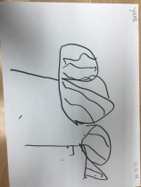
‘The Fridge Page’ from Wyndford Nursery… Please use this App to access this
newsletter in your first language
November/ December ‘19
Welcome to our new style of newsletter which will be distributed on a monthly basis.
You can stick it on the fridge for ease of reference…
Need to know…
We are delighted to welcome Jillian O’Neill as shared Key Person for the Red Group, alongside Lorna Johnston. Unfortunately, due to circumstances within his family life, Sean had to be supported to find a nursery closer to home.
We are delighted to welcome to the team, our new cleaners, Lynn and Jackie. They play a very important role within our team in supporting infection prevention. We are very grateful of their cheerful disposition and the fact that they know what ‘a good clean’ looks like!
Over the next few weeks, we will also welcome our new Lead Practitioner Attainment, Lynn Hughes she joins us with very considerable experience of improvement change and during the course of her interview, communicated a strong understanding of values- led practice. She will be a great asset to what is becoming a very strong team.
Finally, in the near future, we will welcome a depute head to Wyndford. This will be the first time that we will have had this position and look forward to the additional experience and support which this individual will add to our existing team.
Important dates-
- Weeks begin. 11 and 18 Nov- Opportunity for Parent/ Carer conversations with your child’s Key Persons
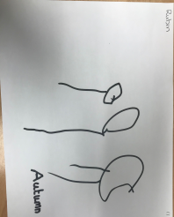
- Week begin 18 Nov- Book Week Scotland. We are hoping that our friends from the Glasgow Gaelic School will join us in Scots music and stories.
- Mon 18 Nov- Nursery Garden Development Day
- Sat 23 Nov, 10am to 12noon- Community Coffee Morning, Wyndford Nursery.
- Thurs 28 Nov, 1pm- Residents’ Discussion Forum
- 29 Nov-Nursery closed- In- service Day
- Thurs 5 Dec- Christmas Enterprise Day
- Fri 6 Dec- Dental Fluoride Varnishing
- Thurs 12 Dec- Nursery closed- General Election (building used a Polling Station)
- Mon 16 Dec- Nursery Nativity, St. Gregory’s Church Hall, 10am and 2.30 pm
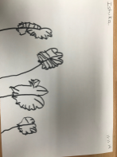
- Wed 19 Dec- Children’s Christmas Party (We are hoping to have a special visitor on this day…)
This is an unusual nursery day, in that what happens in the morning is repeated in the afternoon. This can therefore be a tiring day for full time children. If you have alternative arrangements for this day, it might be a more reasonable ‘ask’ for your child to attend either AM or PM party. However, this is not essential.
- NB Thurs 19 Dec at 2.30pm-Term time children finish for Christmas break and return to nursery on Mon 6 Jan.
- NB Tues 24 Dec- 50 wk children finish for Christmas and return to nursery on Fri 3 Jan.

In conversation…
- The nursery has been invited to share our practice in relation to ‘making children’s thinking visible’ at University of Strathclyde’s Post Graduate Diploma Conference on Thurs 28 November. In addition, as part of Mary Pat’s role within the Scottish Govt. Early Learning and Childcare Steering Group, focused on the creation of a national resource to support workforce development, we have been asked to make a podcast in respect of nurturing practices within the nursery community. All of this is really positive news for the nursery and for the community of Wyndford, more generally.

In conversation continued…
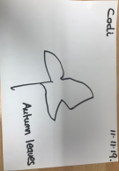
- Our creativity via the development of Nature Nursery has been recognised and, moving forward, we understand that we are to receive enhanced registration for outdoor nursery spaces. We will share more information in relation to this as we receive it. For now, we are understanding that this will enable us to access additional funding to support the continued development of our outdoor environment for learning.
- Christmas Fayre preparations- we would really appreciate the help of a few parents/ carers to support our ‘to do’ list ahead of our Christmas Fayre. Please speak with Ashleigh if you are able to help us- thank you.
- Santa’s sleigh-we are currently exploring arrangements to help you to fill Santa’s sleigh… in the same spirit as we did last year. We will be in touch in due course once we have more information about what will be possible this year.
- We would ask the parents/ carers of all AM children to bring your child to meet their Key Person at the start of each session. This is really important from a health and safety perspective. Thank you
- Outdoor Start- in addition to each group having the opportunity to participate in Nature Nursery for a fortnight block, we are keen to offer the opportunity for each group to participate in Outdoor Start on a weekly basis. This would mean that you would take your child directly to the Wellie Shed on arrival at nursery and sign them in on the outdoor fire register.
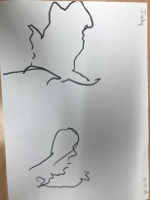
- Appropriate clothing- please ensure that your child comes to nursery dressed appropriately for current weather conditions. incl hats and gloves/ wellies and wellie socks. Please make use of the pre- loved clothing rail and speak with Mary Pat or Lynda if you can’t find what you are looking for on the rail as we have other supplies in storage.
Learning through play…
- ‘The experiment’- we gathered some really interesting observations about children as learners and the responses of adults around them in supporting children’s thinking, when many of the resources recently ‘disappeared’ from the play room environment… We observed children not notice each other more; to show greater respect for each other; to be less possessive and territorial within their play; to come alive as story makers- with very little…
Moving forward, we are now beginning to consider the nursery as a thinking space- as opposed to a place where you come to engage with ‘stuff’. Children have shown us that they are more creative thinkers without the ‘stuff’.
- We continue to explore the use of stories, as a narrative form of assessment, as this approach fits well with our child centred principles. Please remember to ask your child’s Key Persons about the stories that they are currently writing/ have been written by other colleagues, about your child’s learning. We are very keen that you are contributing to these as part of the on- going, collaborative assessment around your child.
- Please speak to your child’s Key Persons about our recent development, SEE SAW App, enabling access for child’s family of their electronic journal. This is a secure platform accessed only by nursery and the family of the individual child. We ‘tested’ this across last session with a couple of families and have been really delighted with their feedback. This is something which we feel all children and families should benefit from and was, in fact, commented upon during our recent inspection. Moving forward, there should be no reason for families not to know how their child is progressing in their development and learning. YOU SHOULD ALL HAVE RECEIVED YOUR OWN PERSONAL QR CODE BY NOW. WHICH WILL ENABLE YOUR SECURE ACCESS TO YOUR OWN CHILD’S ONLINE JOURNAL PLEASE REMEMBER TO ‘LIKE’ AND ADD YOUR COMMENTS.
PLEASE SPEAK WITH CHERYL IF YOU HAVE ANY TROUBLE ACCESSING THIS.
MOVING FORWARD, IT IS OUR INTENTION TO PRINT OFF THE ONLINE JOURNAL AT THE END OF EACH TERM AND ADD IT TO EACH CHILD’S ‘SPECIAL BOOK’, SUPPORTING CHILDREN TO REGULARLY REVISIT PREVIOUS LEARNING, BUILDING ON WHAT HAS GONE BEFORE.
- Learning for Sustainability-Supporting children to understand their role in looking after the world.
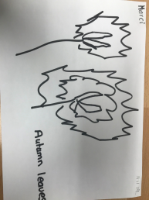
Please take time to explore the Family Challenges sheet and share any learning you have undertaken with your child’s Key Person.

