Hyndland Learning Community – Primary/Secondary Transition - May 2020

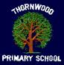
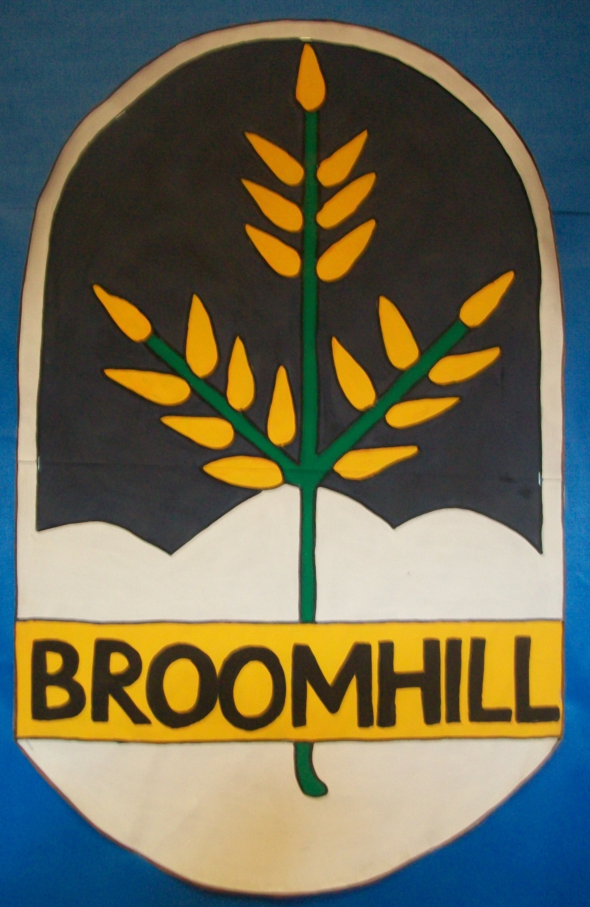

My Primary 7 Learner Profile

We are really excited that you will be joining us next session in our new first year intake. Whilst we are unable to welcome you in person to the school for our 2 day visit at present, we are really keen to get to know each and every one of you before you join us.
Staff at Hyndland Secondary are busy gathering lots of information about you from your primary 7 teacher but we are also really keen to hear about your strengths and achievements at primary school as well as your thoughts about starting high school.
Please complete the profile on the following pages and we will then gather these in from your primary teachers.

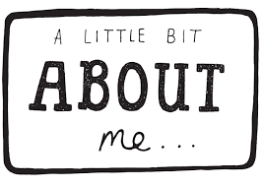

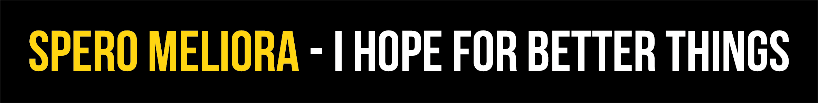
About me - My Personal Statement

About me - tell us some basic information about yourself, what do you enjoying doing? What age are you? Who do you live with?

What are your hobbies and interests outside of school?

What are your interests in school? Do you attend any school clubs / activities?

Looking back at primary school, what are your biggest achievements so far?

About my learning

What subjects and/or type of work do I enjoy doing most in primary school? Do you like Maths and Numeracy work or do you prefer story writing and Literacy work? Why do you enjoy these areas of work the most?

What subjects and/or type of work do you find tricky in class and why do you find these things more difficult?

My Skills and Qualities - from the list below - what skills and qualities have you developed during your time in primary school? Place a tick beside the skills relevant to you.
Teamwork  I can work well as part of a team to complete a task. |  | Leadership  I can take the lead and inspire others in my class or school.
Organised  I can stay on task and keep focused until I complete a task. |  | Confident  I feel sure of myself and what I am able to do. I am happy to volunteer to do things / answer questions in class.
Creative  I can see things in many ways. I can develop new ways to do things. I enjoy using my imagination to solve challenges. |  | Communication  I can express my thoughts and feelings in writing and by talking. I am a good listener and enjoying talking to people.
Motivation  I enjoy learning and doing new things. I like to get things finished in school and at home. |  | Enterprise  I enjoy making decisions and thinking about the effects of these decisions.
Problem Solving  I enjoy making decisions and thinking about the effects of these decisions. I enjoy learning new work and gaining new skills. I am not afraid to try something new. |  | Caring  I am kind to other people. I get concerned if people are unhappy or upset.
My journey to high school

What are you most looking forward to when you move to Hyndland Secondary School in August?

What worries you about moving to high school in August?

In the future - my goals and aspirations – what do I want to be able to achieve when I go to high school and then beyond – what careers am I interested in?

