you | your | come | some
said | here | there | they
go | no | so | my
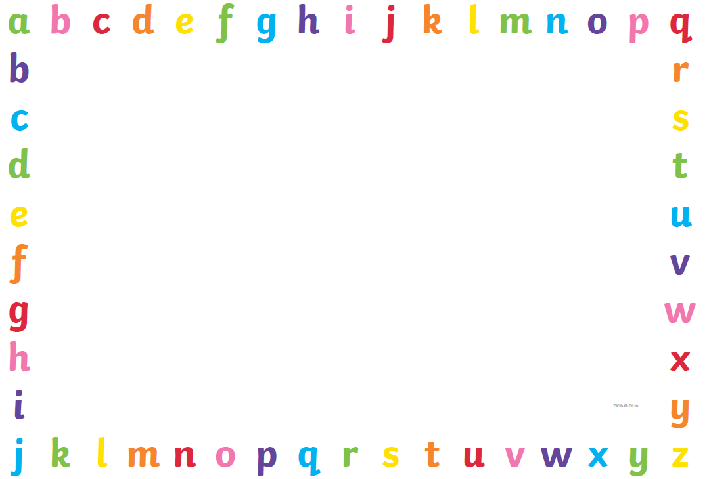
Tricky Words Set 2

