about | all | at | back
big | but | came | didn’t
for | got | out | put
some | down | then
everybody |  | looked
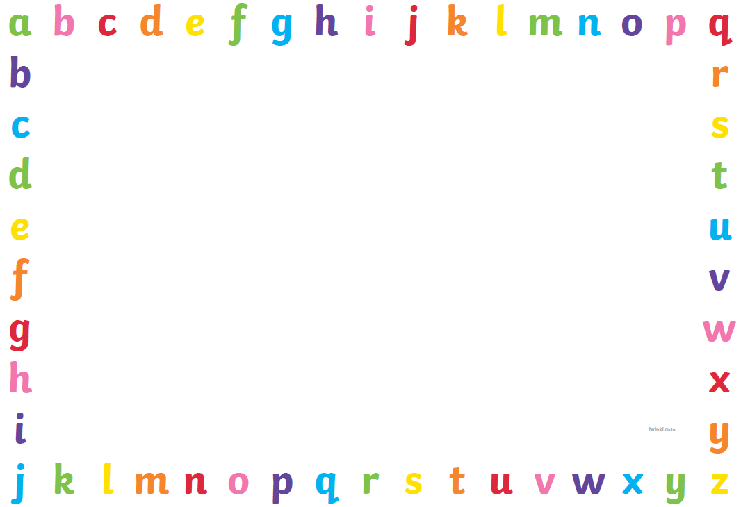
Key Words Stage 3

