gave | had | he | her
on | made | let’s | his
she | play | one | sat
yes | was | said | I
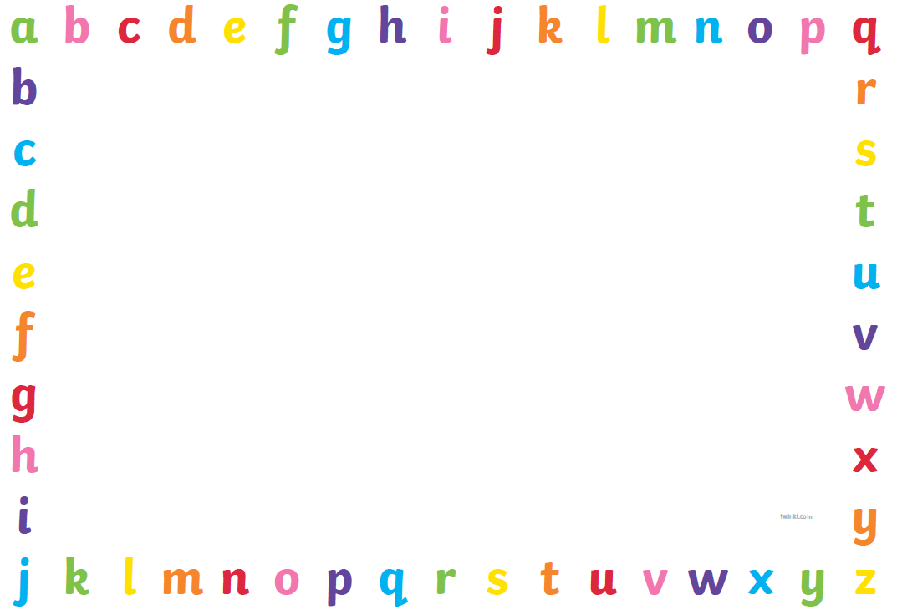
Key Words Stage 2

