Wellshot Primary School
Equality Policy

Rationale
Glasgow City Council Education Services is committed to equality and fairness, and our legal duties, obligations and associated responsibilities within the Equality Act 2010 across all our schools and early years establishments. We want to ensure that equality is embedded in all our establishments and that our values and cultures promote equalities. We want all our children and young people, staff, families and partners to feel highly valued and be treated fairly. We strive towards creating learning environments that reflect the diversity of the school community, both within the curriculum and in our workforce. We want everyone to have positive experiences and opportunities and recognise their contribution as global citizens to a world free from discrimination and one that promotes justice for all.

Our Equality policy seeks to ensure that are everyone regularly thinks about how they are taking forward equality in their roles and settings as a catalyst for positive change, equality and fairness. It will encourage all to reflect on their commitment, activities and culture and how to adapt to a continually changing and rapidly evolving society.

In taking forward our Equality policy we are continuing to support the aim of creating a nurturing school within a nurturing city where children and young people feel respected and included.

We want schools to continue to celebrate the diversity of communities across our city, to challenge ourselves and each other, and consider our actions and impact across all the protected characteristics. Fundamentally, we support Glasgow’s vision of a world class city with a thriving and inclusive economy where everyone can flourish.

Introduction
This policy sets out Wellshot’s approach to promoting equality, as defined within the Equality Act (2010). It covers age*, sex, race, disability, religion or belief, sexual orientation, pregnancy and maternity, and gender reassignment. This policy should be read in conjunction with other school policies and guidelines particularly the school’s Promoting Positive Relationships policy, which should take account of the guidance in the Revised Anti Bullying Strategy 2019 [2Mb]. Our policy will set out how the school aims to remove barriers to learning for children and young people as individuals or groups.

Wellshot Primary School will adhere to the technical guidance on how to apply the Equality Act 2010 in Scottish schools as outlined in the following link; https://www.equalityhumanrights.com/en/publication-download/technical-guidance-schools-scotland

Our School Context
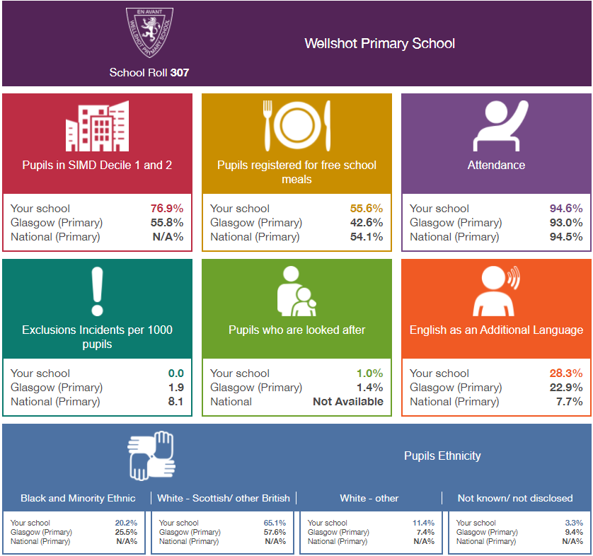

Aims and Values
The school is committed to provide equality and excellence for all in order to promote the highest possible standards.
The core values on which the policy is based include:
- a culture of respect for others
- promoting equality and social justice
- a community where pupils are well prepared for life in a diverse society

These align with the school’s motto, vision and values which are

‘Wellshot is a Family’

- F – Fair and Fun
- A – Achievement for All
- M – Mutual Respect
- I – Inclusive
- L - Learning is challenging
- Y - You are Nurtured and safe

Trust Respect Friendship Cooperation Happiness

Our School’s overall approach to promoting Equality
Our school’s Equality Policy provides a framework to pursue its equality duties as outlined in the 2010 Equality Act. We will strive to take all reasonable steps to;

- eliminate unlawful discrimination, harassment and victimisation
- advance equality of opportunity between people who share a protected characteristic and people who do not share it
- foster good relations and positive attitudes between all characteristics and different groups

Through the Equality Policy, the school will seek to ensure that no children and young people, staff, parents, guardians or carers or any other person through their contact with the school receives less favourable treatment. This includes the protected characteristics identified within the Equality Act (2010) i.e. age*, sex, race, disability, religion or belief, sexual orientation, pregnancy, undergoing or who have undergone gender reassignment.

This does not mean that all learners should be treated in exactly the same way: it means that we may need to deliver learning in a range of ways to meet the differing needs of people so that all receive the same standard of education as others as far as this is possible.

*(NB ‘age’ is also a protected characteristic but not in relation to pupils of any age in a school).

The school seeks to:
  - promote understanding and engagement between communities
  - provide opportunities to engage their communities
  - encourage all children and families to feel part of the wider community
  - understand and respond to the needs and hopes of all our communities
  - tackle discrimination and inequality
  - increase life opportunities for all
  - ensure that learning, teaching and the curriculum explore and address issues of equality and social justice

We should be committed to promoting and teaching about children and young people’s rights especially with Scotland incorporating the UNCRC into law.

- Many covered in RME (religion – protected characteristic)
- Need for more diverse representation in children’s literature
- Visualising a point of reference for LGBT+
- Lack of understanding of the power of words/language (racism/LGBT)
- Building into/ Focus Weeks etc.
- Whole School Read-Aloud – focus on diversity
- Exposure to sectarianism (Divided City)
- ‘Rainbow award’ – most inclusive class
- Lessons on stereotyping

For example
- Black History Month
- Chinese New Year
- World Religious Celebrations (Eid, Diwali)
- Cultural Celebration days
- Sense over Sectarianism
- PSHE Curriculum – Anti-Bullying
- Rights Respecting Schools – Article of the Week
- LCFE – Techer talk
- Makaton
- PATHS
- Weekly SLT Whole School Assemblies

Roles and Responsibilities

The Headteacher is responsible for ensuring:
  - the policy is readily available and that, staff, children and young people and their parents/carers know about it
  - its procedures are followed
  - regular up to date information and data is uploaded to the establishment Education Perspective Report, annually
  - all staff know their responsibilities, including the Headteacher as leader of learning, and receive training and support in carrying these out
  - the school takes appropriate action in cases of harassment and discrimination towards learners and staff and follows appropriate procedures. For learners these are outlined in Chapter 7 of Glasgow’s revised Anti-Bullying Strategy. Revised Anti Bullying Strategy 2019 [2Mb]. For staff the procedures are outlined in the employees Bullying and Harassment policy.
  - the school has appropriate channels and processes in place to encourage all voices to be listened to so that we can support children and young people’s confidence in reporting bullying incidents.

All school staff are responsible for:
  - promoting equality and a collaborative ethos in the classroom/playground
  - developing school/class rules which challenge discriminatory behaviour
  - modelling good practice and being positive role models
  - proactively supporting learners if they face discrimination or inequalities linked to a protected characteristic
  - reporting discriminatory incidents following recording and reporting procedures as outlined in Chapter 7 of Revised Anti Bullying Strategy 2019 [2Mb]
  - recognise and tackle bias and stereotyping
  - promote equality and social justice
  - undertake CLPL opportunities to keep up to date with the law and practice on equality

Children and young people are responsible for:
  - supporting the school’s equality ethos
  - treating everyone in the school community with respect
  - supporting students who being treated unfairly, bullied and disrespected
  - sharing concerns or issues with a member of staff.

Parents/Carers are responsible for:
  - supporting the school’s equality ethos
  - sharing concerns or issues with senior staff
  - encouraging their children to uphold equality values and principles outside of the school environment

Partners and visitors are responsible for:
  - supporting the school’s equality ethos
  - sharing concerns or issues with senior staff

Responsibility for overseeing equality practices in the school lies with the Head Teacher
Responsibilities include:
  - co-ordinating and monitoring work on equality issues
  - dealing with and monitoring reports of harassment (including racist and homophobic incidents) through SEEMIS. For more details on how to take this forward please to refer to Education Services Anti-Bullying policy which is available at Glasgow Online
  - monitoring the progress and attainment of children and young people with protected characteristics
  - monitoring exclusions

Monitoring, Reviewing and Assessing Impact
  - The school’s Equality Policy can be supported by actions in the School Improvement Plan
  - The policy will be regularly monitored, reviewed and updated by all stakeholders to ensure that it is effective in eliminating discrimination, promoting access and participation, equality and good relations between different groups, and that it does not disadvantage particular sections of the community. To support this you should use the ‘Equalities Self-Evaluation Tool’
  - Any pattern of inequality found as a result of self-evaluation will be used to inform future planning and decision-making
  - Progress in improving equalities in the school will be reported on in the school’s Quality and Standards Report
  - This policy links to other policies and in general the principles of equality will apply to all other school policies.

Equality Policy

Appendix 1

This information is collated and updated annually so that we can have a clear picture of the context of the school population. This will be used to contextualise our policy and ensure that it reflects the diversity of our school community.

To collect the information you should refer to either data from Focus or SEEMIS

School Context (as at insert date)

Details | (insert date here)
 | Number | %
Staff (teaching and support staff) | 36
Sex
Male | 4 | 11.1%
Female | 32 | 88.8%
Ethnicity/Race
White British/Scottish | 35 | 97.2%
White Other | 1 | 2.7%
Black and Minority Ethnic | 0
Not known/disclosed | 0
Disability (disclosed) | 0
Children and Young People
Sex
Male | 164 | 51.25%
Female | 156 | 48.75%
Ethnicity/Race
White British/Scottish
White other
Black and Minority Ethnic | 28 | 8.75%
Not known/disclosed | 1 | 0.31%
Additional Support Needs
EAL | 63
Disability | 0
Looked after/Care Experienced | 4
SIMD 1&2 | 232 | 72.5%

Appendix 2 Resources, Organisations and Policies

https://www.equalityhumanrights.com/en/publication-download/technical-guidance-schools-scotland

- Revised Anti Bullying Strategy 2019 [2Mb].

www.crer.scot Coalition for Racial Equality and Rights

www.stephenlawrenceday.org Stephen Lawrence Foundation website

www.respectme.org.uk Anti-bullying service

www.tie.scot LGBT inclusive education charity

www.lgbtyouth.org.uk Supports LGBT young people

www.gda.scot Glasgow based charity run by and for disabled people

www.enableglasgow.org.uk Works with people in Glasgow with disabilities and their carers

www.glasgowwomensaid.org.uk Supporting women, children and young people experiencing domestic abuse

We will continue to add to this list over time.

