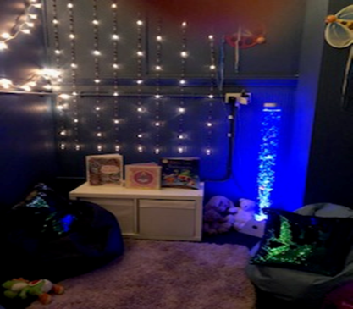

**Wellshot Primary**

**Standards and Quality Report 2017-2018**

**Wellbeing and Inclusion (continued)**

**Should you wish to discuss any**

**aspect of out Standards and**

**Quality Report please contact:**

**Jennifer McCluskey—**

**Head Teacher**

**Telephone@ 0141 778 1091**

**E-mail: Headteacher@wellshot-pri.glasgow.sch.uk**

**Our plans for**

**August 2018—June 2019**

• **Enhanced transitions support not only children from Nursery to**

**primary but also support children**

**within the school to move classes**

**and meet new teachers.**

• **P7 children have additional**

**Support from Quarriers to**

**transition from Primary to**

**Secondary.**

• **Gold Stars and Dragon Marks provide a programme for P6 and P7 on Domestic Abuse.**

• **Our Bounce Back programme promotes Resilience.**

• **Our Quiet Room is always**

**accessible to children.**

• **Nurturing Principles are at the heart of everything we do.**

• **After school clubs provide**

**children from P1-P7 with**

**experiences and skills.**

• **Literacy for All will move into Year 3. We will finalise or work on Writing,**

• **Glasgow Counts will move into Year 2 and we will look at Mathematics as well as**

**Number.**

• **Digital Leaders will drive**

**forward improvement in**

**Digital Learning.**

• **New approach to early**

**learning will move into P3.**

• **Baby Strings will not include P3.**

• **There will be a CDO in P1 and in P2.**

• **Progress in literacy and**

**numeracy is expected for all**

**children across all stages.**

**This Standards and**

**Quality Report will**

**summarise our**

**achievements last session, It will also let you know what our priorities are for this session.**

**Our aim, as always, is to improve**

**outcomes for our**

**children.**

**This Standards and**

**Quality Report will**

**summarise our**

**achievements last session, It will also let you know what our priorities are for this session.**

**Our aim, as always, is to improve**

**outcomes for our**

**children.**



**This Standards and**

**Quality Report will**

**summarise our**

**achievements last session, It will also let you know what our priorities are for this session.**

**Our aim, as always, is to improve**

**outcomes for our**

**children.**