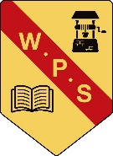
Wallacewell Primary
Parent Council
Agenda
Monday 13th November 2023

- Welcome, Introductions & Check-In
- Previous Minutes
- School Capacity
- Next meeting date
- AOCB

