[Ecotourism and Sustainable Tourism: Trends](http://www.mozaik.com/blog/online-marketing-2/ecotourism-and-sustainable-tourism-trends" \o "Permalink to Ecotourism and Sustainable Tourism: Trends)

**Ecotourism** is an alternative form of tourism whose sole purpose is holiday activities and the core element of this type of tourism is natural-based.

The basic intention of this type of tourism is to **raise awareness amongst travellers** about the natural setting or place that they visit for and at the same time minimize any corrosive (in terms of negative impact on environment) impact of the human activity. The idea of Ecotourism was raised and **evolved during the 80s** where the necessity for environmental care became more imperative, in order to protect the natural habitat from human intervention for the future generations.

The main characteristics of Ecotourism, concern mainly destinations where the **cultural and environmental heritage** are in abundance, in certain parts of our planet. The increasing demand for alternative types of tourism, such as Ecotourism, make countries (like Greece) more popular as destinations.

According [to Responsible Travel](http://www.responsibletravel.org/news/Fact_sheets/Fact_Sheet_-_Global_Ecotourism.pdf), there’s a constantly rising need from consumers for Ecotourism.

* 96% of Condé Nast Traveler readers think hotels and resorts should be **responsible** **for protecting the environment** they operate in.
* 74.5% says that a hotel’s environmental policies can influence their decision to stay there.
* In 2005, an analysis found that more than 2/3 of US and Australian travelers and 90% of UK tourists believe that within the hotel’s responsibility should be considered the active p**rotection of the environment and the support of local communities.**
* 46 % of the German’s think ‘it is an added value to stay in an environmentally friendly accommodation
* 80 % of the Dutch want information on ethical issues in their travel information.

Based on the indisputable figures above, a third party observer can realize that it is essential for the hospitality industry to embrace this **rapidly growing type of tourism**, and (the hospitality industry to) incorporate within its philosophy all the vital concepts of ecotourism.

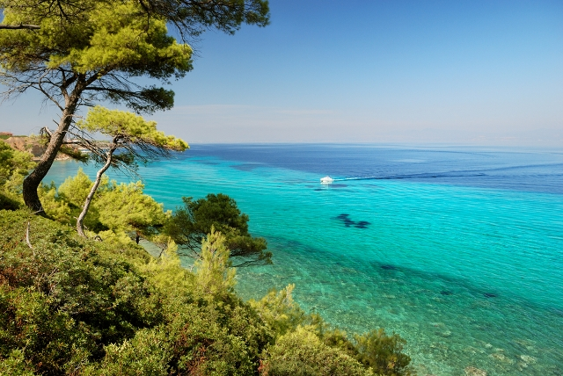

By embracing the core elements of Ecotourism, then the hotels (that are integral part of the hospitality industry), will see a **significant growth on their profits**. The hotels by implementing the 3 basic core components (of Ecotourism), conservation, communities and education will manage to become the pole of attraction the environmental-friendly (and sensitive) travelers.

One of the most important trends that the hotel industry should realize, is the fact that Ecotourism is not addressing only to small businesses but also to larger businesses which can commercially offer this product (by respecting and conserving at the same time the natural habitat).

The hospitality industry should combine the not only theoretically but also practically the concept of ecotourism with sustainable tourism. According to Zoe Chafe (2005), **"sustainable tourism** is the form of tourism that meets the needs of present tourist and host regions while protecting and enhancing opportunities for future’’.

The key points in which the hospitality industry has to focus on, are the below:

* **Protection of cultural heritage**; in this way the natural heritage adds value to the the cultural heritage. This mix of products creates the ideal framework for the hotels in order to become the pole of attraction for travelers.
* Provision of **incentives** for the reconstruction of cultural heritage monuments and the preservation of the natural environment, since he concept of volunteering and offer to the community is quite developed amongst travelers.
* Promotion of **authentic souvenirs**; the hospitality industry could promote local, authentic souvenirs made by locals.
* More and more hotels should pursue and obtain titles that promote their eco-friendly profile, by being **‘’eco-labelled’’**. For example [the Blue Flag](http://www.blueflag.org/), or the [Green Key](http://www.green-key.org/), are a good starting point…
* **Co-operation with the public sector** in order to ensure that the hotels keep the high standards that they have set for their travelers.

The hospitality industry by taking into consideration the aforementioned figures and fact and the emerging trends on Ecotourism and sustainable tourism, is feasible to achieve maximum profits.

**Sustainable tourism task**

Like all forms of development, tourism can have both positive and negative impacts. The aim of sustainable tourism is to maximise benefits such as job creation, foreign exchange earnings and new infrastructure while safeguarding cultural heritage and living culture and minimising negative environmental and social impacts, especially of mass tourism.

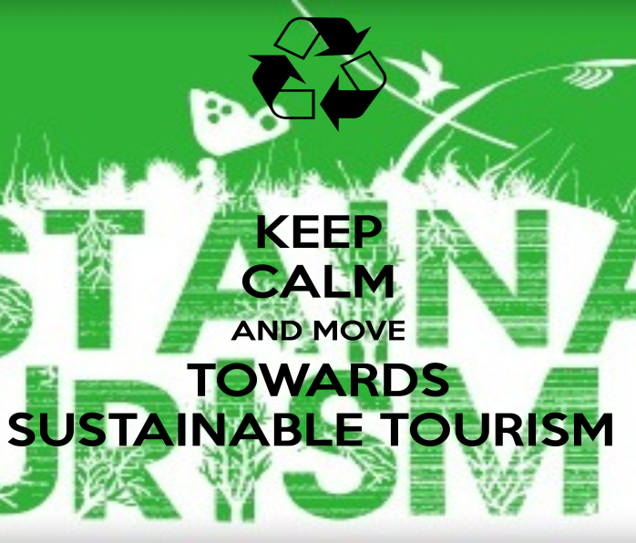

Describe and explain the positive and negative impact of Travel and Tourism on a chosen place. Use powerpoint, and structure your presentation the following way:

* Introduction- What is sustainable tourism?
* What positive impacts does tourism bring?
* What negative impacts does tourism bring?
* Case study- A sustainable tourist resort.
* Conclusion

Use the following sources to help with your presentation:

* <http://coolgeography.co.uk/GCSE/AQA/Tourism/Sustainable/Case%20study%20Sust%20Tourism.htm>
* <http://www.sustainabletourism.net/cs_destination.html>
* <http://www.tnvacation.com/green/>
* <http://www.s-cool.co.uk/a-level/geography/tourism/revise-it/case-study-zimbabwe>
* <http://www.tourismexcellence.com.au/Growing-Destinations/Benefits-of-Tourism.html>
* <http://www.nationalparks.gov.uk/learningabout/ourchallenges/tourism/impactsoftourism>