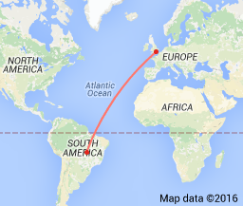**Unit title: Travel and Tourism: UK and Worldwide (National 5)**

**Unit code: H2Y3 75**

**Outcome 1 — Performance and Written Evidence**

Detailed descriptions of a ***minimum of three destinations***

* one from the rest of the UK (out-with Scotland)
* one European
* one long haul destination

Detailed descriptions of ***three attractions in or near*** each of the identified destinations

****Suggested Destinations : **Destinations could include but is not limited to:**

**Scenic areas:**

* in UK: The Cotswolds, The Peak District, Snowdonia
* in Europe: The North Italian Lakes, The Black Forest, The Dordogne
* worldwide: The Grand Canyon, Yosemite, The Himalayas, Uluru, Amazonia

**Activity/special Interest:**

* in UK: The Lake District, The Norfolk Broads, Newquay, The Yorkshire Dales
* in Europe: The Swiss Alps, The Danube, Monte Carlo, The Algarve
* worldwide: Orlando, Las Vegas, Masai Mara, The Andes, The Red Sea

**Coastal/island:**

* in UK: Blackpool, Cornwall. Pembrokeshire, Brighton
* in Europe: Majorca, Costa del Sol, Crete, Benidorm, Marmaris, Canary Islands
* worldwide: Florida, Caribbean, the Maldives, Phuket, Bali, Hawaii

**Towns/cities:**

* in UK: London, York, Cambridge, Bath
* in Europe: Dublin, Rome, Paris, Barcelona, Berlin
* worldwide: New York, Rio de Janiero, Sydney, Hong Kong, Cape Town

Evidence may be produced in a variety of formats including, but not limited to:

e-portfolio

written descriptions

PowerPoint presentation

personal blog or wiki

poster/display

video or podcast

talk