**Travel and Tourism: UK & Worldwide**

***Name: …………………………………………………………………………………………………… National 4 / 5***

Outcome 1 – The learner will - **Meet customer holiday needs by:**

1. Gathering information on travel and tourism destinations
2. Describing a range of tourist attractions, activities and amenities at each destination

**All work must be your own**

**DESTINATION: ……………………………………………………………………………………………………………….…………**

1. From Glasgow how would you get to your destination? Name main airports, airlines, train stations etc.
2. With information from worldclimate.com complete the climate graph below showing average temperatures and rainfall for your destination. Remember line graph = temperature and bar graph = rainfall.

[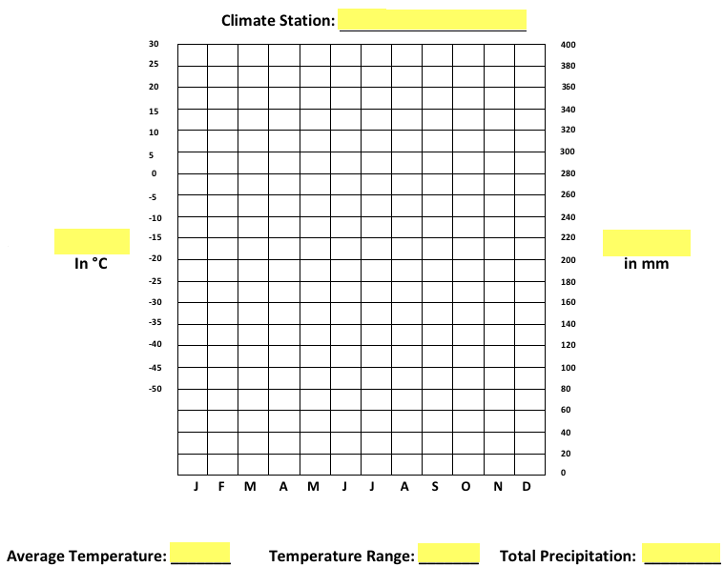](http://www.google.co.uk/url?sa=i&rct=j&q=&esrc=s&frm=1&source=images&cd=&cad=rja&docid=gl36L0Qz9K7J7M&tbnid=IPKfYgR67e1XBM:&ved=0CAUQjRw&url=http://cgg3o1.wordpress.com/&ei=17ZKUsutCYmAtAajhYHAAg&bvm=bv.53371865,d.d2k&psig=AFQjCNFoEdOM7CNDitrtmz9-n20KK4glJw&ust=1380714555989363)

**Temperature (oC)**

**Rainfall (mm)**

1. Describe the location / importance of your chosen destination along with additional information on local specialities
2. List 4 historical attractions/museums/parks etc. (dependant on location)
3. For three attractions in your location provide information regarding cost, opening hours and activities included.
4. Within your destination chose 2 places to eat, e.g. restaurants, cafes, bars and check average prices and popular dishes.
5. Name one expensive and one low cost form of accommodation, providing information on cost, location etc.