Scotland- Advantages and Disadvantages of tourism

To be successful in Outcome 1 of the Scotland section, you must be able to explain the positive and negative impacts of travel and tourism.

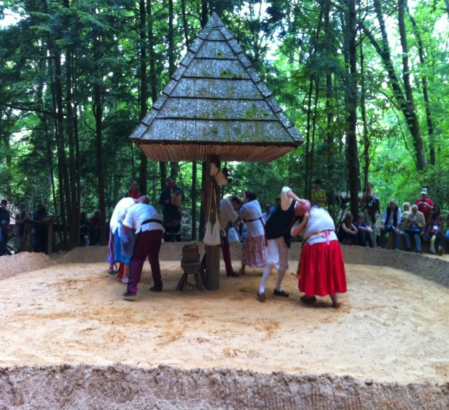

To do this, I want you to do the following:

1. Put a heading in your jotter *Positives and Negatives of Tourism.*
2. Read through the sheet detailing the positive and negatives. Pick 3 of each that you think are most important

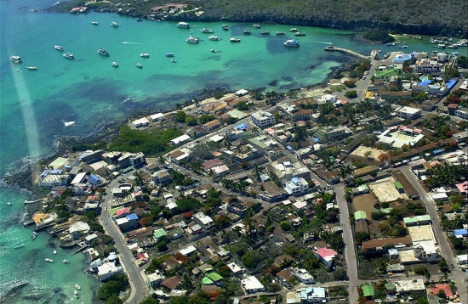

1. Create a powerpoint. Give it a title Positives and negatives of tourism
2. EXPLAIN why you picked your 3 positives and 3 negatives.
3. You may include images /pictures /diagrams