Scotland- Coastal/Island resort

To be successful in Outcome 1 of the Scotland section, you must investigate a Coastal/Island resort within Scotland e.g Ayr, North Berwick, Outer Hebrides, Helensburgh.

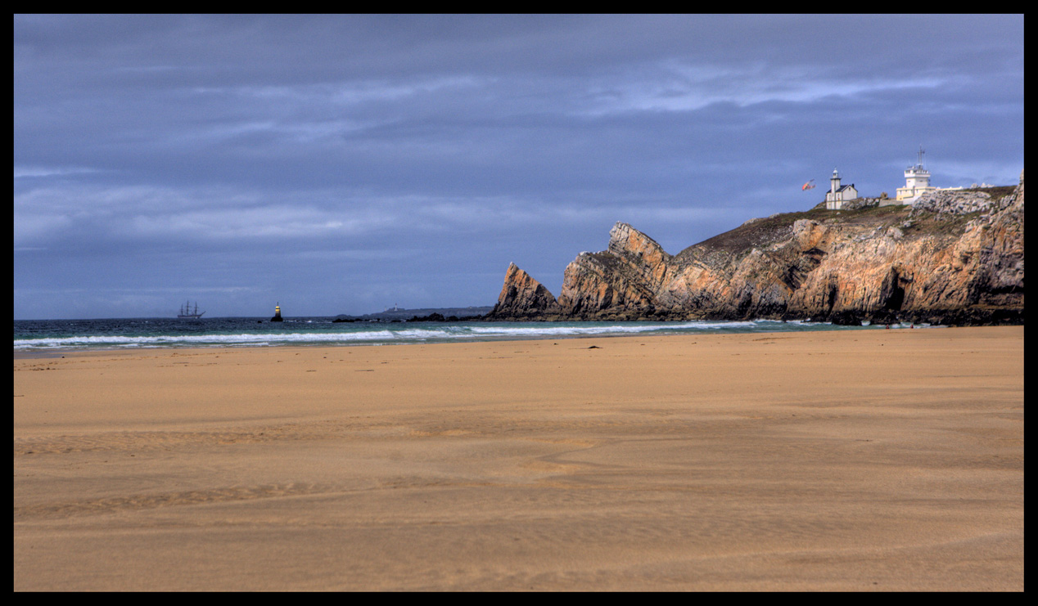

The following must be mentioned in your investigation:

* Introduction- Say why you should visit your Coastal destination
* 3 accommodation options i.e Budget, Mid- range and 5 star
* Attractions and things to do in your Coastal area.
* How do I get to your destination from Glasgow?
* Recommend some nice restaurants and bars.
* Climate information for your destination
* Image and reputation

Produce a word document or power point to present the findings of your investigation.