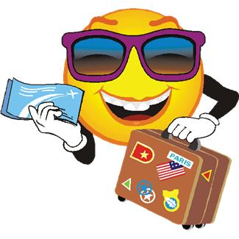

**Cfe Level 4**

**Travel and Tourism**

**Introduction**

**WHAT IS TRAVEL AND TOURISM ABOUT?**

This course explains how the development of tourism may bring benefits but can also cause problems. It shows how careful planning is needed to maximise the benefits and minimise the problems. It also looks at how both **physical** and **human** factors can affect the development of tourism.

**Learning Outcomes** - in this course you will learn about:

* the tourist industry
* different types of holidays
* tourist **destinations** in the UK, Europe and the wider world
* the problems tourism can cause
* how tourism can change the **environment**
* how to plan and book a holiday
* how to deal with problems which may arise before or during a holiday

**Figure 1: Booking a holiday using travel agent**

**TASK 1**

Copy the learning outcomes above into your jotter.

**WHY IS LEARNING ABOUT TOURISM IMPORTANT?**

We all like holidays – it is a time when we can relax and enjoy ourselves. Learning about tourism can help make those holidays even more enjoyable and interesting. It can also help us understand the tourist industry, an industry that creates jobs and wealth but needs careful management if it is not to cause problems for people and spoil the environment.

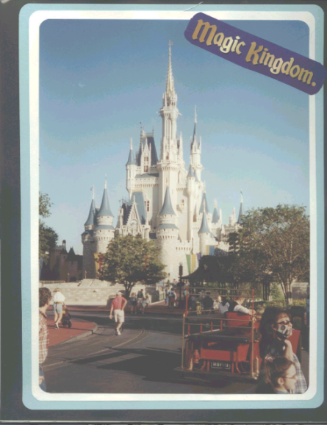

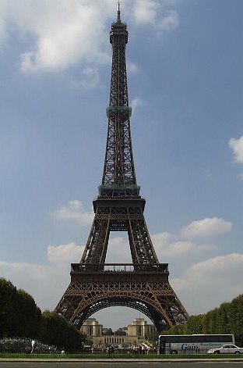

Paris, France

Florida, USA

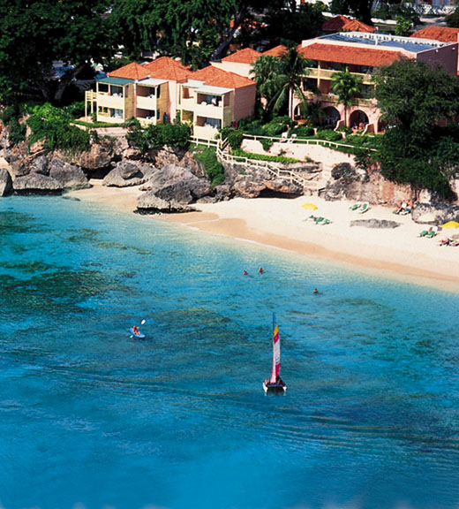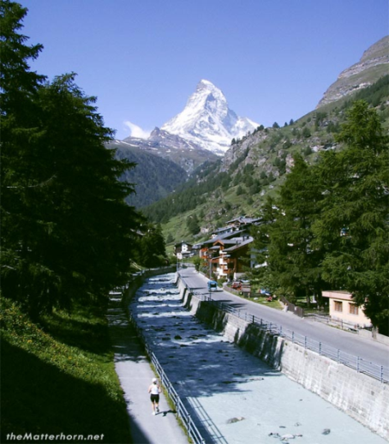

Barbados, Caribbean

Matterhorn, Switzerland

**Figure 2: Some popular tourist destinations**

**TASK 2**

Look at the photographs above. Write a description of each photograph describing the scene and why people might choose to visit.

Write down which one you would most like to visit and explain why.

**WHAT IS THE TOURIST INDUSTRY?**

There are many different types of jobs. People who work in farming or mining are involved in **primary industry** producing raw materials. S**econdary industries** employ people to make things, usually in a factory.

A third type is in **tertiary industries**. Tertiary industries provide a **service.** People who give help to others, such as teachers, nurses and shop assistants are part of this industry. The number of jobs available in tertiary industries has is increasing and this is partly due to the growth in tourism.

Tourists are people who travel for pleasure. The tourist industry looks after the needs of people. The industry employs a large number of people including travel agents, hotel waiters, tour guides and coach drivers. Can you think of more?

Tourism is big business. It is one of the world’s fastest growing industries and now employs more people worldwide than any other industry.

**Figure 3: Tourist-related jobs in the UK**

|  |  |
| --- | --- |
| **Tourism-related jobs** | **% employed** |
| Restaurants, cafes, | 22 |
| Pubs/bars | 21 |
| Nightclubs/social clubs | 10 |
| Hotels, Guest-houses, B&Bs | 21 |
| Libraries, museums, art galleries | 11 |
| Sports & health clubs, leisure centres | 15 |

**Figure 4: The Importance of Tourism to the UK**

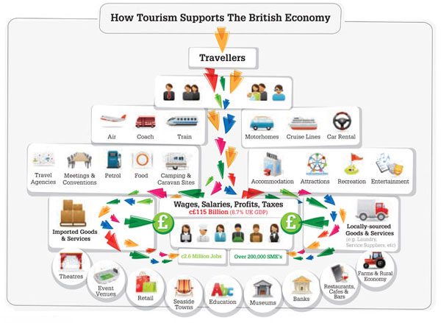

**TASK 3**

1. What is a **‘tertiary industry’**?
2. Write down three examples of jobs which are in tertiary industry.
3. Make a list of ten jobs related to travel and tourism.
4. Draw a **divided bar graph** to show the information in Figure 3.

[**Hint** – draw a rectangle 10cm in length and 2cm wide. 1mm on the bar will represent 1%. Colour the categories and make a key beside the graph.]

1. Use figure 4 above to write a paragraph about the importance of the tourist industry to the UK.

**WHY HAS TOURISM GROWN?**

Most of us like to spend longer periods of leisure time by taking a holiday. This involves staying away from home overnight and we then become a ‘tourist’.

Tourism is one of the world’s fastest growing industries and is important in creating jobs. In the UK, travel and tourism employs more than **2 million** people and the country earns more than **£75 billion a year** from the industry.

So why has tourism grown? There are many reasons why tourism has become a rapidly growing industry.

* **More leisure time** – people have more time off from work while still getting paid.

**Figure 5**: **Increase in annual holiday leave (% of population)**

|  |  |  |  |  |
| --- | --- | --- | --- | --- |
| **YEAR** | **2 weeks** | **2-3 weeks** | **3-4 weeks** | **Over 4 weeks** |
| 1966 | 60 | 30 | 9 | 1 |
| 1996 | 0 | 0 | 6 | 94 |

* **People are better off** – average wages are higher than in the past.
* **Better transport** – new roads and motorways, high speed railways more ferry routes and air travel mean that it is quicker to get to places.

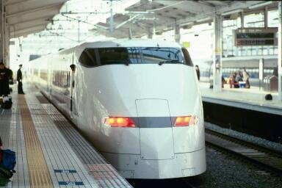

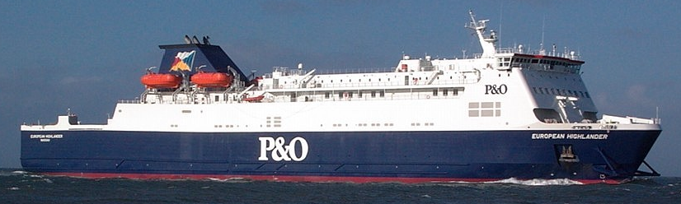

**Figure 6: Improvements in transport**

* **Cars** – more people own cars and this means they can travel distances even for a short holiday.
* 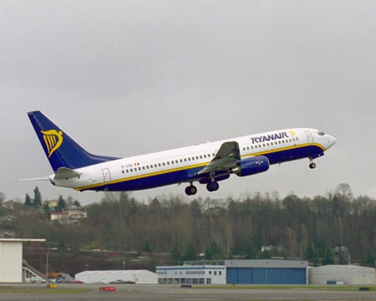**Air travel** – since the 1960s, air travel has become cheaper and faster and there are more frequent routes within the UK and to other countries. **‘Budget airlines’** such as Ryanair and Easyjet have further reduced costs and many airports have been enlarged and improved, or even new ones built near resorts abroad to cut down the **Figure 7: Ryanair jet** travel time.
* **Package holidays** – this is a holiday for a set period of time booked through a travel agent, in which the travel, **accommodation** and sometimes meals are included in the price.
* **Self-catering holidays** – camping, caravans and apartments also lower the cost of going on holiday because you can buy and cook your own meals.
* **Advertising and TV programmes** – holiday programmes, magazines, brochures and the internet show us new places and opportunities.
* **More retired people** – as people are living longer, many who have retired have time and money to visit places and take holidays.
* **Other factors** – many people who live in large towns or cities like to escape to countryside environments and the unreliable British weather is often a major factor for many when deciding on a destination.

**TASK 4**

1. Use the information on pages 6 -7 to make a detailed spider diagram to show the reasons for the growth of tourism.

2. (a) Collect the pie chart circles and use the information in Figure 3 to colour one for 1966 and one for 1996. Stick them in your jotter and write a heading. Colour a key beside the pie charts.

(b) Describe the changes shown by the pie charts.

(c) How have these changes affected tourism?

3. **Active Activity – What is the tourist industry?**

* Collect the worksheet and cut out the statements to make cards.
* Arrange the cards in a pyramid as shown below.
* Keep moving them around until you are happy with the order.
* Stick them down in your chosen order.
* 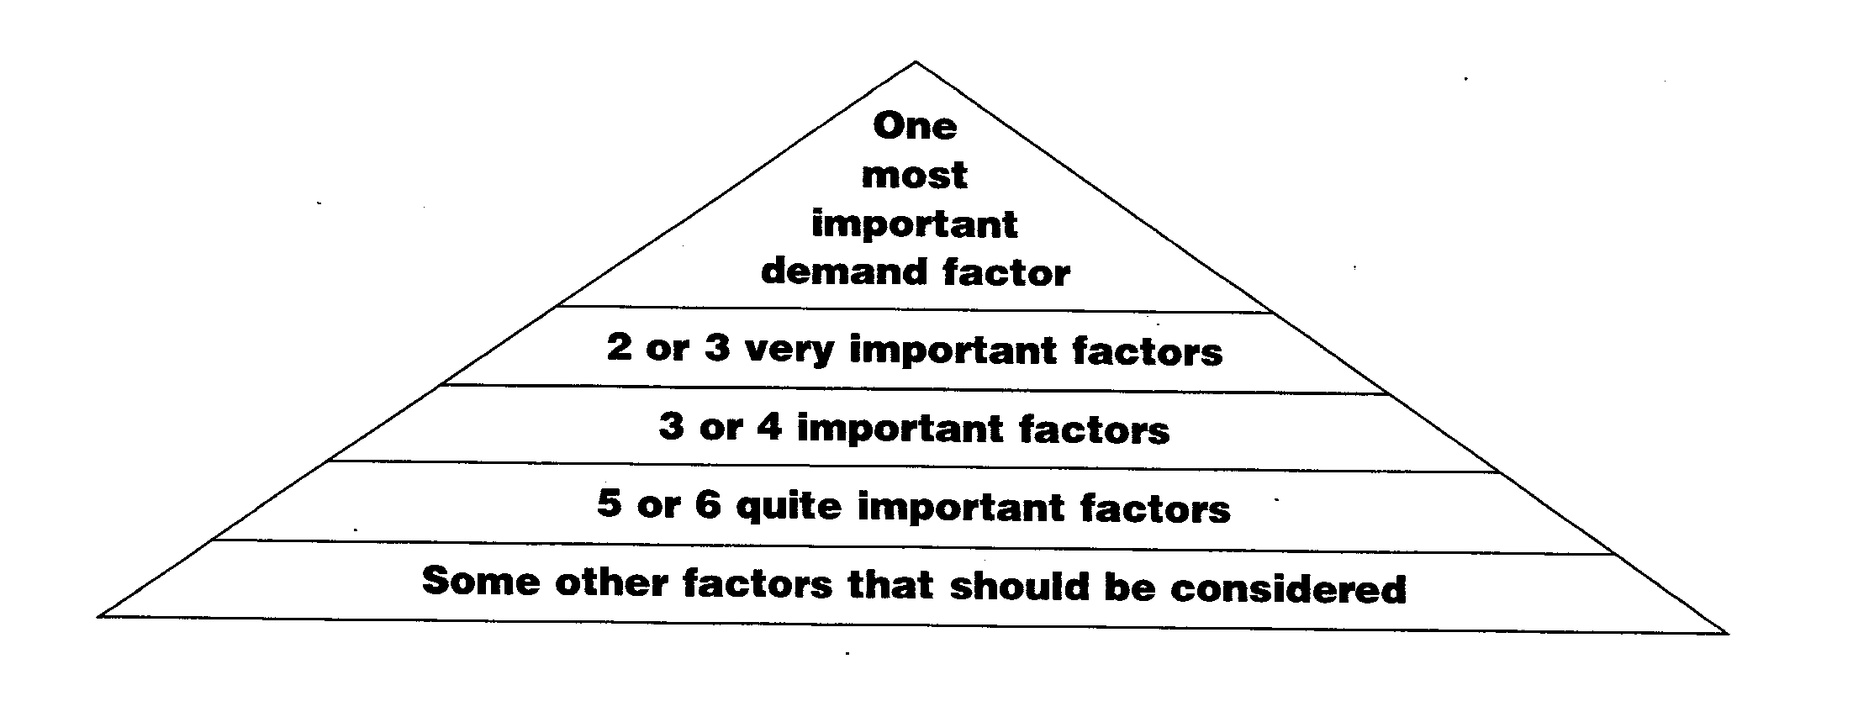Now answer the question below in your jotter using the statements.

Use the statements and information on pages 6 – 7 to write a few paragraphs to **explain** why tourism has grown.

**THE GROWTH OF TOURISM IN THE UK**

The UK was the first European country to promote leisure time but it was only the rich who could afford to travel. Holidays were linked with improving health and so seaside towns and **spa** towns became popular as they had cleaner air compared to the dirty, polluted cities of the 17th and 18th Centuries.

**Figure 8: Thomas Cook first began trips for tourist in 1841 and are one of the biggest British tour operators today.**

During the 19th century, changes meant that working-class (poorer) people began to take holidays. These changes were:

* In the **1820s** sea bathing was believed to be healthy and the clean coastal air good for health;
* In **1841**, Thomas Cook began trips for tourists with accommodation and travel included;
* The building of the railways from **1846** meant that large numbers of people could be transported quickly;
* By the **1890**s most people had at least a week’s holiday, although it was usually without pay.

By the mid 20th century, the British tradition of spending two weeks relaxing on a beach, with nearby attractions such as funfairs, had become established. These resorts were referred to as **“bucket and spade”** resorts.

In England, resorts such as **Blackpool**, **Brighton** and **Scarborough** developed. In Scotland, the Ayrshire coast was popular with people from Glasgow arriving by train to places such as **Ayr**, **Largs** and **Girvan**. **Dunoon** and **Rothesay** were also easy to reach using the paddle steamers which brought tourists down the Clyde.

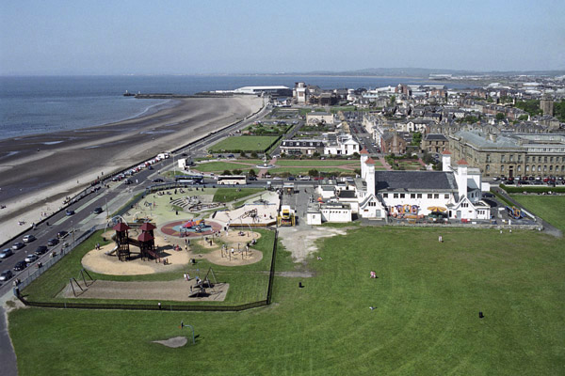 **Figure 9: Ayr Seafront**

**TASK 5**

1. When did people in Britain first start to take holidays?

2. What **three** reasons are given for this?

3. Why do you think people from Glasgow travelled to the Ayrshire coast?

4. List the names of the main resorts of the Ayrshire coast.

5. How did people from Glasgow travel to Dunoon and Rothesay for holidays?

6. Figure 9 shows Ayr Seafront. Some tourist features can be seen.

On your copy of figure 9, label the following features:

SANDY BEACH FIRTH OF CLYDE ESPLANADE PAVILION PLAYPARK GARDENS FOUNTAIN AYR HARBOUR PRESTWICK COUNTY BUILDINGS

7. Make a list of places in and around Ayr to visit and events held in the town.

[Use the Ayrshire Tourist Board site on the Internet]

8. Use figure 10 below to complete the key on your map of UK holiday resorts.

Stick this into your jotter.

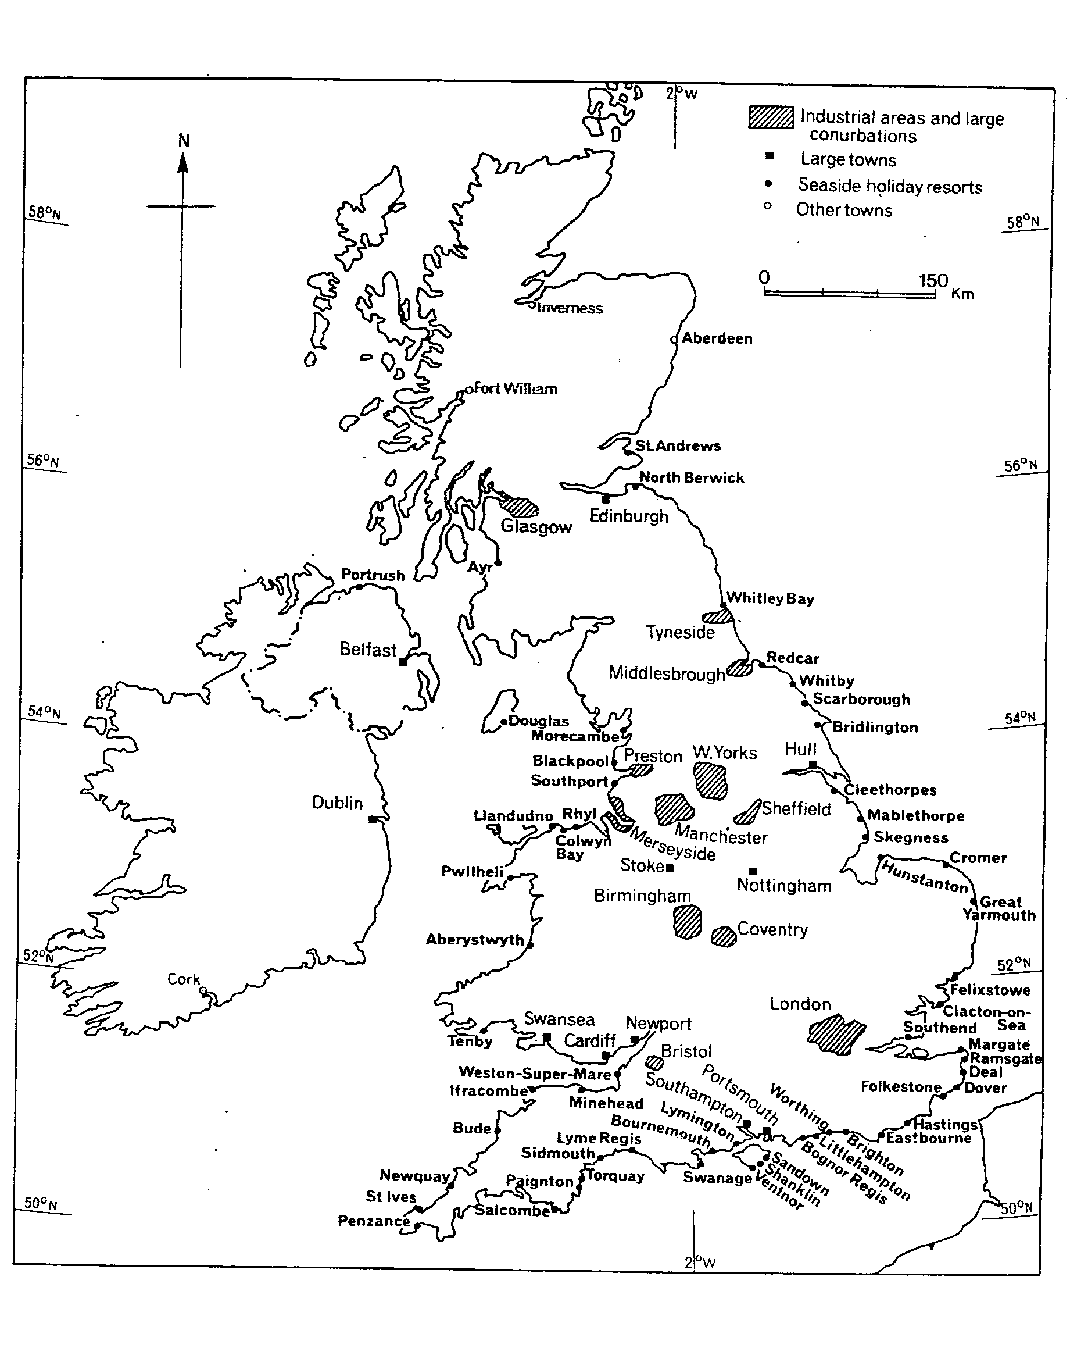 **Figure 10: UK Seaside Resorts**

**CASE STUDY OF A BRITISH SEASIDE RESORT: BLACKPOOL**

Blackpool is a typical seaside resort. The opening of the railway in 1846 made Blackpool a busy, popular holiday destination as it was within an hour’s journey from the dirty, smoky cotton towns of Manchester, Bolton and Rochdale.

In the 20th century, cars and coaches made Blackpool much more **accessible** to people from Scotland and this improved further when the motorways were built in the 1950s and 1960s.

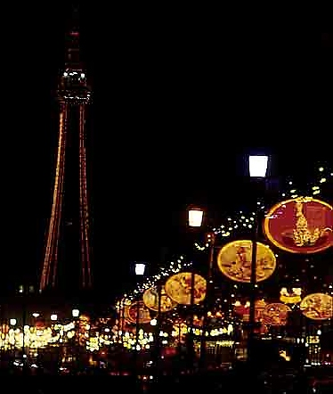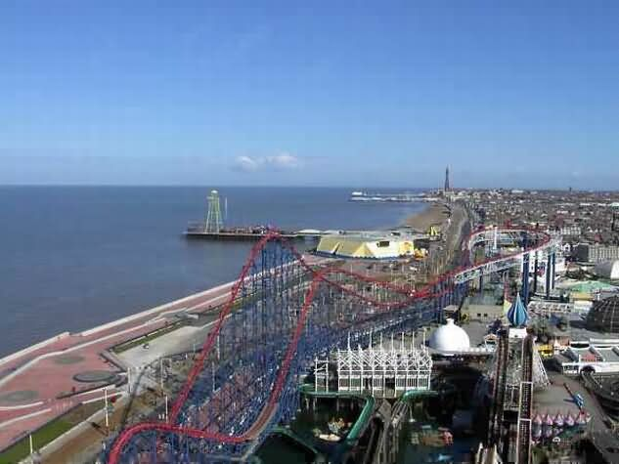**Figure 11: Blackpool Seafront and the Figure 12: The Illuminations ‘Pleasure Beach’**

Attractions of Blackpool:

* An 11 km stretch of wide sandy beach backed by a **promenade** where people liked to walk
* Along the promenade are the more expensive hotels where guests pay more for a sea view.
* Major attractions are **Blackpool Tower**, the **piers** and the **Pleasure Beach**.
* In the zone behind the sea front are the cheaper hotels and **guest-houses**, and Blackpool’s town centre which contains the shopping areas and offices (called the **Central Business District** or **CBD**)
* The railway station and bus station are also in this area so that people don’t have far to walk to reach the beach and other attractions.

**TASK 6**

1. Where did most of Blackpool’s visitors come from in the 19th century?

2. What developments made the resort popular for Scots in the 20th century?

3. **Copy** and **complete** the heads and tails:

**HEADS TAILS**

The promenade is a theme park with roller- coasters

The CBD is a zone of expensive hotels

The area facing the beach is a walkway alongside the beach

The Pleasure Beach is a zone of shops and offices

**Figure 13: Fun Map of Blackpool**

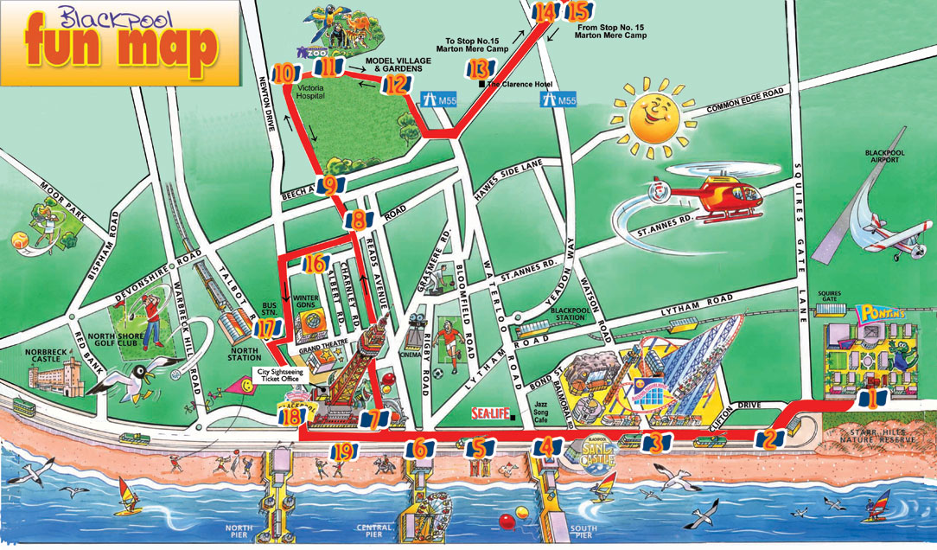

Blackpool’s heyday as a holiday destination is long gone. The number of visitors staying and spending money in Blackpool has fallen in the past 40 years as people often go abroad for better weather and to seek out more exotic locations. However, the resort still attracts many people on short breaks, especially in September when the **illuminations** are an attraction (Figure 9). It is also an important conference-centre.

**TASK 7**

1. Use figure 13 to make a list of attractions and places for visitors to Blackpool.

2. Which activities would be suitable even if the weather was poor?

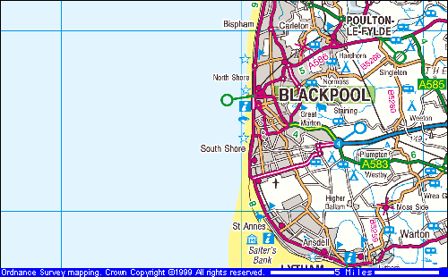 **Figure 14: OS 1: 50 000 Map of Blackpool**

**TASK 8**

1. The OS Map shows places of interest for tourists in blue.

Copy **six** symbols and use a key to write their meaning.

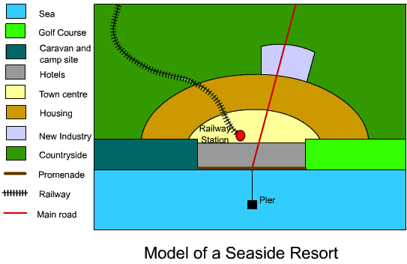2. KEY **Figure 15: Model of a Seaside Resort**

Thediagram in figure 15 shows the layout of a typical British seaside resort.

(a) Stick a copy of the diagram in your jotter and colour it in.

(b) Draw and colour the key beside the Model Diagram.

(c) Look back at the Fun Map (figure 13) and the OS Map (figure 14).

Write down at least **six similarities** of the layout of Blackpool and the model and at least **two differences**.

3. Visitors still holiday in Blackpool but how has the type of tourism changed?

4. Use the Fun Map and OS Map to draw a sketch map of Blackpool.

**ICT – EXTRA TASK**

Make a leaflet to show the attractions of Blackpool, or any other British seaside resort.

**TOURISM IN THE UK TODAY**

Tourism has changed considerably in the last 40 years. Improvements in transport, information, income and leisure time and competition from other countries such as Spain and the USA, means that most people no longer choose British seaside resorts for their **annual holiday**.

However, some, like Blackpool, are still popular for **day-trips** and **short-breaks** but they now have modern facilities which provide for visitors all year round and when the weather is poor. Some have become important **conference centres** attracting business people and politicians.

Many tourists come and visit the UK from overseas and this **international tourism** is very important to the **economy**. However, many residents of the UK travel within the country and this is known as **domestic tourism**. Income from domestic tourism accounts for 80% of the total earned from tourism in the UK.

Nowadays, the main destinations in the UK can be divided into a number of types:

1. **Coastal resorts**, eg. Blackpool, Brighton,
2. **Scenic landscapes**, eg. the Yorkshire Dales, the Peak District
3. **Mountainous areas and ski centres**, eg. the Lake District, the Cairngorms
4. **Capital cities and heritage/historical centres**, eg. London, York, Oxford
5. **Leisure/activity centres/theme parks**, eg. Center Parcs, Alton Towers, Legoland
6. **Luxury hotel/spa hotel breaks,** eg. Gleneagles, Cameron House
7. **Business-conferencing centres**, eg. NEC, Birmingham, SEC Glasgow

**TASK 9**

Draw a mind map to show the main holiday types of UK as described above. Add examples of each type using the information and the photos on page 18.

**Figure 16: UK Tourist Destinations**

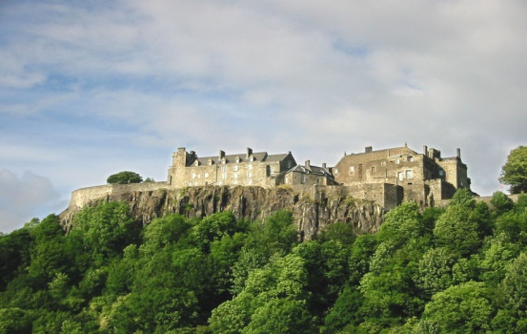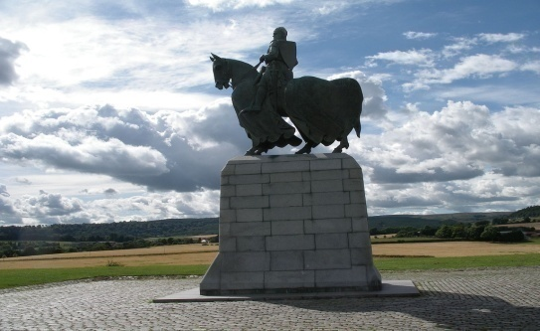

London

Stirling Castle

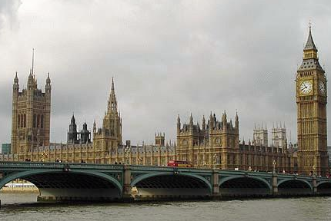

Bannockburn Battlefield

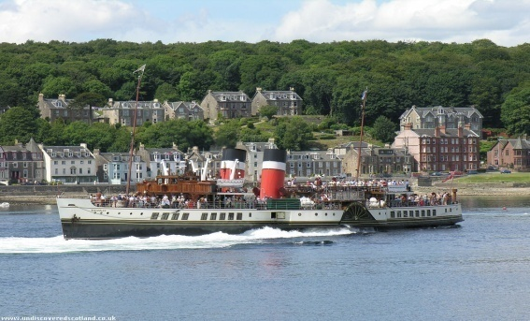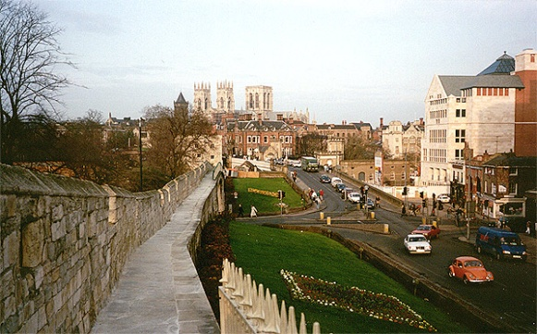

York

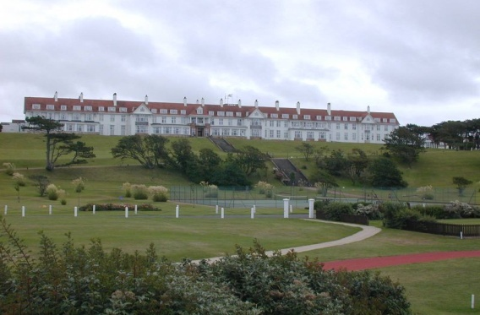

Turnberry

Rothesay

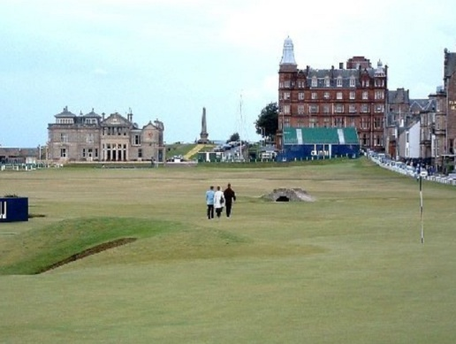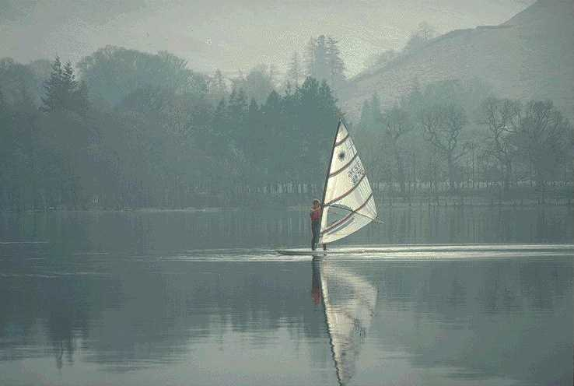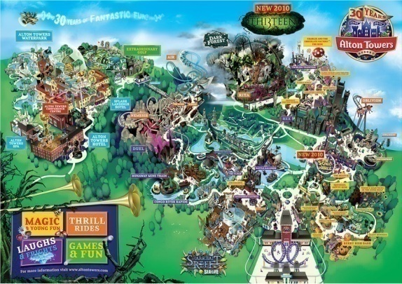

Alton Towers

Lake Windermere

**[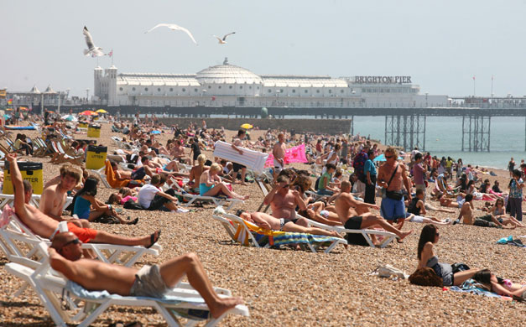](http://www.guardian.co.uk/uk/gallery/2009/jun/29/weather-heatwave-uk?picture=349688251)**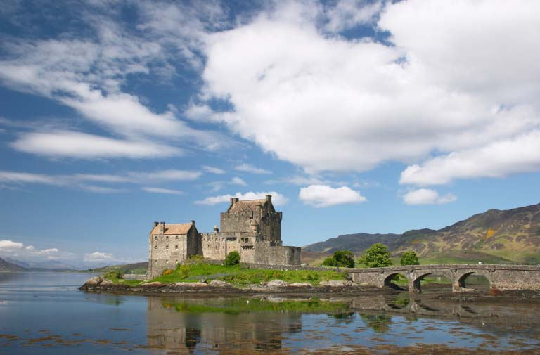

St. Andrews

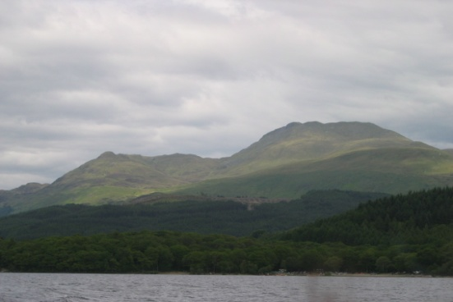

Ben Lomond

Eilan Donan Castle

Brighton

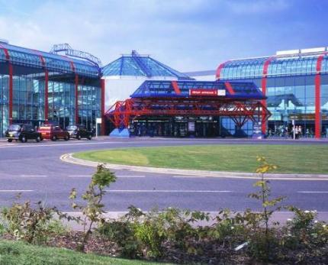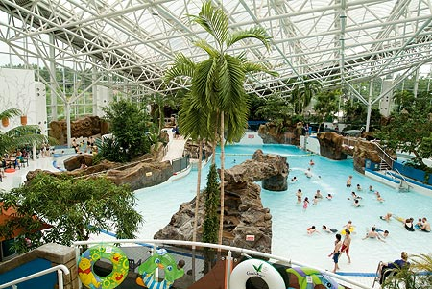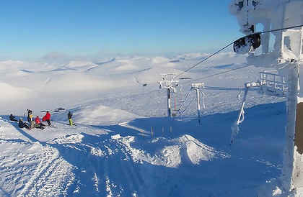

Center Parcs

NEC Birmingham

Cairngorm

**WHAT ARE THE DIFFERENT TYPES OF TOURISM?**

**Mass tourism Figure 17: Ibiza, Spain**

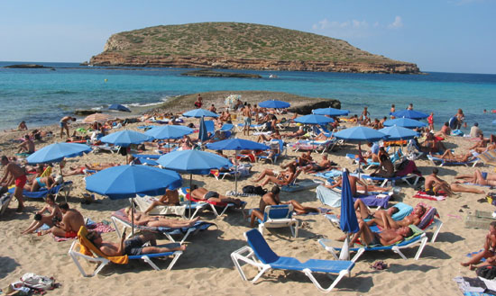Mass tourism developed as improvements in transport allowed the movement of large numbers of people in a short space of time. Britain’s resorts were the first to experience mass tourism and the term can now be applied to the coastal resorts of Spain and others globally.

**Winter tourism Figure 18: Zermatt, Switzerland**

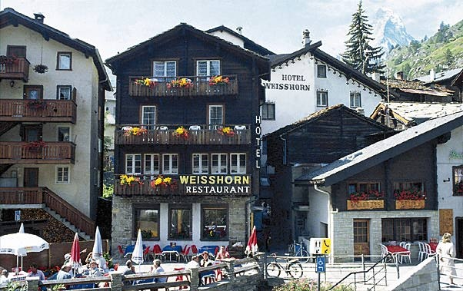Although ski-ing was first started in Norway Switzerland was the first to become popular for winter sports. Other Alpine countries, such as Austria, Italy and France, also developed resorts. Major ski resorts can now be found all over the world. Not everyone comes to ski – sailing, walking, climbing and enjoying the dramatic scenery and clean, fresh air are other attractions.

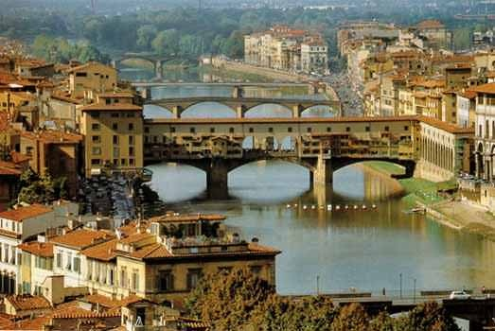**Cultural/heritage tourism**

Many people enjoy visiting destinations to admire the architecture (buildings) or learn about events from history. Others cities, such as Florence or Rome contain many fine collections of art or have links with literature or music. British cities such as London, Edinburgh and York attract many visitors who come to see buildings, museums, art galleries and theatres. **Figure 19: Florence, Italy**

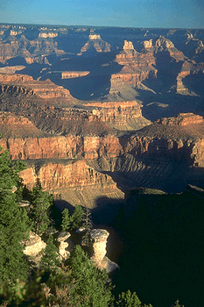**Geotourism**

Some people visit areas which have dramatic landscapes or important features to be studied or admired. Iceland offers visitors a chance to see ice-sheets and active volcanoes. While breath-taking features such as the Grand Canyon in the USA and Ayers Rock (Uluru) in Australia are also popular.

**Figure 20: The Grand Canyon**

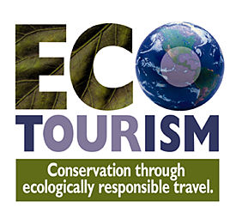**Ecotourism**

Ecotourism is also known as ‘green tourism’. It involves visiting places to appreciate the scenery, wildlife and culture and to eat local food while staying in simple accommodation. It creates jobs while protecting the environment.

**Figure 21: Ecotourism**

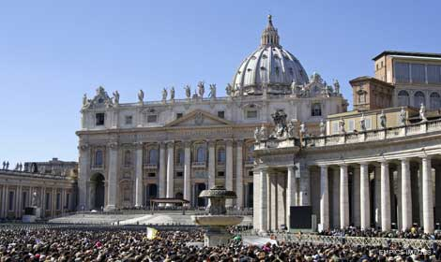**Religious tourism**

There are many sites of religious importance around the world. The Saudi Arabian city of Mecca attracts pilgrims (people making religious visits) by Muslims while other destinations include the Vatican in Rome, Lourdes in France and Knock in Ireland.

**Figure 22: Vatican City**, **Italy**

**War or ‘dark’ tourism**

This type of tourism involves visits to ‘dark’ sites such as battlegrounds, scenes of genocide such as concentration camps or to war cemeteries. Dark tourism is connected with acts of mourning and remembrance or with education.

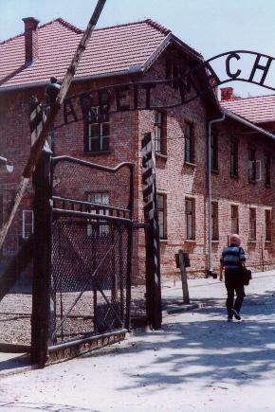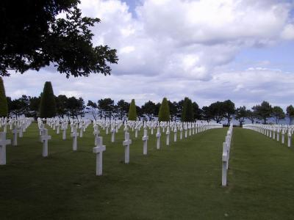**Figure 23: Auschwitz, Poland** **Figure 24: Normandy, France**

**Doom tourism**

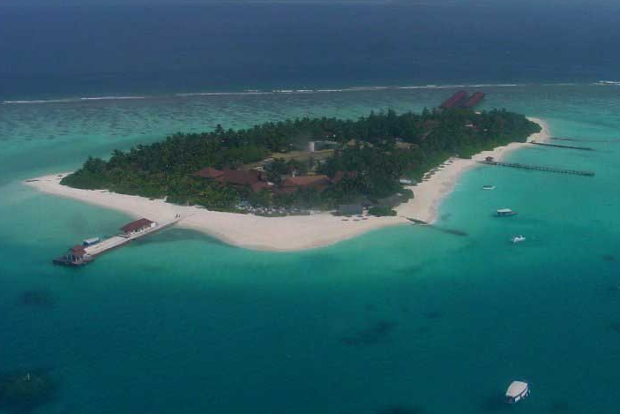

Also known as “Last Chance Tourism”, this trend involves travelling to places which are environmentally threatened, for example the ice sheets of Alaska and the coral reefs of the Great Barrier Reef in Australia. Basically, people want to visit before they disappear!

**Figure 25:The Maldives,**

**Space tourism(!)**

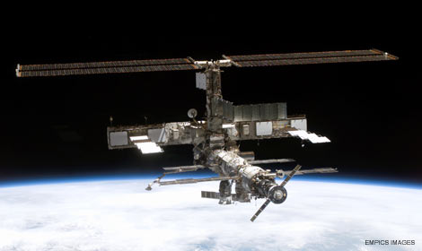If you have a spare £20 million then you may be able to book a journey to space through Virgin Galactic or enjoy a stay at the International Space Station!

**Figure 26: The International**

**Space Station**

**Sports tourism**

Since the late 1980s, sports tourism has become increasingly popular. Events such as the Rugby World Cup, the Olympics, the Commonwealth Games, football World Cup and Euro Football Championships have enabled specialist travel companies to gain official ticket allocation and then sell them in packages that include flights, hotels and excursions.

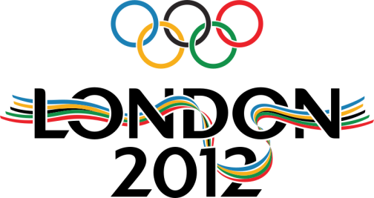

F**igure 27: London Olympics 2012**

**TASK 10**

Read the information on pages 19 – 22.

1. Match up the heads and tails below and copy them into your jotter.

**HEADS TAILS**

Geotourism is the trend of going to places which may be in danger of disappearing

Mass tourism is when pilgrims visit sacred sites

Cultural tourism is when people travel to major events such as the Olympic Games

Winter tourism is when large numbers of people visit one area eg. the coast of Spain

War tourism is visits to places which are important natural landscapes

Ecotourism is visits to resorts which offer ski-ing

Religious tourism is holidays in places where there is no damage to the environment involved

Doom tourism is visiting important sites such battle sites or concentration camps

Sports tourism is visiting cities to look at architecture, art galleries and museums

2. Draw a spider diagram to show the different types of tourism and use the photos figures 16 - 28 (or the Internet) to add examples of each.

**RECENT TRENDS IN TOURISM**

Tourism continues to grow especially in Europe where travel for short breaks is common. Tourists have a wide range of budgets and tastes, and a wide variety of resorts and hotels have developed to cater for them. Some people prefer simple beach holidays while other like quieter or family-friendly resorts.

The developments in transport and technology, such as jumbo-jets, low-cost airlines, the internet and more accessible airports have made many types of tourism more affordable. The UN World Health Organisation estimated that in 2009 there were 500,000 people on a plane at any time.

Changes in lifestyle, for example there are more retired people in the UK, mean an increase in travel and the internet gives opportunity to book a trip far in advance or on impulse at the last minute.

However, there have been a few setbacks in recent years. The terrorist attacks of September 11 were followed by others in tourist destinations such as **Bali** and **Sharm-el-Sheik** and in cities such as **Madrid** and **Mumbai**.

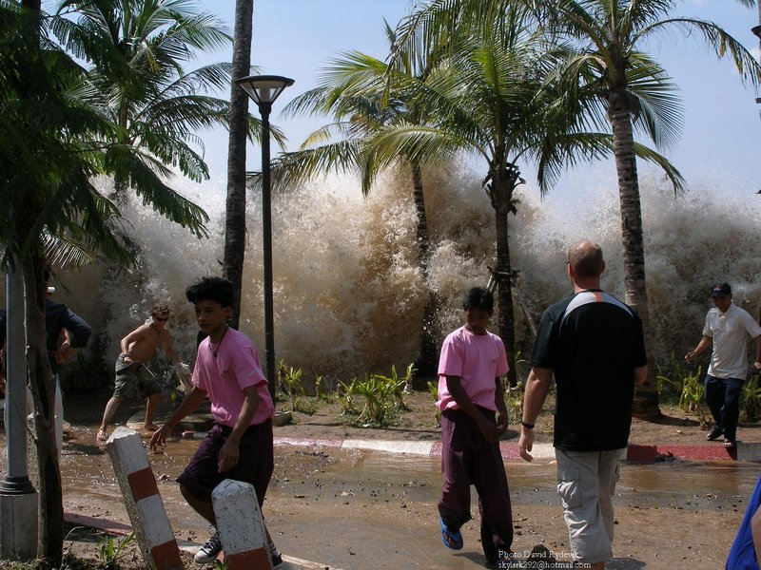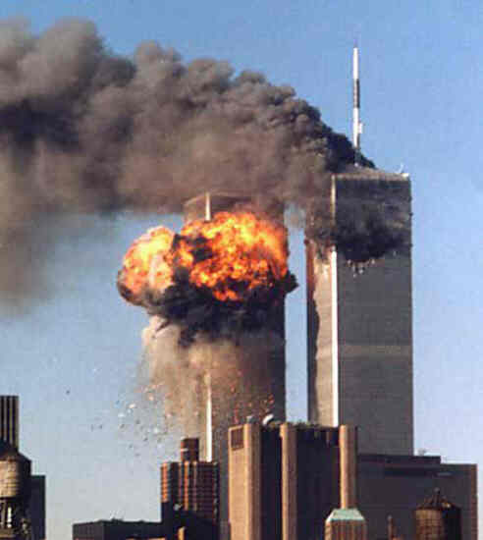

**Figure 30: 9/11** **Attacks** **Figure 31: Boxing Day Tsunami, 2004**

Terrorism has also had an impact on travellers around the world as airlines and other types of transport have introduced stricter security measures. This can lead to lengthy queues and delays for passengers.

Natural disasters can affect tourist areas. The Boxing Day **tsunami** of 2004 hit the Asian countries on the Indian Ocean such as Thailand, Malaysia, Sri Lanka and the Maldives and many tourist lives were lost. The eruption of the Icelandic volcano **Eyjafjallajokull** in April 2010 resulted in European air traffic being grounded for a week and caused chaos for many stranded abroad.

In the last few years, a downturn in the economies of some of the world’s richest countries, including the USA and UK, has meant that people have less money to spend non-essentials such as expensive holidays.

**TASK 11**

1. What developments have made tourism more affordable?

2. Name **three** tourist destinations that have been affected by terrorism?

3. Give an example of a security measure which has been introduced since the terrorists attacks and threats of the last decade.

3. What impact does terrorism have on tourism?

4. How have natural disasters had an impact on travel and tourism?

5. The downturn in the economy has caused a growth in people taking a ‘**staycation**’. What does this mean? Who might benefit from this trend?