Sunnyside Primary
and
Language and Communication Resource


SUNNYSIDE
1 Powrie Street
GLASGOW
G33 5LA

A Community of Learners



Welcome to Sunnyside Primary School

&

Language and Communication Resource

Dear Parent/Carer,

We are very happy to welcome you and your child to our school.
The School was opened in 1973 and became co located with Sunnyside Language and Communication Resource (LCR) in August 2010.
The LCR caters for primary aged children who have specific language, and / or communication difficulties which meet identified criteria.
We hope that you will find Sunnyside a happy and secure place where your child is made to feel that he/she belongs.
We have an “Open Door” policy here in Sunnyside, where parents are always welcome. We do, however, ask that you come to the office in the first instance, rather than speak to the class teacher, if you have any worries or concerns. It is important that parents and staff work together to provide the best possible educational experience for all of our children. Everyone has a part to play in keeping Sunnyside a warm and nurturing place where children are encouraged to learn and to develop skills for life.
Your child’s time here is very important to you and your family and we are looking forward to sharing their learning journey with you.

Aileen McCaffer
Head Teacher

Last updated October 2024


School Vision, Values and Aims

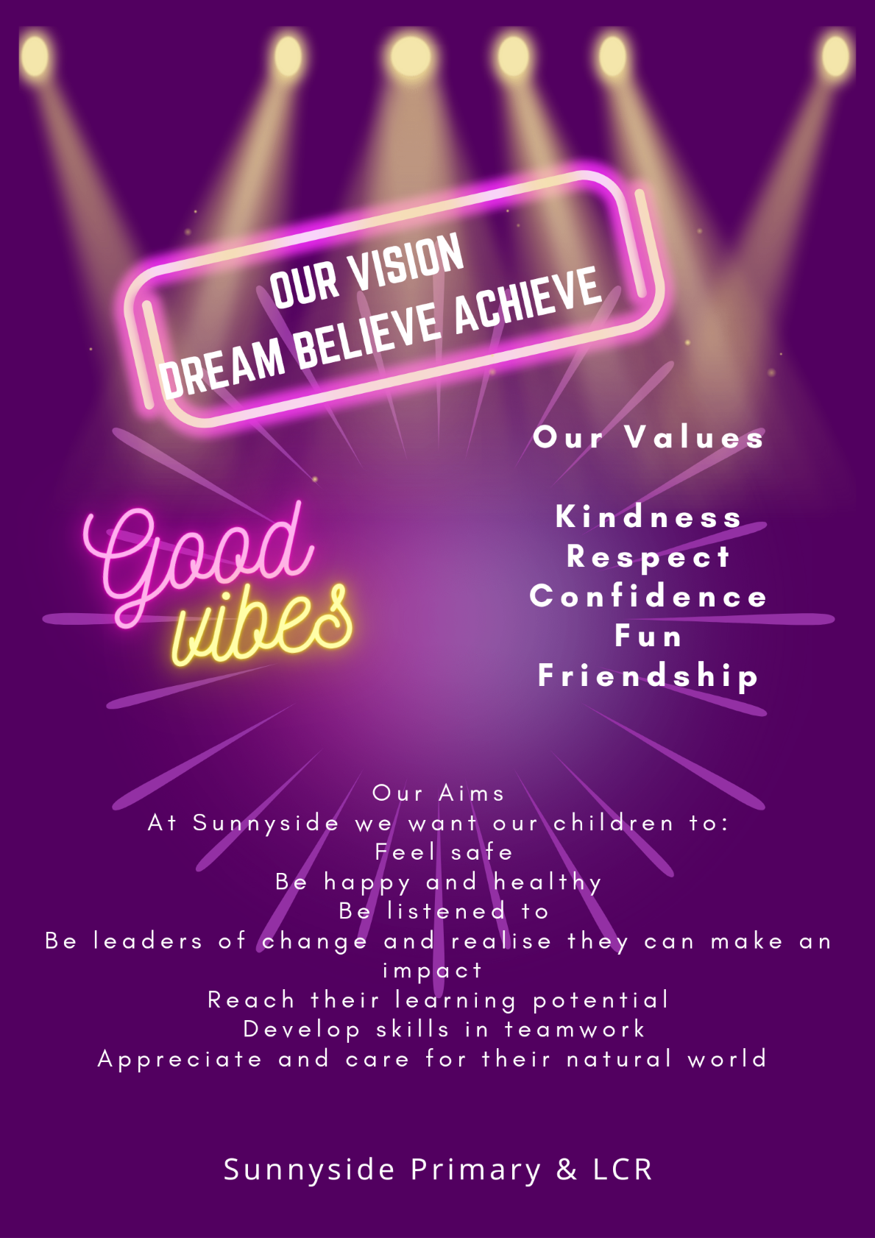

School Information

Address: Sunnyside Primary School & LCR
1 Powrie Street
Craigend
GLASGOW
G33 5LA
Phone: 0141 774 5777
E-Mail: Headteacher@sunnyside-pri.glasgow.sch.uk
Twitter: @SunnysidePri

Parent Council Facebook Sunnyside Primary Parent Council

Glasgow City Council Schools and Learning Website:
https://www.glasgow.gov.uk/index.aspx?articleid=15894

Background information

Co-educational school
Non-denominational mainstream school
LCR for pupils from the north and east of the city
Current Roll: Mainstream - 205
LCR - 24
Capacity: 440 (Parents should note that the working capacity of the school may vary dependent upon the number of pupils at each stage and the way in which the classes are organised.)
Stages covered: P1 – P7

School staff

A full list is available on request and parents will be updated on any changes as required.

The leadership team is as follows:

Mrs Aileen McCaffer Head Teacher
Mr Robert Boyd Depute Head Teacher
Ms Lisa Perrie Principal Teacher – Mainstream
Miss Gayle McGeachy Acting Principal Teacher - Mainstream
Mrs Angelique Watt Principal Teacher – LCR

Enrolment

Registration of Primary 1 children takes place in November and is advertised widely in local press etc. Prospective parents are welcome to visit the school and should contact the school office. Enrolment is now conducted online – see the link below.

Families living outwith the catchment area are welcome to make a placing request to attend Sunnyside Primary School but must enrol their child online as a first step. Further information is available using the following
https://www.glasgow.gov.uk/index.aspx?articleid=18426

Children allocated a place in the LCR will have been identified following an assessment and review meeting called an Area Inclusion Group meeting. Once a place has been allocated, we will contact parents and arrange transition.

Organisation of Classes


The following guidelines set by Scottish Government apply.
P1 maximum 25
P2&3 maximum 30
P4-7 maximum 33
Composite classes maximum 25
Composite classes have pupils from more than one stage.

The School Day

Monday – Friday 9.00am – 3pm
Morning Interval 10.30am – 10.45am
Lunch 12.15pm – 1.00pm

P1 children will remain in school until 3pm from the first day of term.

A breakfast club runs from 8am – 8.45am daily.

School Term Dates

Details of school term dates are available on the Glasgow City Council website: https://www.glasgow.gov.uk/index.aspx?articleid=17024

Pupil Absence

Within Sunnyside Primary School and LCR good attendance is encouraged at all times and children rewarded accordingly. Parents are asked to advise if their son or daughter is going to be absent. This should be done as early as possible on the first day of absence. If the young person is going to be absent for some time, it would be helpful to know at the earliest opportunity. The school uses daily text messaging to inform parents and carers of absence if no contact is made. All unexplained absences are investigated by the school and appropriate action taken. All calls must be made to the Pupil Absence Reporting Line on 0141 287 0039. The line is open between 08.00-15.30 Monday to Friday. Alternatively, you can use the online form on the Glasgow City Council website: https://www.glasgow.gov.uk/index.aspx?articleid=18832

Medical & Healthcare

The NHS school health team visits at various times during the year for routine health checks, vaccinations and medical examinations. Parents are kept informed by letter.

If a child becomes ill during the course of the school day, he/she may require to be sent home. Please ensure that you keep the school informed of all contact details.

Parents should inform the school of any medical requirements relating to their child. If a child requires medication during the school day, parents must complete the appropriate medical form. This is available on request from the school.

Emergencies

We make every effort to maintain a full educational service, but on some occasions circumstances arise which lead to disruption. Schools may be affected by, for example, severe weather, temporary interruption of transport, power failures or difficulties of fuel supply.

In such cases, we shall do all we can to let you know about the details of our closure or re-opening by using letters, texts, Twitter, the Parent Council Facebook Page and the local media etc.

School Uniform

Sweatshirts, cardigans, polo shirts and ties with the school logo are available for purchase from Aspire Academy Schoolwear – https://aspireacademyglasgow.com/

Our uniform was agreed in consultation with pupils and parents. It is expected that all children attending Sunnyside Primary School and LCR will adhere to this dress code.

At Sunnyside we are very proud of our school uniform. Its bright colours stand out wherever we go and members of the public often remark on how smart we look!
Our uniform choice consists of
- White or yellow shirt
- School tie
- Yellow polo shirt
- Dark grey or black skirt or trousers (no denim)
- Purple sweatshirt or cardigan
- Purple fleece
- Purple rain jacket
- Gym bags
- Black School shoes
- Soft soled shoes for indoors

PLEASE LABEL ALL CLOTHING CLEARLY WITH YOUR CHILD’S NAME

PE Kit

It is important that pupils come prepared to learn and for PE this requires appropriate clothing. All jewellery should be removed. Pupils who are not participating in PE must have a note or a medical certificate. Pupils who are unable to participate in practical PE should still bring their kit to allow them to assist in the lesson by refereeing, keeping scores or assisting with the distribution of equipment. This ensures that they are still able to take part in some way in the work of the class and do not miss out on the knowledge and understanding of the course.

There are forms of dress that are unacceptable in school, such as items of clothing which:

- Potentially encourage factions (such as football colours)
- Could cause offence (such as anti-religious symbolism or political slogans)
- Could cause health and safety difficulties (such as loose fitting clothing, jewellery)
- Could cause damage to flooring
- Carry advertising particularly for alcohol or tobacco
- Could be used to inflict damage on other pupils

Clothing & Footwear Grants

Parents/Carers receiving Income Support, Job Seekers Allowance (Income Based), Working Tax Credit, Housing Benefit, Council Tax Benefit or Universal Credit (see link below for income threshold details) will normally be entitled to monetary grants for footwear and clothing for their children. Information and application forms may be obtained from schools and at
https://www.glasgow.gov.uk/index.aspx?articleid=17885


School meals

Our school provides a lunch service which offers a variety of meals and snacks. Medical diets for children can be provided. Further information can be found here: http://www.fuelzoneprimary.co.uk/UserFiles/files/Medical_Diet_Leaflet%20-%20June%202017%20WEB.pdf. Please inform the Headteacher.

All children in P1-5 are entitled to a free school meal.

If you plan to send your child/children to breakfast club, you should inform the staff of any medical dietary requirements.

Children and young people of parents/carers receiving Income Support, income-based Job Seekers Allowance, Working Tax Credit, Child Tax Credit only, Universal Credit (see link below for income threshold details) and income-related Employment and Support Allowance are entitled to a free midday meal. Information and application forms for free school meals may be obtained at
https://www.glasgow.gov.uk/index.aspx?articleid=17885

Transport

The education authority has a policy of providing free transport to all pupils who live outwith a certain radius from their local school by the recognised shortest walking route. This means that the provision of transport could be reviewed at any time. Parents/Carers who consider they are eligible can apply online at
https://www.glasgow.gov.uk/index.aspx?articleid=17882

Transport for Children Attending the LCR

Pupils are transported daily to and from the LCR by taxi or bespoke arrangements for individuals. They are supervised at all times by a designated escort. The education department arranges transport.

Parents/carers are requested that, if their child is ill, they contact Transport Co-ordination Centre 0141 287 1056, so that they can notify the relevant taxi operator. Contact that number also to resume transport on the child’s return to school.

It is the responsibility of the parent/carer to take a child to the taxi and collect from the taxi. Children are not allowed to enter buildings unaccompanied. The escort is required to stay in the taxi with the children and is not allowed to leave the children unattended in the taxi in order to take a child to their door.

Parents/carers will normally be advised if there is a change of escort, but there may be occasions when this is not possible. Should an escort who is not known to you come to collect your child, please feel free to contact the school for clarification. Please note that any changes to transport arrangements must be made through the Transport Co-Ordination Centre and any change requires 5 days notice.

Transfer from Primary to Secondary School

Children and young people normally transfer between the ages of 11 ½ and 12 ½, so that they will have the opportunity to complete at least 4 years of secondary education. Parents and carers will be informed of the school arrangements no later than December of P7. Children from our school normally transfer to:
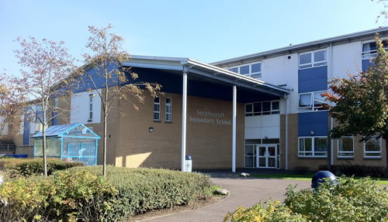
Smithycroft Secondary School
282 Smithycroft Road
Glasgow
G33 2QU
Phone: 0141 582 0220
Email: headteacher@smithycroft-sec.glasgow.sch.uk
www.smithycroft-sec.glasgow.sch.uk

Glasgow Secondary School staff work with our pupils from Primary 6 onward to prepare them for the transfer to secondary school.

Communication with Parents

At Sunnyside Primary School and LCR we use a variety of ways to keep in touch.

Open Door Policy – the senior leadership team are available for all parents and carers at any time providing they are not teaching or in another meeting. Please contact the school office for an appointment.

Newsletters – will be sent out electronically on a regular basis to keep parents informed about the work of the school.

Letters – further information which requires a response may be sent out in letter form.

Twitter/Parent Council Facebook page – will contain a great deal of information about the school. It is a good idea to check this regularly.

Text messaging – You may also receive text reminders about events/school closures etc.

Meetings - Parents and carers are welcome in the school to discuss any aspect of their child’s development and progress. To avoid disappointment, it is advisable to make an appointment. There are various opportunities throughout the year when parents can discuss their child’s progress with the class teacher and view their child’s work.

Groupcall App – please download the Groupcall App to keep up to date quickly and efficiently.

Within the LCR links between school and home are also developed in a variety of ways:
- Home/school diary where relevant information can be shared.
- Parental/Carer workshops are scheduled throughout the year and we welcome parents’ suggestions re topics.
- Schedule of review meetings to discuss progress and the way ahead
- Newsletters/letters/Snapshot Folders
- Escorts provide a daily link.
- Home visits can be arranged if appropriate but must be agreed by the Head of Establishment or Depute.

Parents and carers are welcome at other events throughout the school year e.g. workshops, information evenings, class performances, religious and other assemblies. The school newsletter and Twitter will keep you informed.

Emergency Contact Information

At the start of each school session, parents will be issued with the annual data check form. Please ensure that this is completed and returned to the school. It is also important that you let us know if there are changes to your telephone number(s) and email or to those of your emergency contacts throughout the year.

Data Protection – use of information about children and parents/carers

We collect information about children attending school (and also about parents/carers, emergency contacts etc. provided in the annual data check) to allow us to carry out the Council’s functions as the education authority for the City of Glasgow. This may sometimes involve releasing personal information to other agencies and other parts of the Council, particularly in relation to child protection issues or criminal investigations, and it may also be used for research purposes (see the link below for more details regarding this).

Information held by the school is, in legal terms, processed by Glasgow City Council. The Council is registered as a data controller under the Data Protection Act 2018 and all personal data is treated as confidential and used only in accordance with the Data Protection Act, the General Data Protection Regulations, and the Information Use and Privacy Policy approved by the City Council. For more information on how we use personal information, or to see a copy of the Information Use and Privacy Policy, see https://www.glasgow.gov.uk/index.aspx?articleid=18010

Education specific privacy statements can be accessed at https://www.glasgow.gov.uk/index.aspx?articleid=22069 .

Appointments during school hours

If your child has an unavoidable appointment, please give them a letter for their class teacher and then collect them from the school office at the specified time.

Comments & Complaints

In Sunnyside Primary School and LCR we aim to have positive relationships across our school community. However, if you have a comment or complaint about any aspect of school life, please contact the Headteacher in the first instance.

Glasgow City Council complaints procedures are available: https://www.glasgow.gov.uk/index.aspx?articleid=16133

Customer Care Team
Customer & Business Services
Glasgow City Council
City Chambers
Glasgow G2 1DU

Tel: 0141 287 0900
e-mail: customercare@glasgow.gov.uk or education.customercare@glasgow.gov.uk

The above website also includes information on data protection and freedom of information.

Curriculum

Curriculum for Excellence 3-18

Curriculum for Excellence has been introduced to raise standards of learning and teaching for all 3 to 18 year olds. It aims to help prepare children and young people with the knowledge and skills they need in a fast changing world. As part of Curriculum for Excellence all children from pre-school to the end of S3 will receive a rounded education known as a Broad General Education (BGE). Curriculum for Excellence is all about bringing real life into the classroom and taking lessons beyond it.

Through the experiences we provide at Sunnyside Primary School and LCR we want our children to become Successful Learners, Confident Individuals, Responsible Citizens and Effective Contributors. We are committed to providing children with a broad general education and focus on eight curriculum areas.

Expressive Arts | Health & Wellbeing | Languages | Mathematics
Religious & Moral | Sciences | Social Studies | Technologies

Progress in learning is indicated through curriculum levels as detailed below.

Level | Stage
Early | The pre-school years and P1 or later
First | To the end of P4, but earlier or later for some
Second | To the end of P7, but earlier or later for some
Third & Fourth | S1-S3, but earlier for some

Expressive arts: The inspiration and power of the arts play a vital role in enabling our children and young people to enhance their creative talent and develop their artistic skills.

Health and wellbeing: Learning in health and wellbeing ensures that children and young people develop the knowledge, understanding and skills which they need now and in the future to help them with their physical, emotional and social wellbeing.

Science: Science and its practical application in healthcare and industry is central to our economic future, for our health and wellbeing as individuals and as a society.

Social Studies: Through social studies, children and young people develop their understanding of the world by learning about other people and places both past and present, societies, their beliefs and values.

Religious and moral education: Religious and moral education includes learning about Christianity, Islam and other world religions, and supports the development of beliefs and values.

Languages: Knowing other languages and understanding other cultures is a 21st century skill set for students as they prepare to live and work in a global society.

Mathematics: Mathematics equips us with the skills we need to interpret and analyse information, simplify and solve problems, assess risk and make informed decisions.

Technologies: The range of subjects in technical education has changed significantly over the last two decades and now includes craft, design, engineering and graphics.

There will be opportunities throughout the year for parents and carers to learn more about aspects of the curriculum and to be consulted about significant changes if appropriate.

Useful websites

Education Scotland: www.education.gov.scot
National Parent Forum of Scotland: www.npfs.org.uk
Parentzone: https://education.gov.scot/parentzone/
Connect: https://connect.scot/

Religious Observance

Our school is fortunate to have a close link with the local church. The minister assists with the Christianity element of Religious and Moral Education and provides opportunities for religious observance. Parents have the right to withdraw their child from religious observance and should inform the school in writing.

In addition, parents and carers from religions other than Christianity may request that their children may be permitted to be absent from school in order to celebrate recognised religious events. Only written requests detailing the proposed arrangements will be considered. Appropriate requests will be granted on up to 3 occasions in any 1 school session.

Assessment and Reporting

We have three Parents’ Meetings when the class teacher can discuss your child’s progress – one in October (Meet the Teacher), one in February (Open Afternoon) and one formal individual meeting in May/June. Before the summer meeting the Annual Written Report is sent home.

We track pupils’ progress and gather evidence of their developing skills.

The assessment of pupils’ progress is continuous throughout the session. This will be carried out on a formal and informal basis.

Within the LCR progress is discussed and documented within a multi-disciplinary team.

Review meetings are held to discuss each pupil’s progress. A post placement meeting takes place approximately 8 - 10 weeks after placement in the LCR. There is an annual review later in the year. These reviews involve the Parents/Carers, the Resource/Mainstream Teachers, the Headteacher/ Depute and, where appropriate, the Educational Psychologist and/or the Speech and Language Therapist. A report will be presented, and issued in advance of the meeting.

A Wellbeing and Assessment Plan (WAP) is drawn up for some children, based on his/her strengths and needs. Long term and short term learning outcomes are set and these are continually reviewed. Parents contribute to the process of setting learning outcomes for their child and the child is encouraged to set a personal outcome. The teachers use all work done in jotters/workbooks, maths progress tests, examples of work etc. to provide information on each child’s achievement. Progress towards learning outcomes in the WAP and in forward plans is assessed regularly.

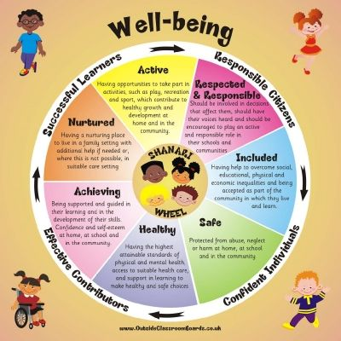
Useful websites
www.curriculumforexcellencescotland.gov.uk
www.educationscotland.gov.uk/parentzone/index.asp

Nurturing City

The Glasgow City Council vision ‘towards the nurturing city’, puts building positive, trusting relationships at the core of our work. We ensure children, young people and families feel they belong, they are listened to and they are valued by embedding the principles of nurture across our early years, primary and secondary establishments. Staff are trained in attachment and nurture which deepens understanding of child development and enhances effective practice by responding to the needs of all children and young people in a consistent and caring way. Nurture is a universal approach which builds resilience, helping to reduce the impact of adversity. Effective communication and collaboration with parents and carers builds an ethos of partnership working putting the child at the centre, fostering high quality learning contexts.

Each of our nurturing establishments contribute to the development of Glasgow as a nurturing city, creating safe environments which allow our children and young people to flourish by raising attainment and promoting positive mental health and wellbeing.

Support for Pupils

The school has a duty to ensure that all pupils have equal access to the curriculum, with appropriate support for their needs if required. This applies to the content of lessons, teaching strategies and minor adaptations to the school environment. There are a wide range of factors which may act as a barrier to learning. We are committed to working closely with parents and carers to ensure that they are fully involved in any decisions about support for their children’s needs.

Any parent or carer seeking further advice regarding this policy should contact the Headteacher in the first instance.

Further information relating to additional support needs is available on the Glasgow City Council website at https://www.glasgow.gov.uk/index.aspx?articleid=18941

Information on the Glasgow City Councils’ Parental Involvement Strategy can also be found at https://www.glasgow.gov.uk/index.aspx?articleid=17870

School Improvement

On an annual basis, the school completes a Standards and Quality report. The Standards and Quality report highlights progress in key curricular areas such as literacy, numeracy and health & wellbeing. Our priorities for improvement are detailed in our School Improvement Plan which is discussed with our Parent Council. Any parent or carer seeking a copy of the plan can contact the school office.

Promoting Positive Behaviour

Children’s Rights as outlined in the UNCRC (United Nations Convention on the Rights of the Child) are fundamental to a good school ethos. Adults in our school will work with children to ensure they are aware of their rights and fully respect the rights of others. Therefore, the approach within Sunnyside Primary School and LCR is to build a positive ethos that demonstrates care and respect for all. Positive behaviour is recognised and celebrated.
We run a positive behaviour policy, which depends on children earning House Points. We celebrate these at our weekly assemblies, and award children for being Successful Learners, Effective Contributors, Confident Individuals and Responsible Citizens. We look to use praise at every opportunity to motivate our pupils and help them stay on target for good behaviour.
Class teachers also reward pupils in various ways.
When a child’s behaviour causes concern in class we have clear guidelines, which are used by all staff.
Firstly we issue a verbal warning, and then children are given a visual warning in the manner of a yellow card followed by a red card. If their behaviour still causes concern then they will be put onto “Penalty Time” where they are removed from our Golden Time reward from 2.30-3pm on a Friday and will spend time with a member of the Management Team to allow them to reflect on their behaviour. Parents are lettered should this happen.
Should you have any concerns over behaviour issues regarding your child please contact the school at the earliest opportunity to allow the matter to be resolved as quickly as possible.

Use of C.A.L.M. Intervention

In accordance with Glasgow Education Services Policy the LCR staff may use the C.A.L.M. system (Crisis Aggression Limitation and Management) to manage challenging behaviour if necessary.
All members of LCR staff are involved in this training programme which is designed to de-escalate and diffuse challenging behaviour effectively and safely.

The highest standards of behaviour are expected of pupils at all times. Where this is not the case, a variety of sanctions are used. Parents are asked to co-operate with the school in encouraging a sense of responsibility and good behaviour in their children.

Playground

An adult presence is provided in playgrounds at break times in terms of the Schools (Safety and Supervision of Pupils) (Scotland) Regulations 1990.
Incidents of unacceptable and or unsafe behaviour in the playground will be dealt with firstly by a member of the playground team and reported to the class teacher should it be deemed necessary. The child’s name may then be placed in the Playground Behaviour Book. If a child’s name appears three times in the book then parents will be informed. Serious incidents are dealt with by Senior Management and parents again informed.
In extreme weather, children will be kept in their classes supervised during interval and lunch. P7 pupils will monitor P1-P6 with an adult presence in each corridor. Children who do not behave in a safe and responsible manner may be removed from class and be taken to a member of the Senior Management Team who will supervise them.

Homework

Continuing to learn at home helps children to achieve more and is a vital part of our partnership with parents. Please check your child’s schoolbag for communication about home learning and specific tasks. A copy of our homework policy is available on request from the school office.

Parent Council

We have an active Parent Council that represents the views of all parents. All parents are welcome to attend Parent Council meetings and can become members at the AGM in September. Parent Council minutes are available on request. Visit the Parent Council Facebook page for more information.

Pupil Voice

We have four “Houses” in Sunnyside:
- Earth
- Mountain
- Ocean
- Sky
Each House has specific roles within the school, promoting the Conservation ethos of the school and also encouraging leadership amongst our young people.
Staff members meet regularly with the House teams and they drive forward change for improvement.

Extra Curricular Activities

We have a wide range of activities that run after school to extend the learning experience. Please check your child’s schoolbag and texts for information as places are popular and usually limited.
Good links with community organisations and our Active Schools Co-ordinator are vital for the success of these programmes.

Useful Contacts

Parentzone Scotland is a unique website for parents and carers in Scotland, from early years to beyond school. The website provides up-to-date information about learning in Scotland, and practical advice and ideas to support children’s learning at home in literacy, numeracy, health and wellbeing and science. Information is also available on Parentzone Scotland regarding additional support needs, how parents can get involved in their child’s school and education. Furthermore, the website has details about schools including performance data for school leavers from S4-S6; and links to the national, and local authority and school level data on the achievement of Curriculum for Excellence levels. Parentzone Scotland can be accessed at https://education.gov.scot/parentzone.

Glasgow City Council

Education Services
City Chambers East
40 John Street
Glasgow G1 1JL

Tel: 0141 287 2000

www.glasgow.gov.uk

Local Councillors North East (21)

Councillor Maureen Burke, Labour Party
City Chambers
George Square
Glasgow
G2 1DU
0141 287 5865
maureen.burke@councillors.glasgow.gov.uk

Councillor Ruairi Kelly, SNP
City Chambers
George Square
Glasgow
G2 1DU
0141 287 4057
ruairi.kelly@glasgow.gov.uk@councillors.glasgow.gov.uk

Councillor Mandy Morgan, SNP
City Chambers
George Square
Glasgow
G2 1DU
0141 287 5629
mandy.morgan@councillors.glasgow.gov.uk

