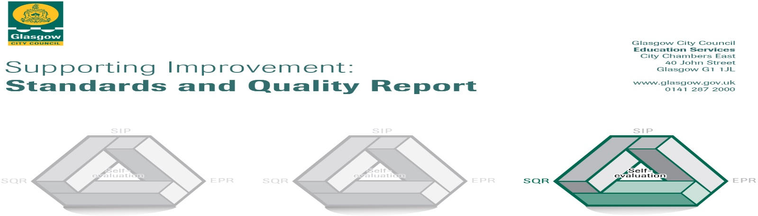

The summary report is provided for parents/careers and partners to outline our achievements this session and our priorities for next session. Throughout this session we have taken forward our priorities as detailed in our school improvement plan. Through our processes of self-evaluation, we have identified how we can improve outcomes for our children and young people.

Our achievements and improvements this year.
We would like to highlight the following improvements/achievements:

All pupils, staff and parents were involved in the school’s audit and evaluation of UNCRC.
Achieved Silver Award for Rights Respecting School.

All classes are represented by ensuring Pupil Voice is heard and acted upon, allowing our children to feel they can affect change.

PT responsible for Conservation ensures that all pupils have access to a curriculum in conservation which is progressive. All children in the school are involved in campaigns to raise awareness of environmental issues throughout the year.

Digital Schools Award achieved.

Play Pedagogical approaches used throughout the school. Commended by the Glasgow Play Team and asked to offer Open Doors for other schools’ staff to attend. Extremely positive comments made.

All teachers report increased confidence in teaching writing using the Stephen Graham approach. Planning and assessment will reflect this for next session.
The majority of learners report that they are confident in writing tasks.

FARE Family Support Worker employed through PEF funding to support our children and families.

Here is what we plan to improve next year.
- Achievement and Progress: Improve attainment in Literacy and Numeracy.
- Engagement, Participation and Inclusion: Embed inclusive practice throughout the school.
- Connected Learning: further improve the use of technology across the curriculum at all stages.

How can you find out more information about our school?
Please contact us directly if you require further information or if you wish to comment on the report.

The contact e-mail address is: headteacher@sunnyside-pri.glasgow.sch.uk

Our telephone number is: 0141 774 5777

Our school address is: 1 Powrie Street, Craigend, G33 5LA

Further information is available in: newsletters, the school Twitter account, and the school handbook

