St. Vincent’s Primary
Here are some useful websites and apps that will help support and develop your children’s learning.
www.sumdog.com
www.activelearnprimary.co.uk
www.educationcity.com
www.bbc.co.uk/cbeebies ( P1-P3)
ww.bbc.com/bitesize
www.topmarks .co.uk
www.ictgames.co.uk
www.mathplayground.com
www.learenglishkids.britishcouncil.org
www.scratctchmit.edu.
www.sciencekids.co.uk
www.crickweb.co.uk
https://kids.wordsmyth.net/we/
https://www.brainpop.com/
Please remember to keep updated with your child’s learning by following us on our School Twitter and St. Vincent’s Glow Blog Page.
https://.com/vincents-st?lang=en 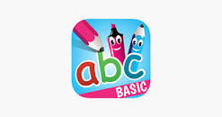
https://blogs.glowscotland.org.uk/gc/stvincentsprimary/

