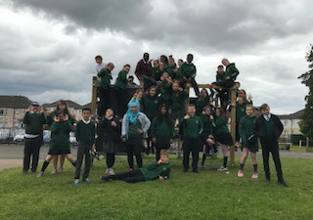
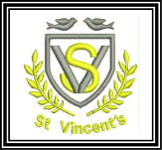
Primary 7 June Newsletter

It’s with great pride and a little sadness that we are getting ready to wish our Primary 7 Pupils
Bon Voyage as they get ready to embark on the next stage of their Educational journey.
Most of them have been with us since Primary 1 and all of them have become an integral part of the school. We will miss them but look forward to hearing about their success in St Paul’s, Hillpark and Bellahouston. No matter what they go on to do in life I hope they will remember fondly their time spent as part of the St Vincent’s family.
However they still have a couple of events to take part in.
- Monday 17th June - @ 1.30 Awards Day and Leavers Presentations
- Tuesday 18th June - @ 6-8pm Leavers disco Extravaganza
- Friday 21st June - P7 Rouken Glen Day Out (Weather dependant)
- Thursday 27th June - @ 10am Leavers Mass in St Vincent’s Parish Church
(All Parents are invited to join us for the Mass)
A message for the pupils
“AS you leave St Vincent’s it is normal to feel both nervous and excited but know this. You are leaving with all the tools you need to succeed both at High School and in life. Keep living up to our school motto ‘Be Excellent’ in everything you do. Be Caring, Be Kind but most important of all be all you can be. Come back and see us once in a while and let us know how you are doing because once part of the St Vincent’s family always part of it.
I wish the best for each and every one of you, and I am confident that I will be as proud of the men and women you become as I am of you now.
Good Luck and God Bless”

Mr B. Tracey

