FREE SCHOOL MEAL APPLICATION

Glasgow City Council provide free school meals for pupils who meet the following eligibility criteria:
- Income Support or Jobseekers Allowance – you will need a copy of your award letter dated within the past 3 months.
- Both Working Tax Credit and Child Tax Credit with a household income of £7920 or less – you will need to enclose a copy of your recent award letter showing your household income and detailing your children's names.
- Universal Credit with a monthly earned income of not more than £660- you will need to supply a copy of your most recent statement
- Child Tax Credit only with an annual income of less than £17,005
- Income related Employment and Support Allowance
- Asylum Seeker, receiving support under part IV of the Immigration Act 1999. Please provide a valid/current Application Registration Card (ARC), BAIL201 Letter or Mears Tenancy Agreement
HOW TO APPLY FOR FREE SCHOOL MEALS
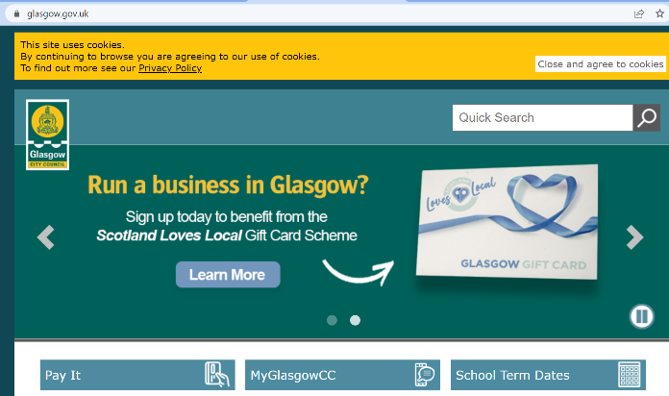
Log onto
www.glasgow.gov.uk

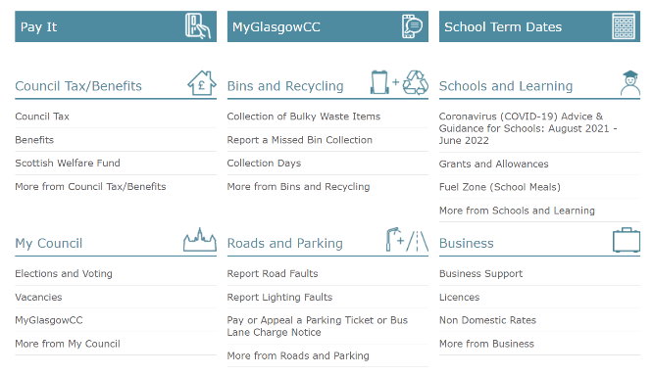

Select the Grants and Allowances
from the Schools and Learning
section

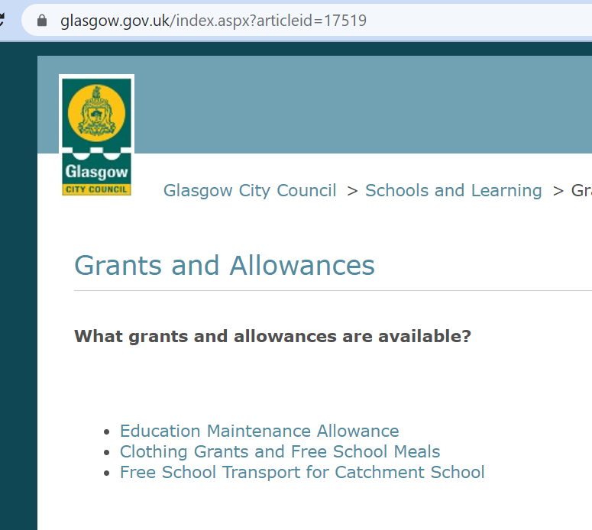
Select the link - Clothing Grants and Free School Meals
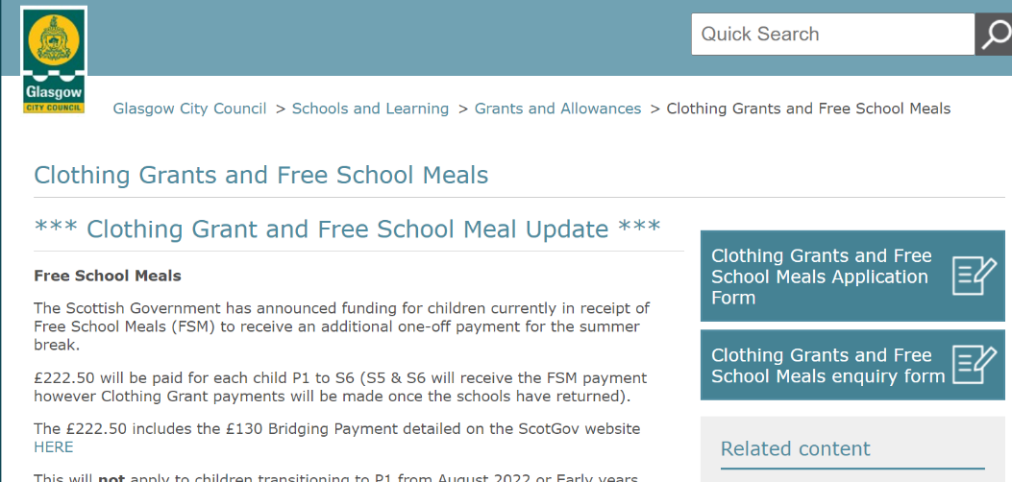
Select the link and complete the application form

SCHOOL CLOTHING GRANT
Families on low incomes may also be eligible to receive a School Clothing Grant award of £120 for a Primary aged child or £150 for a Secondary aged child. The award is given annually to assist with the cost of purchasing essential school clothing for families. You may be eligible for a school clothing grant if you have a child that attends a Glasgow school, and you receive any of the following benefits:
• Housing Benefit / Council Tax Reduction (this is not Council Tax single person's discount or student discount)
• Universal Credit (UC), and your monthly take home pay is £660 or less.
• Income Support/Income based Job Seeker's Allowance (JSA) or any income related element of Employment and Support Allowance (ESA)
• Child Tax Credits only (CTC) with an annual income of less than £17,005
• Working Tax Credit and Child Tax Credit with an annual income of less than £17,005
• Support under Part VI of the Immigration and Asylum Act 1999

