
St Saviour’s Primary
Govan

School Handbook
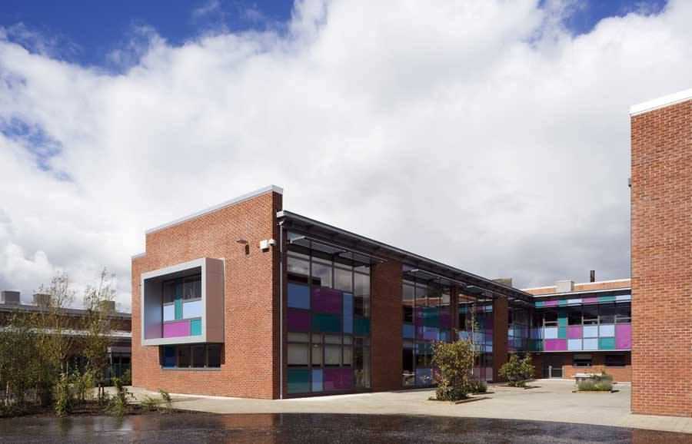
Last updated June 2025



@StSavioursGovan

st-saviours-pri.glasgow.sch.uk
Govan Road Campus

635 Govan Road
Glasgow
G51 2AQ

0141 445 8904


Head teacher’s Introduction

Dear Parents,

I would like to welcome you and your child to St Saviour’s Primary School and I look forward to working with you.
I hope that this handbook gives you a glimpse of life at St Saviour’s Primary School.
We hope to organise many activities throughout the school year that will give parents/carers the opportunity to meet and work with the staff of the school. We look forward to seeing you at these various occasions during the session.
We will keep you up to date with school events throughout the year through letters, texts and our social media platforms so please check these regularly.
If you ever have any queries, concerns or information you wish to pass on please feel free to contact me. I will be delighted to help you in any way I can.

Kindest Regards,

Brian Tracey
Head Teacher


Our Vision, Values and Aims

Vision
St Saviour’s vision is that all of our children will…
Challenge, Believe, Learn & Achieve
Values

St Saviour’s pupils will be nurtured to become responsible and successful citizens who are…
Honest, Respectful, Caring & Achieving
Aim
That in the school community of St Saviour’s …
We Listen, We’re Respectful
We are Kind and Do Our Best
Together we will make St Saviour’s
Better than the Rest
School Information

Address ST. SAVIOUR’S PRIMARY SCHOOL
GOVAN ROAD CAMPUS
635 GOVAN ROAD
GLASGOW
G51 2AQ

Telephone 0141-445 8904

Email headteacher@st-saviours-pri.glasgow.sch.uk
Blog https://blogs.glowscotland.org
Glasgow City Council www.glasgow.gov.uk/en/residents/goingtoschool

Present School Roll – 160
Maximum Roll – 231
Parents should note that the working capacity of the school might vary dependent upon the number of pupils at each stage and in the way in which the classes are organised.

St Saviour’s Primary School is a Roman Catholic school. The school campus is shared with Riverside Primary School and Broomloan Nursery School. We belong to the Lourdes Learning Community and the school serves the Govan area of the city. Our school building is fairly newly constructed and opened in June 2010
The school is at the heart of a very close community with many parents and grandparents being former pupils of the school.
Our premises consist of eight mainstream class teaching areas, a shared Library, General Purpose room, Gym and a Dining Room/Assembly Hall. Our school has a floodlit astro-turf football pitch which is extremely well used by the school and the community. We have a garden area which is being jointly developed and will provide excellent outdoor learning opportunities for the school and Nursery pupils.

Staffing
A full list is available on the school website and parents will be updated on any changes as required.
The leadership team is as follows:

Head Teacher Mr B Tracey
Depute Head Teacher Mrs E. Kane
Principal Teacher Mrs L. Kane
Principal Teacher Mrs L. Neilson
Acting Principal Teacher Mr A. Mallon

School Hours
Breakfast Club: 8.00am-8.45am (more info in meals section)
School starts: 9.00am
(A soft start 8.45 – 9.00 is available to all pupils)

Interval: 11.00am –11.15am

Lunch break: 12:45-1:30pm

Dismissal: 3pm

Enrolment

Registration of Primary 1 children takes place in November and is advertised widely in local press etc. Prospective parents are welcome to visit the school and should contact the school office. Enrolment is now conducted online – see the link below.

Families living out with the catchment area are welcome to make a placing request to attend a Glasgow Primary School but must enrol their child online as a first step. Further information is available using the following
https://www.glasgow.gov.uk/index.aspx?articleid=18426

Organisation of Classes
The following guidelines set by Scottish Government apply.
P1 maximum 25
P2 maximum 30
P3-7 maximum 33
Composite classes’ maximum 25

(Composite classes have pupils from more than one stage in the same class)

School Term Dates
Details of school term dates are available on the Glasgow City Council website:

Pupil Absence
Within St Saviour’s Primary School good attendance is encouraged at all times and children rewarded accordingly. Parents are asked to advise if their son or daughter is going to be absent. This should be done as early as possible on the first day of absence. If the young person is going to be absent for some time, it would be helpful to know at the earliest opportunity. The school uses daily text messaging to inform parents and carers of absence if no contact is made. All unexplained absences are investigated by the school and appropriate action taken. All calls must be made to the Pupil Absence Reporting Line on 0141 287 0039. The line is open between 08.00-15.30 Monday to Friday. Alternatively you can use the online form on the Glasgow City Council website: https://www.glasgow.gov.uk/index.aspx?articleid=18832

Why good attendance is vital for your child’s future!!
Glasgow Education authority statistics show how well children learn in comparison to their attendance. As you can clearly see the children who attended school the most had the highest achievement figures of being on or ahead of track for their expected progress.

Achievement in: | Children attending below 80% | Children attending between 80-90% | Children attending more than 90%
Numeracy/maths | 53% | 68% | 88%
Listening/talking | 80% | 84% | 92%
Reading | 60% | 81% | 88%
Writing | 40% | 71% | 77%

Medical & Healthcare
During the year the NHS carry out routine health checks, vaccinations and medical examinations. Parents are kept informed by letter.
If a child becomes ill during the school day, he/she may require to be sent home. Please ensure that you keep the school informed of all contact details and update these as required.

Parents should inform the school of any medical requirements relating to their child. If a child requires medication during the school day, parents must complete the appropriate medical form. This is available on request from the school office.

Emergencies
We make every effort to maintain a full educational service, but on some occasions circumstances arise which lead to disruption. Schools may be affected by, for example, severe weather, temporary interruption of transport, power failures or difficulties of fuel supply.
In such cases, we shall do all we can to let you know about the details of our closure or re-opening by using letters, texts and the local media etc.

Breakfast Club
The school has a breakfast club which runs every morning. There is no cost for children with a free meal entitlement awarded. For children who are not free meal entitled the cost is £2.00 a day. (For a family it is £2 for oldest child and £1 for subsequent children.) Breakfast is available from 8.00 a.m. to 8.45 a.m. with last entry at 8.30am. The breakfast and consists of fruit juice, milk and a choice of cereals and toast.

Saint Saviour’s Primary School operates a Buddy System where New Entrants will be allocated a Buddy from Primary Seven who will take care of them in their first few weeks in Primary School. The children will be introduced to their buddies during their visits in April/May.

School House System

To encourage a sense of identity and commitment
amongst pupils, St Saviour’s operates a School House System.
We have four houses, and on starting school, children join one of the following

Fire House Red
Air House Yellow
Earth House Green
Water House Blue

Membership of their house is sustained from Primary 1 to Primary 7.

The children can gain house points for a variety of reasons. The emphasis is on positive reinforcement and personal challenge. Weekly points totals are followed with interest at assembly and the end of session tally determines the annual house winners. The wining house is awarded the House Cup and get to go on an end of term house trip.
At our annual sports day the children also compete for their house and the winners are awarded the House Sports Cup.

Supervision of Playgrounds
An adult presence is provided at break times in terms of the Schools (Safety and Supervision of Pupils) (Scotland) Regulations 1990. All support staff and Senior Leadership staff , unless in class, help supervise the dinner hall and playground at both break and lunch.

Entry and Exit
All children should enter by the pedestrian school gates in Neptune Street .
Children can enter from 8.45 a.m. and staff will be in place to supervise them until classes start at 9am.
If children are not accessing the Breakfast Club, they do not need to be on site before 8:45 a.m. Parents are encouraged not to arrive to collect children before 2:55pm. Entry to the school during the day should be made through the office. This is to keep the playground as secure as possible.
At 3pm Dismissal time Primary 4 to Primary 7 will exit by the gate at Neptune Street. Staff will escort them to this gate. Primary 1-3 will exit by the Govan Road side door where staff will hand the children to their parents/ carers. N.B. Staff will not hand over a child to anyone they do not know so if an aunt etc is picking up the office needs to be informed.
Children who are not picked up for any reason will be taken to the front foyer to wait. Senior or Clerical staff will supervise this.

Child Protection Policy – MC57

All educational establishments and services must take positive steps to help children protect themselves by ensuring that programmes of health and personal safety are central to the curriculum and should have in place a curriculum that ensures that children have a clear understanding of the difference between appropriate behaviour and inappropriate behaviour on the part of another person, no matter who.
As with other areas of the curriculum, you will be kept informed of the health and personal safety programme for your child’s establishment.

Should any member of staff have concerns regarding the welfare or personal safety of any child they must report these concerns to the head of establishment. The head, or person deputising for the head, after judging that there may be grounds for concern regarding the welfare or safety of any pupil must then immediately advise the duty senior social worker at the local social work services area office of the circumstances.

The Child Protection Co-ordinator for the school is the Headteacher, Mr Brian Tracey. In his absence, Mrs Eilis Kane followed by all members of the Senior Leadership Team.


School Uniform
Our Uniform consists of:
- Grey/black school trousers or skirt
- White polo shirt/ shirt & school tie*
- Grey/Red jumper/cardigan or school sweatshirt/cardigan with logo*
- School Tracksuit

* School sweatshirts/cardigans & blazers can be ordered from the school suppliers website. Ties and badges can be purchased directly from the school office.

Please ensure that ALL items of your child’s clothing are clearly labelled with your child’s name and class.
Our uniform was agreed in consultation with pupils and parents. It is expected that all children attending Glasgow Primary School will adhere to this dress code.

PE Kit
It is important that pupils come prepared to learn and for PE this requires appropriate clothing. A school tracksuit is available to order and can be worn to school on P.E. days. Ill-fitting or inappropriate clothing that could potentially encourage factions or cause offence (such as football colours, anti-religious symbolism or political slogans) must not be worn. All jewellery should be removed. Pupils who are not participating in PE must have a note or a medical certificate. Pupils who are unable to participate in practical PE should still bring their kit to allow them to assist in the lesson by refereeing, keeping scores or assisting with the distribution of equipment. This ensures that they are still able to take part in some way in the work of the class and do not miss out on the knowledge and understanding of the course.

Clothing & Footwear Grants
Parents/Carers receiving Income Support, Job Seekers Allowance (Income Based), Working Tax Credit (check link below for thresholds), Housing Benefit, Council Tax Benefit or Universal Credit (check link below for thresholds) will normally be entitled to monetary grants for footwear and clothing for their children. Information and application forms may be obtained from schools and at
https://www.glasgow.gov.uk/index.aspx?articleid=17885

School meals
Our school provides a lunch service which offers a variety of meals.
Medical diets for children can be provided. Further information can be found here: http://www.fuelzoneprimary.co.uk/UserFiles/files/Medical_Diet_Leaflet%20-%20June%202017%20WEB.pdf. Please inform the Headteacher if a special diet is required..

Children who prefer to bring packed lunches will be accommodated in a suitable area.

As of this year all children in P1-6 are entitled to a free school meal.

If you plan to send your child/children to breakfast club, you should inform the staff of any medical dietary requirements.

Children and young people of parents/carers receiving Income Support, income-based Job Seekers Allowance, and Working Tax Credit (check link below for thresholds), Child Tax Credit only (check link below for thresholds), Universal Credit (check link below for thresholds) and income-related Employment and Support Allowance are entitled to a free midday meal. This should be applied for even if your child is receiving a free meal up to P6 as it has many other benefits. Information and application forms for free school meals may be obtained at
https://www.glasgow.gov.uk/index.aspx?articleid=17885

Transport
The education authority has a policy of providing free transport to all pupils who live outwith a certain radius from their local school by the recognised shortest walking route. This means that the provision of transport could be reviewed at any time. Parents/Carers who consider they are eligible can apply online at
https://www.glasgow.gov.uk/index.aspx?articleid=17882

Transfer from Primary to Secondary School
Children and young people are normally transferred between the ages of 11½ and 12½ so that they will have the opportunity to complete at least 4 years of secondary education.
Parents and carers will be informed of the School arrangements no later than December of the year preceding the date of transfer at the start of the new session.

Our DESIGNATED Secondary School for transfer of P7 Pupils is:

Lourdes Secondary School
47 Kirriemuir Avenue
Glasgow
G52 3DF
Tel: 0141 582 0180

Lourdes Secondary School staff work with our pupils to prepare them for the transfer to secondary school and in some cases enhanced transition is provided as required.

Communication with Parents
At St Saviour’s Primary School we use a variety of ways to keep in touch.
The senior leadership team are available for all parents and carers providing they are not teaching or in another meeting. Please e- mail or phone for an appointment.

Newsletters – will be sent out on a regular basis to keep parents informed about the work of the school.
Letters – further information which requires a response may be sent out in letter form.
School blog/X/Showbie App – will contain a great deal of information about the school. It is a good idea to check this regularly.
Text messaging – You may also receive text reminders about events/school closures etc.

Meetings - Parents and carers are welcome in the school to discuss any aspect of their child’s development and progress. To avoid disappointment, it is advisable to make an appointment. There are various opportunities throughout the year when parents can discuss their child’s progress with the class teacher and view the child’s work. There will be two formal Parents evenings throughout the year and details/ appointment slips will be sent out nearer the time
Parents and carers are welcome at other events throughout the school year e.g. workshops, information evenings, class performances, religious and other assemblies. The school newsletter and website will keep you informed.

Emergency Contact Information
At the start of each school session, parents will be issued with the annual data check form. Please ensure that this is completed and returned to the school. It is also important that you let us know if there are changes to your telephone number(s) or to those of your emergency contacts throughout the year.

Appointments during school hours
If your child has an unavoidable appointment, please inform their class teacher or the office and then collect them from the school office at the specified time.

Comments & Complaints
In St Saviour’s Primary School we pride ourselves on the positive relationships across our school community. However, if you have a comment or complaint about any aspect of school life, please contact the Headteacher in the first instance. Headteacher@st-saviours-pri.glasgow.sch.uk

If, in the unlikely event, you feel that the complaint is not dealt with to your satisfaction the following procedures are available.
Glasgow City Council complaints procedures are available : https://www.glasgow.gov.uk/index.aspx?articleid=16133

Customer Care Team
Customer & Business Services
Glasgow City Council
City Chambers
Glasgow G2 1DU

Tel: 0141 287 0900
e-mail: customercare@glasgow.gov.uk or education.customercare@glasgow.gov.uk

The above website also includes information on data protection and freedom of information.

Curriculum

Curriculum for Excellence 3-18
Through the experiences we provide at St Saviour’s Primary School we want our children to become Successful Learners, Confident Individuals, Responsible Citizens and Effective Contributors. We are committed to providing children with a broad general education and focus on eight curriculum areas.

Expressive Arts | Health & Wellbeing | Languages | Mathematics
Religious & Moral | Sciences | Social Studies | Technologies

Progress in learning is indicated through curriculum levels as detailed below.

Level | Stage
Early | The pre-school years and P1 or later
First | To the end of P4, but earlier or later for some
Second | To the end of P7, but earlier or later for some
Third & Fourth | S1-S3, but earlier for some

Useful websites
Education Scotland www.education.gov.scot
National Parent Forum of Scotland www.npfs.org.uk

Religious Observance
We are served by St Anthony’s Parish in Govan. The Parish Priest, Father Bernard Waave regularly visits the school. He leads the preparations for the sacraments of Reconciliation P3, Holy Eucharist P4 and Confirmation P7.
Masses and Services are regularly celebrated at St Anthony’s Church or in school and parents are always most welcome to attend.
Parents and carers from religions other than Christianity may request that their children may be permitted to be absent from school in order to celebrate recognised religious events. Only written requests detailing the proposed arrangements will be considered. Appropriate requests will be granted on up to 3 occasions in any 1 school session.

Assessment & Reporting
All children are assessed both formally and informally throughout the year. This allows children and their teachers to identify their strengths and areas for improvement. A variety of assessment methods are used to enable staff to pass on information to parents about the progress of their child. Assessment records are kept by the class teacher and form the basis of discussion at Parents’ Evenings in October and March. An annual report is sent to parents towards the end of each school year.
If you have any concerns about your child’s progress do not hesitate to contact the school.

Support for Pupils
The school has a duty to ensure that all pupils have equal access to the curriculum, with appropriate support for their needs if required. This applies to the content of lessons, teaching strategies and minor adaptations to the school environment. There are a wide range of factors which may act as a barrier to learning. We are committed to working closely with parents and carers to ensure that they are fully involved in any decisions about support for their children’s needs.

Any parent or carer seeking further advice regarding this policy should contact the Headteacher or Depute Headteacher in the first instance.

Further information relating to additional support needs is available on the Glasgow City Council website at https://www.glasgow.gov.uk/index.aspx?articleid=18941

Information on the Glasgow City Councils’ Parental Involvement Strategy can also be found at https://www.glasgow.gov.uk/index.aspx?articleid=17870

Nurturing City
St Saviour’s operates a whole school nurture approach. Staff are trained in attachment and nurture which deepens understanding of child development and enhances effective practice by responding to the needs of all children and young people in a consistent and caring way. Nurture is a universal approach which builds resilience, helping to reduce the impact of adversity. Effective communication and collaboration with parents and carers builds an ethos of partnership working putting the child at the centre, fostering high quality learning contexts.

School Improvement
On an annual basis, a copy of our Standards and Quality report will be published on our social media platforms. The Standards and Quality report highlights progress in key curricular areas such as literacy, numeracy and health & wellbeing. Our priorities for improvement are detailed in our School Improvement Plan which is discussed with our Parent Council. Any parent or carer seeking a copy of the plan can contact the school office or e mail the head Teacher.
Promoting Positive Behaviour
Children’s Rights as outlined in the UNCRC (United Nations Convention on the Rights of the Child) are fundamental to a good school ethos. Adults in our school will work with children to ensure they are aware of their rights and fully respect the rights of others. Therefore, the approach within our School is to build a positive ethos that demonstrates care and respect for all. Positive behaviour is recognised and celebrated. Our school operates a system of class charters to set out expected behaviour. This is celebrated through awards at assemblies and certificates sent home to parents etc. We recently achieved the UNICEF Rights Respecting Schools Silver Award as a recognition of the work done throughout the school over the past few years.
The highest standards of behaviour are always expected of pupils. We are very fortunate in St Saviour’s that this is almost always adhered to. Where this is not the case, a variety of restorative practices are used and parents informed. Parents are asked to co-operate with the school in encouraging a sense of responsibility and good behaviour in their children.

Parent Council
All parents are welcome to attend Parent Council meetings and can become members at the AGM in September. We are always looking for new members.

Pupil Council
Our Pupil Council is made up of 2 representatives from each year group. This is an important group which ensures that the views of pupils are heard.

Extra Curricular Activities
We have a wide range of activities that run between Monday – Friday to extend the learning experience. These have included drama, arts and crafts, dance, netball, basketball and football. Please check your child’s schoolbag for information as places are popular and usually limited.

Good links with community organisations and our Active Schools Co-ordinator Alix Drever are vital for the success of these programmes.

Useful Contacts

- St Saviour’s School Blog https://blogs.glowscotland.org.uk/gc/stsavioursprimary/
- Borders School Wear www.border-embroideries.co.uk/schools
www.beschoolwear.co.uk
- Free School Meals www.glasgow.gov.uk/index.aspx?articleid=17885
- Fuel Zone www.glasgow.gov.uk/fuelzone
- Clothing Grant www.glasgow.gov.uk/index.aspx?articleid=17885
- Parent Pay https://app.parentpay.com/public/client/security/#/login

Parentzone Scotland https://education.gov.scot/parentzone.

Connect www.connect.scot

Enquire Scotland
Enquire is a national advice service for families with additional support needs. www.enquire.org.uk

Douglas Hutcheson .
Executive Director of Education
Glasgow City Council
Education Services
City Chambers East
40 John Street
Glasgow G1 1JL

Glasgow City Council
Education Services
City Chambers East
40 John Street
Glasgow G1 1JL

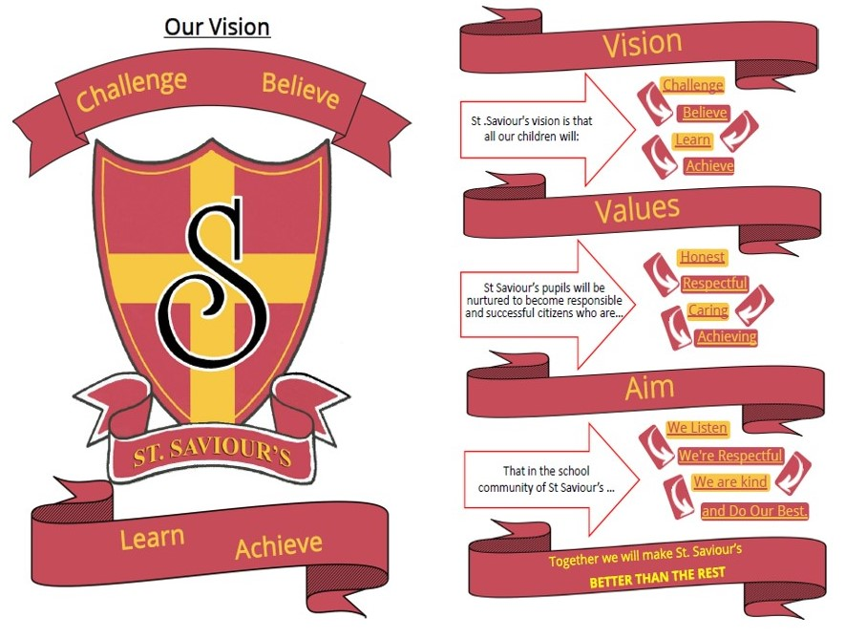
Tel: 0141 287 2000

