Traci Kirkland (she/her)
Head of Charity
T: 0141 445 3718 / M: 07443964017
My Normal Working Days are Mon - Fri 8.30 - 4
GCP Helpline: 0800 310 0054
www.govancommunityproject.org.uk

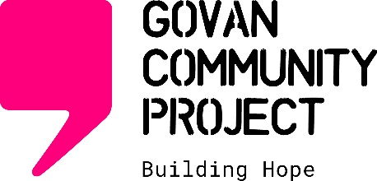

Fairfield Hall, Pearce Institute, 840 Govan Road, Glasgow G51 3UU
Regulated by the OISC. Ref No. N201900059
Scottish Charity No: SC042012 Company No: SC390721

