 | Our ref: | SCFZ/ph4
 | Email: | RoadSafety@glasgow.gov.uk
 | Date: | January 2022

Dear Parent/Carer

Glasgow School Streets Project – St Saviour’s Primary

I am writing to advise you that St Saviour’s Primary School has agreed to take part in the Glasgow School Streets project.

Following installation of the approved signs (as below), only authorised vehicles will be allowed to access Neptune Street (from Vicarfield St) and Southcroft Street (between Vicarfield St and Govan Rd) during the hours of 0830 to 0915 and 1430 to 1515, Monday to Friday. You will receive notification of the date on which the project will go live in due course.
The purpose of the project is to restrict the movement of traffic within the school zone at peak times and thereby support road safety and active travel measures.
What does this mean?
The street listed will effectively be closed to all traffic (other than authorised vehicles). Any person who drives an unauthorised motor vehicle during the restricted times, within the designated street, will be subject to a Fixed Penalty Notice of £50 issued by Police Scotland.
How long will the scheme last?
The scheme will be operational for 18 months and thereafter will be subject to a review and evaluation.
What do the signs look like?
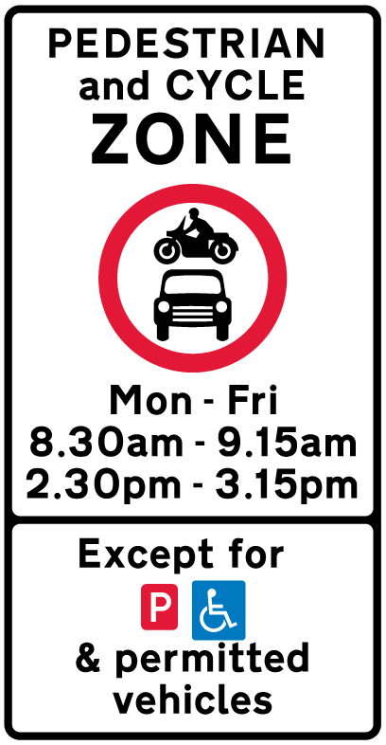

What are the benefits for children and parents?
You should notice a significant change in the number of vehicles within the school zone which in turn, will contribute to a safer and more pleasant environment for children to walk, cycle and scoot to school.
I need my car for an onward journey to work or other place?
Please allow additional time for your journey and park safely out with the restricted streets.
Where can I get more information?
Online at: https://www.glasgow.gov.uk/index.aspx?articleid=24206
Can I make comment about the scheme?
Yes, you can email RoadSafety@glasgow.gov.uk – all comments received will form part of the evaluation and review.
Please find attached a map showing the street affected.

Yours faithfully
Andrew Mollon
Head of Roads

