Primary 5/4 Term 2 Curriculum Newsletter
Miss Elsby
What we are learning about:
Numeracy  In numeracy Primary 5/4 will be exploring the concept of time in Term 2. Primary 4 will be learning to tell time in 5-minute intervals using an analogue and digital clock. Primary 5 will be learning to calculate time intervals and use a timetable. Primary 5/4 will also be learning to measure. This skill will be applied to measuring length, area and capacity within a real-world context. | Literacy  In literacy Primary 5/4 will be learning about fiction writing this term. They will be exploring the novel Billy and the Minpins by Roald Dahl. The class will use this novel as a stimulus for creating their own short stories, developing their creative writing skills. Primary 5/4 will continue to develop their reading strategies making predictions before reading and asking questions using information from the text.
Health and Wellbeing  In Health and Wellbeing, Primary 5/4 will be learning about online and internet safety. The class will be exploring how we can keep ourselves and have fun online. | RERC  In RERC Primary 5/4 will be preparing for Easter by reflecting on the death and resurrection of Jesus. The class will prepare for a Lenten Service.
PE  Bring a P.E kit to school on gym days – Monday and Thursday | Things to bring each day…  - Full bottle of water  - A jacket! (we will be taking part in lots of outdoor learning!)
Throughout this term we will study different themes:  - Science: The Solar System  - Glasgow Architecture  - Developing the Young Workforce |  | 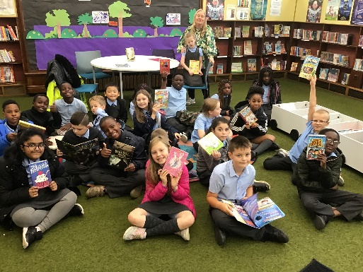
Homework This will be posted on Showbie. Class Code – A26K4
Given on a Monday collected every Friday
- Learn your new spelling list and complete three activities each week.
- Complete your numeracy tasks. Numeracy Activities on Sumdog.
- Take a photo of your work and submit it via Showbie.
- .

