Primary 4 Term 2 Curriculum Newsletter  Ms Doyle |  |  |  | 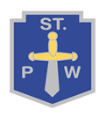
What we are learning about:
Numeracy  In term two, we will focus on multiplication and division strategies. We will learn about 2D/3D shapes, length, and weight. We will be developing our knowledge and skills of fractions. We will challenge ourselves to apply our learning in these topics to word problems and real-life contexts. We will continue to practice our mental maths strategies daily, and are building our independence in numeracy using active stations and play. We will revise the topics that we have looked at in Term 1 as we progress through Term 2. |  | Literacy  This term, we will continue to practice our new spelling and grammar rules each week. In writing, we will focus on describing characters and setting and we develop our persuasive writing skills. We will also link our topic to Talking and Listening activities, presentations and drama. In reading we will focus on our novel ‘The Hoghedge’. The children will practice their reciprocal reading strategies while we are reading the novel. As a class, we continue to enjoy exploring a wide range of books each week.
Health and Wellbeing  In Health and Wellbeing, we will be exploring our rights as children, and how to respect each other’s rights. We will consider the role we play in our community and in our school. We will continue to work on our understanding of emotions, behaviours and building resilience. |  | RERC  Some of our children are preparing for the sacrament of the First Holy communion. This involves reflection on gospel stories, prayers, actions and responses to Mass. As a class we will support each other, pray for, and celebrate our friends who are preparing to receive this very special sacrament.
Things to bring each day (please make sure names are on every item!)
- A change of clothes/shoes (Our PE day will be Monday and Thursday.)
- Full bottle of water
- A jacket, sensible shoes/trainers
Throughout this term we will study different themes:  - Staying safe, healthy, and following the St Paul’s Way.  - Science: Types of energy/ Germs  - Topic: Jobs in our local area |  |  | 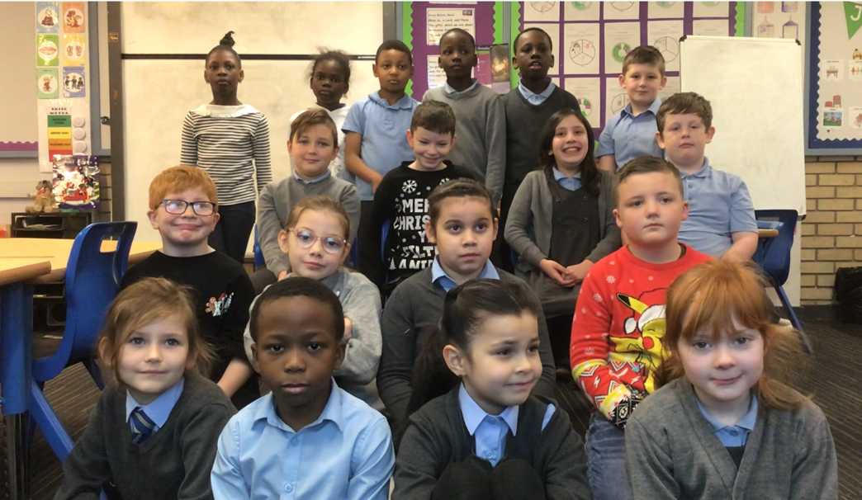
Homework
- Complete all Spelling tasks each day (please follow homework grid in front of jotter)
- Complete Numeracy tasks (Sumdog details can be found at the back of the jotter )
- Return Homework folders every Friday (homework can be uploaded onto Showbie)

