Primary 3/2 Term 3 Curriculum Newsletter  Miss Bamford |  |  |  | 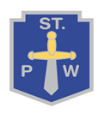
What we are learning about:
Numeracy  Primary 3/2 will continue to develop their addition and subtraction strategies. Primary 2 will be learning to multiply and divide by 2 and 4. Primary 3 will be learning to multiply by 3 and 6. Through a variety of methods, we will be learning to extract key information from data. We will learn to gather and display data appropriately. We will also be learning to describe and create patterns for shapes, pictures, symbols and numbers. |  | Literacy  Throughout this term P3/2 will be learning different spelling patterns each week. We will continue to build on our knowledge on familiar and unfamiliar words. We will develop our reading strategies by learning prediction, questioning, summarising and clarifying skills. Our focus for writing this term will be learning characterisation and setting. We will continue to develop our writing tools to help us become more independent.
Health and Wellbeing  Primary 3/2 will be learning to:  - Identify and recognise their own interests, skills and abilities.  - Recognise the factors that can affect emotions and behaviours.  - Understand the journey of food and the importance of having a varied diet. |  | RERC  During this term P3/2 will be learning about:  - Ways we can participate and celebrate in the St Pauls community.  - The season of Lent and the Easter story.
Things to bring each day…
- Healthy snack
- Full bottle of water (or two)
- Gym kit on Wednesday and Friday.

Throughout the term we will study different themes:  - Glasgow Wood Recycling  - A novel study  - The 50th Anniversary of St Paul’s Primary |  |  | 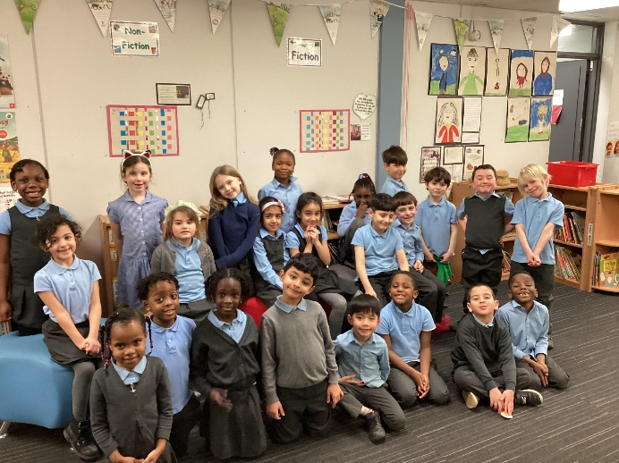
Homework
- Homework will be posted weekly via Showbie. Our class code is 4KD89.
- Learn your new spelling list and complete numeracy activities each week.
- Complete your weekly reading book.
- Ensure reading book comes to school everyday.

