Primary 3 Term 1 Curriculum Newsletter  Miss King |  |  |  | 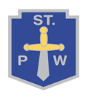
What we are learning about:
Numeracy  This term for numeracy and maths we will be learning to:  - To count, read, order and write numbers up to 100.  - To develop ways of estimating.  - To add and subtract up to 100.  - To make links between multiplication and division.  - To measure lengths in centimetres and metres.  - To use coins and notes to pay and give change for goods. |  | Literacy  This term for literacy we will be learning to spell out tricky words using various strategies. For reading we will focus on exploring reading strategies such as predicting and questioning using fiction and non-fiction texts. In writing we are learning to recount an event to create a piece of text.
Health and Wellbeing  This term we will focus on learning about emotions and how to manage our feelings in a positive way. We will also explore friendships and relationships and how to keep our bodies  Healthy. |  | RERC  - Belonging  - About making good choices.  - About the world that has been created for us.  - About Advent and Christmas.
Things to bring each day…
- Full bottle of water.
- Full gym kit every ………
Throughout the term we will study different themes:  - One Scotland Many Cultures  - Famous individuals |  |  | 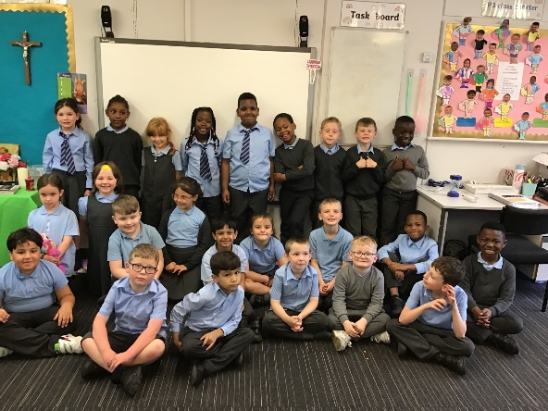
Homework
- Each week complete the activities in your homework wallet and return by Friday.

