Primary 2 Term 1 Curriculum Newsletter  Ms MacKinnon and Mrs Cranney |  |  | 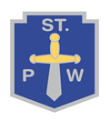
What we are learning about:
Numeracy  We will learn number stories to 10, learning how to add, subtract and link facts. We will also be learning how to count on and back in 5’s and 10’s to 100. We will learn about 3D shapes and how to describe them. We will learn how to create and continue simple patters. We will also learn to read and record o’clock and half past times. | Literacy  We will be learning to spell words with a new spelling pattern each week as well as learning some tricky words. We are learning about how to write a good sentence, remembering to use a capital letter and a full stop. We will be learning how to answer questions on an unfamiliar story we have read.
Health and Wellbeing  We will agree a class charter about how to stay safe in class and school. We will work and play outside often and try to follow the St Paul’s Way. | RERC  We will explore Bible stories and discuss how they influence the way in which we lead our lives.
PE  Bring a P.E kit to school on gym days – Monday and Friday | Things to bring each day…  - A suitable jacket for the weather  - Full bottle of water  - A healthy snack
Throughout the term we will study different themes:  - Staying safe, healthy and following the St Paul’s Way  - Science  - One Scotland , Many Cultures  - Road, Railway and River |  | 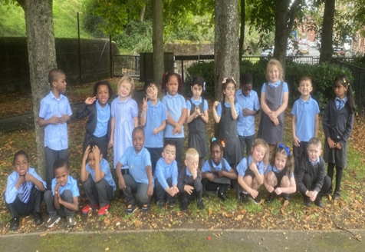
Homework
Homework will be posted on Showbie.
Class Code – PNT7K
- Read for 5-10 minutes each night
- Numeracy Activities on Sumdog

