Primary 7 Term 1 Curriculum Newsletter
Miss Mooney
What we are learning about:
Numeracy  We will be learning to count, read, order and write numbers to 10,000, 100,000 and 1,000,000,000. We will also be learning about fractions, decimals and percentages together with measuring lessons from Mrs Milano. We will regularly problem solve and use money through our class economy. We are fundraising and learning about profit and loss, applying our learning to real life. |  | Literacy  We will be learning to spell tricky words with a new spelling pattern each week. We will improve our ability to write both recount, procedural and explanation texts this term. We will focus on our ability to question and summarise when we read and also prepare and present a talk for the rest of the class. Our novel this term is ‘Divided City’ by Theresa Breslin.
Health and Wellbeing  We will work together to create a Class Charter which reflects our class values and helps us to follow the St Paul’s Way. We will also be focusing on health and wellbeing, looking after our own mental health and showing kindness to each other. PE is a Thursday afternoon; PE kits must be worn! |  | RERC  We will explore the story of creation in further detail and debate the relationship between Religion and Science. We will also focus on the ways in which we can be Stewards of the Earth and look after our world. Additionally, we will be learning about other faiths and know that we are all God’s children.
PE  Bring a Gym Kit every Thursday | Things to bring each day…  - Log in cards for our classroom apps.  - iPad charged (60% or more)  - Full bottle of water (or two)
Throughout the term we will study different themes:  - Staying safe, healthy and following the St Paul’s Way  - Science: Climate change.  - Topic: Fundraising and Scottish Landscapes. |  |  | 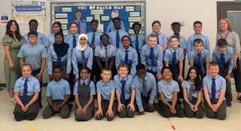
Homework Showbie Class Code EHJGR
- Learn your new spelling list and complete three activities each week.
- Submit homework on Showbie.
- Complete your weekly challenges on Sumdog and Study Ladder.

