Primary 6 Term 1 Curriculum Newsletter  Mrs Simpson |  |  |  | 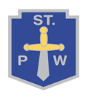
What we are learning about:
Numeracy  During Term 1, we will revise number, focusing on Place Value, Addition, Subtraction, Multiplication, and Division. We will also explore Fractions, Decimals, and Percentages.  This term, we aim to extend our learning through the use of Active Learning, introducing various strategies and applying our learning to real life contexts. |  | Literacy  This term, we will focus on spelling and grammar rules each week.  In Writing, we will build on our knowledge of Recount, Explanation and Procedural Writing.  We have a variety of Fiction and Non-Fiction texts to enjoy in our class library.  Through group work, we will develop our talking and listening skills.
Health and Wellbeing  In Health and Wellbeing, we will be exploring our rights and responsibilities as children. Through creating our Class Charter, we will begin to explore what it means to be a Rights Respecting School. |  | RERC  Our focus for this term will be “Why is there suffering?”  We will examine themes of justice, compassion, and care. We will also learn about “The Israelites” and begin to explore “Laudato Si”.
Things to bring each day: (please make sure names are on every item!)
- A change of clothes/shoes (Our PE day will be Thursday).
- Full bottle of water (this can be re-filled throughout the day).
- A jacket, a bag, sensible shoes/trainers.
Throughout this term we will study different themes:  - Staying safe, healthy, and following St Paul’s Way.  - Science: Body Systems and Cells.  - One Glasgow: Many Cultures! |  |  | 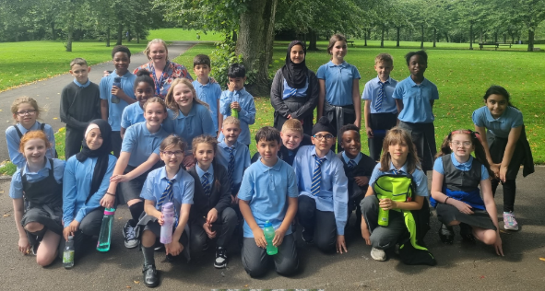
Homework
- All homework will be uploaded to Showbie on a Monday and should be completed by Friday.
- There will be daily Literacy and Numeracy tasks to be completed.
- Sumdog Challenge – complete weekly.

