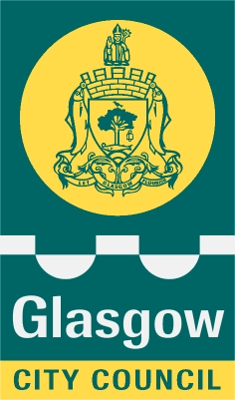
Executive Director of Education Services
Education Glasgow City Council
Maureen McKenna City Chambers East Building
40 John Street
Glasgow G1 1JL

Our Ref MMcK/SMcC Your Ref
Date 25 February 2021

Parent/Carer

Dear Parent/Carer

Free School Meals - key payment dates and updated information

We wanted to write and update you on key dates for the money being paid to families whose children meet the criteria for free school meals.

For P1 to P3 children, your last payment was £25 paid on 19th February 2021.

For P4 to P7 and S1 to S6, you also received £25 last week and you will receive a payment on the 5th March which is £12.50.

There is an additional £100 plus £25 for the spring break for all children with entitlement P1 to S6. This £125 will be paid between 19th March and 22nd March.

If you think that your family might qualify for free school meals please visit our website to find out more details on the eligibility criteria and fill out an application at https://www.glasgow.gov.uk/schoolsandlearning - there’s also a list of frequently asked questions which may help with any enquiry you have.

Please note that any new applicants who meet the criteria and apply by 12 March 2021 will be paid the additional Spring payment as soon as their application is processed. Applications made after this date (12 March 2021), if eligible, will receive free school meals for their children and not the additional £125 Spring payment.

The Scottish Government has still to confirm exactly when children are returning. Our hope is that from 15th March, all P4 to P7 will be able to return. As soon as we have any further information on further free school meal payments we will write to you.

Many thanks for your continued support.

Yours sincerely
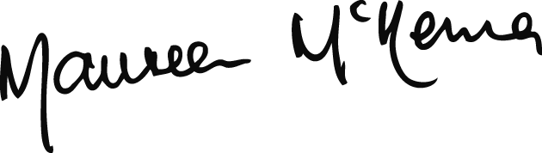

MAUREEN McKENNA
Executive Director of Education

