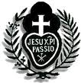
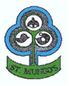
18th March 2020

St Mungo’s Parish/St Mungo’s Primary Parson Street
Townhead
Glasgow G4

Dear Parent/Guardian

P7 SACRAMENT OF CONFIRMATION – Thursday 19th March 2020

Following today’s announcement from the Archbishop of Glasgow Philip Tartaglia that all Public Masses be postponed until further notice, we regret to inform you that the P7 Confirmations will NOT take place tomorrow.

I am sure that given the current circumstances you will understand this decision.

Please be assured that we will be in touch in order to re-arrange the celebration of the Sacrament in the near future.

Please also be assured of our prayers for you and your families at this time.

With every good wish and blessing.

Fr Frank Keevins CP Miss Catriona Ward
Parish Priest Principal Teacher
St Mungo’s Parish St Mungo’s Primary School

