St Maria Goretti Primary

December 2020 Newsletter

**Dates for your Diary**

**Thursday 17th December:** Our online Christmas Panto will be shown in each classroom. This year’s showing will be Cinderella. The children will get crisps and juice.

**Friday 18th December**: Christmas Party – children will dress down this day. The children will get crisps and Juice.

**Friday 18th December:** Raffle will be drawn.

**Covid 19-**

If your child develops symptoms on or after Tuesday 22nd December, you will not be able to contact the school.  Instead, you will be contacted by the Test & Protect team who will discuss the details with you and ask for the information they need.  It is important if your child tests positive during the holidays and has to self-isolate beyond the school return date of 6th January that you contact the school directly as you would for any other absence.

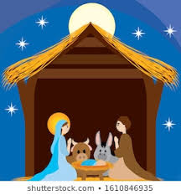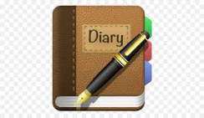

**Food Bank**

If you have any dried/tinned food in your cupboard that you would like to donate to our local food bank please hand it in with your child before Thursday 17th December.

**Christmas Message**

Dear Parents/Carers,

As we prepare for the Christmas Holiday, I wish to thank you for all your support during this successful term. School closes for the Christmas holidays on **Tuesday 22nd at 2.30 pm and reopens on Wednesday 6 January 2021 at 9.00 am.**

On behalf of all the staff and children, I wish everyone a very Peaceful and Happy Christmas.