St. Maria Goretti Primary School

November Newsletter

**Pantomime**

During these challenging and uncertain times we are working hard to try and ensure some festive cheer as we move into December. We are currently looking into online pantomimes which our children can enjoy safely in their classrooms with a snack and drink provided.

**COVID 19 update**

As we are currently in Tier 4 restrictions it is important that we continue to work together as a school community to follow government guidance and keep each other safe.

* When picking up or dropping off adults are advised to wear masks.
* After school clubs will be paused.
* School risk assessments will be reviewed to reflect current guidance

**Catholic Education Week**

This year the school celebrated Catholic Education Week on the week beginning 16thNovember 2020. The theme this year is ‘Jesus Christ; The Way, The Truth and The Life’. Throughout the week children will be further developing their understanding of Gospel Values in their own lives.







**Winter clothing**

During the winter months we need to strike a balance between keeping our school well ventilated and keeping our children warm. I would ask that children come with warm clothing that can be worn on top of their uniforms e.g. hoodies, track suit jackets, etc.

**Winter clothing**

During the winter months we need to strike a balance between keeping our school well ventilated and keeping our children warm. I would ask that children come with warm clothing that can be worn on top of their uniforms e.g. hoodies, track suit jackets, etc.

**Winter clothing**

During the winter months we need to strike a balance between keeping our school well ventilated and keeping our children warm. I would ask that children come with warm clothing that can be worn on top of their uniforms e.g. hoodies, track suit jackets, etc.

**Winter clothing**

During the winter months we need to strike a balance between keeping our school well ventilated and keeping our children warm. I would ask that children come with warm clothing that can be worn on top of their uniforms e.g. hoodies, track suit jackets, etc.

**Winter clothing**

During the winter months we need to strike a balance between keeping our school well ventilated and keeping our children warm. I would ask that children come with warm clothing that can be worn on top of their uniforms e.g. hoodies, track suit jackets, etc.

**Winter clothing**

During the winter months we need to strike a balance between keeping our school well ventilated and keeping our children warm. I would ask that children come with warm clothing that can be worn on top of their uniforms e.g. hoodies, track suit jackets, etc.

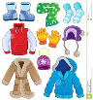

**Christmas Holidays**

The school closes on **Tuesday 22nd December at 2.30pm** and re-opens **Wednesday 6th January at 9.00am**.

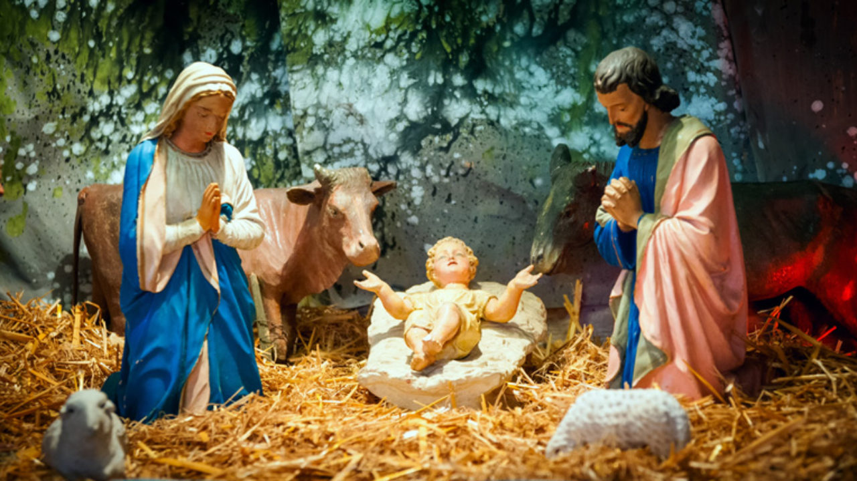

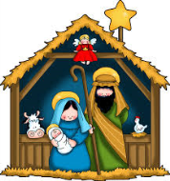

**Christmas Holidays**

The school closes on **Tuesday 22nd December at 2.30pm** and re-opens **Wednesday 6th January at 9.00am**.

**Winter clothing**

During the winter months we need to strike a balance between keeping our school well ventilated and keeping our children warm. I would ask that children come with warm clothing that can be worn on top of their uniforms e.g. hoodies, track suit jackets, etc.

**Christmas Holidays**

The school closes on **Tuesday 22nd December at 2.30pm** and re-opens **Wednesday 6th January at 9.00am**.



**Winter clothing**

During the winter months we need to strike a balance between keeping our school well ventilated and keeping our children warm. I would ask that children come with warm clothing that can be worn on top of their uniforms e.g. hoodies, track suit jackets, etc.