Drop Off and Pick Up

* Maintain 2m distancing from adults and children from another class.
* Walk straight to your class zone in the playground.
* Walk to the end of the fence before crossing the road safely.
* Follow your teacher’s instruction if you leave school with a sibling.
* Place any scooters or bikes in the shelter when you enter the playground.

Cleaning and Hygiene

* Regular hand washing in daily routine.
* Hand sanitising stations can be used only when an adult tells you.
* School will be cleaned regularly throughout the school day.
* Let an adult know if the soap or paper towels are almost finished.
* All desks and chairs are cleaned at the end of each day.
* Only use the bathroom if it is empty or there is a child from your class inside.

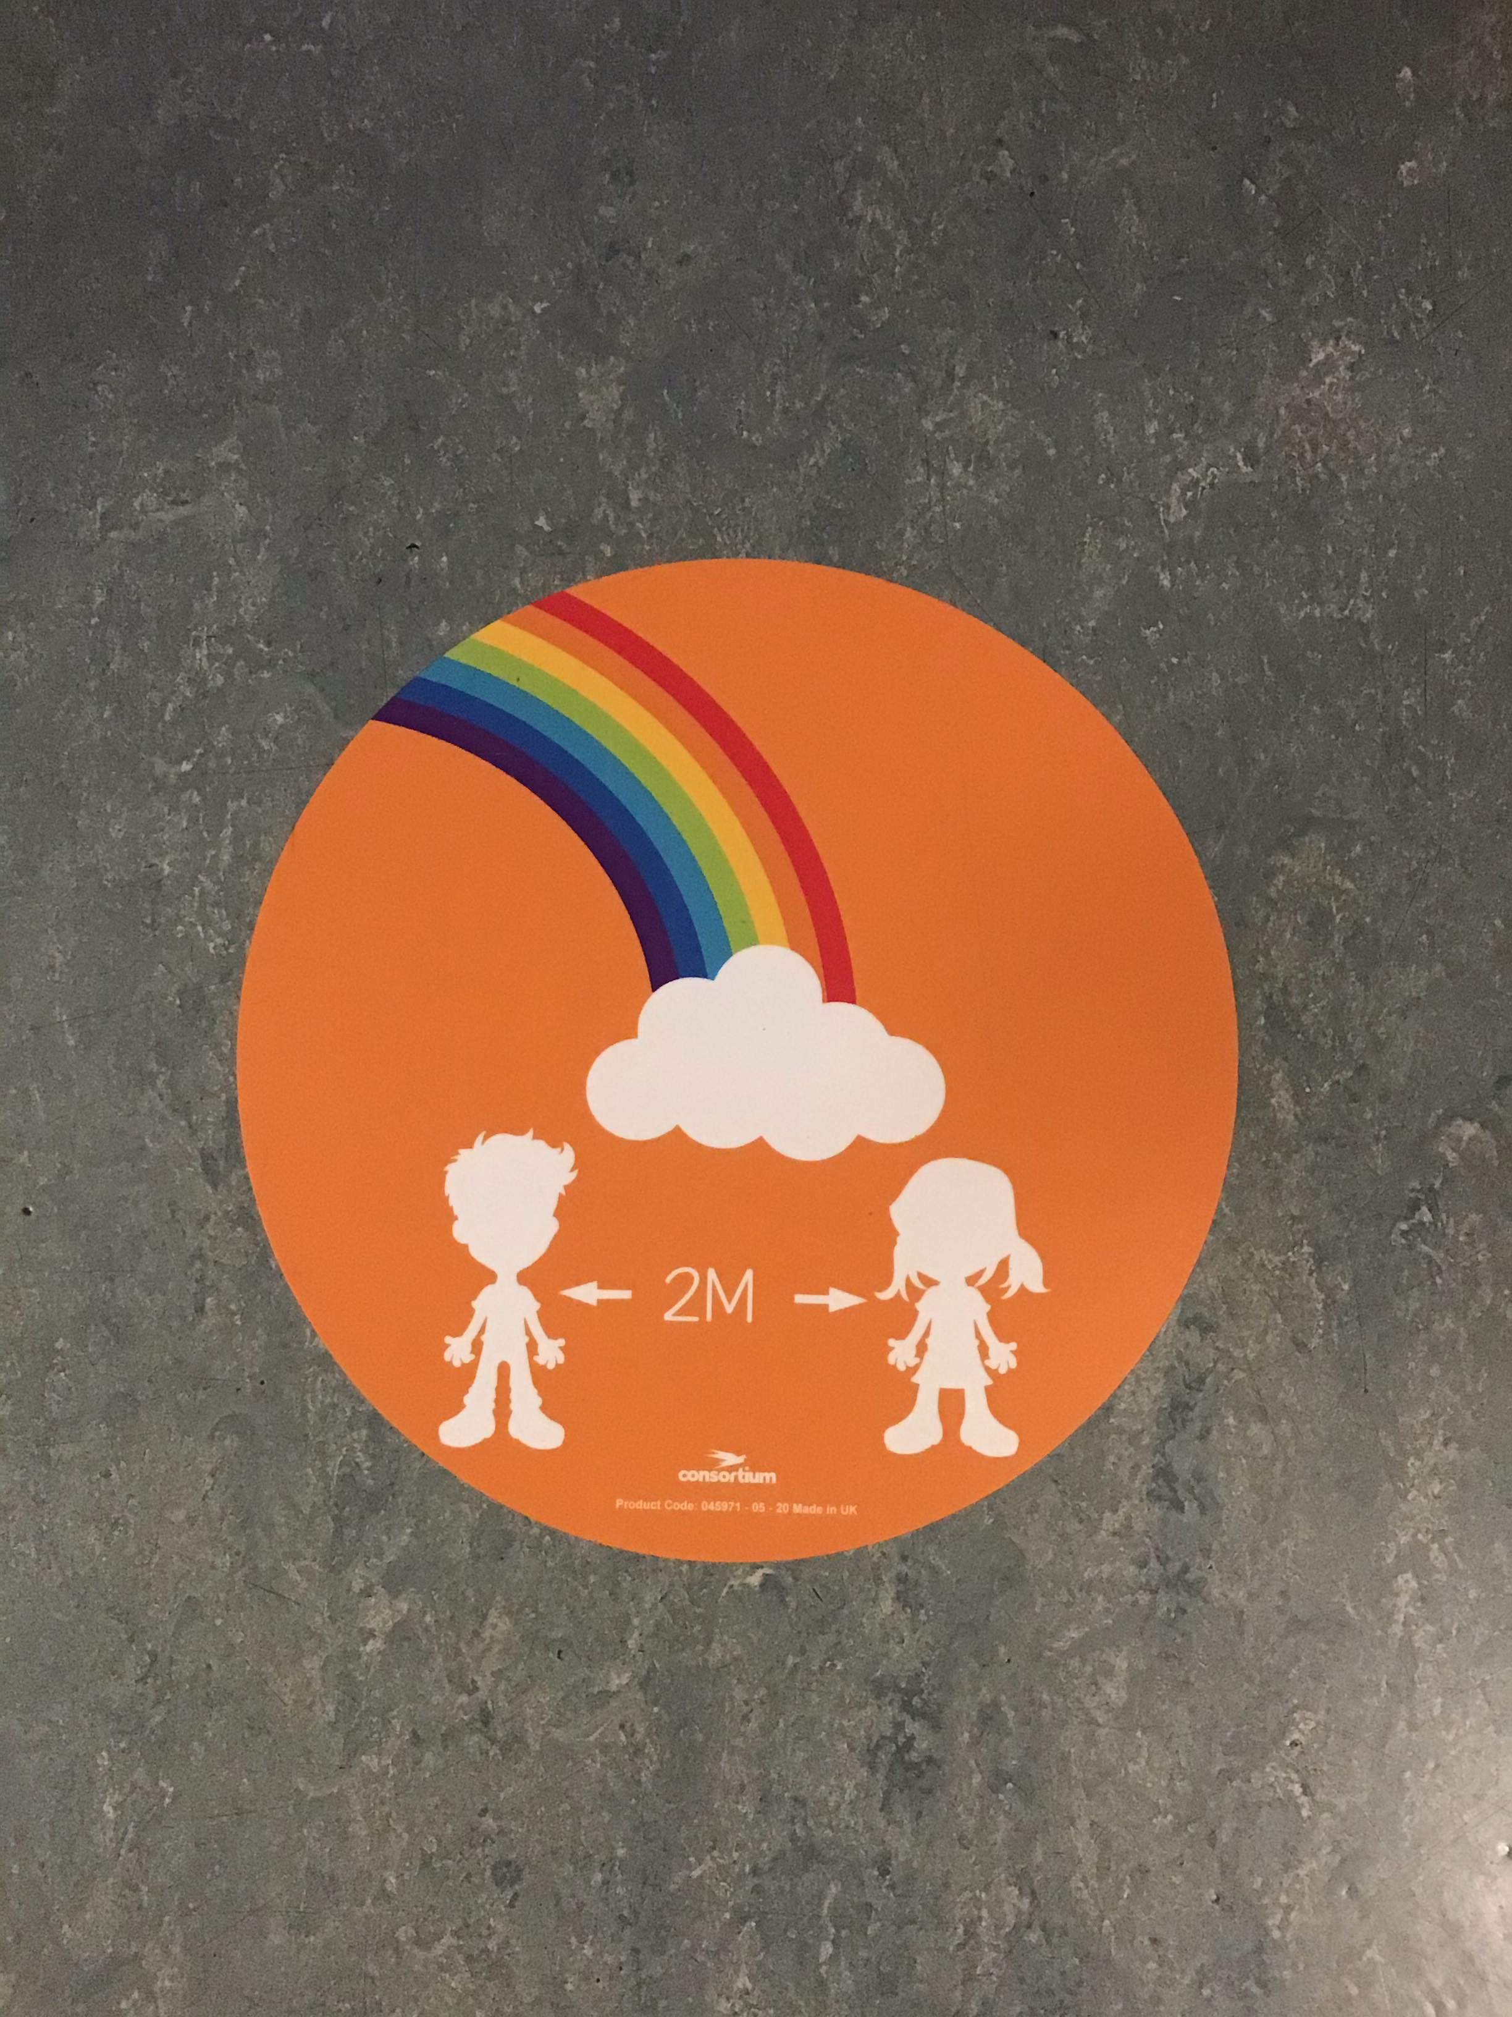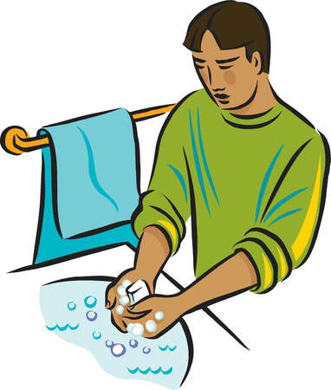

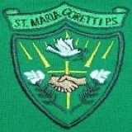

Classroom and Corridors

* Maintain 2m distancing from adults in the class and in corridors.
* Stay in your own seat during wet play and wet lunchtimes.
* Only use your own stationery.
* Snacks and packed lunches will be stored in the cloakroom.
* Water bottles to be brought from home and will be re-filled after lunch.
* Maintain 2m distancing when passing another class in the corridor or on the stairs.

Playground and Dinner Hall

* Each class has their own zone to play in and playtimes are staggered.
* Maintain 2m distancing when speaking to an adult.
* Use bins closest to your play zone.
* Each class will be called to the dinner hall where you will sit with your own class.
* When lining up you must stand on the coloured stickers and only move forward when asked by an adult.
* Maintain 2m distancing when passing another class.

## St Maria Goretti

## COVID - 19

## Risk Assessment