 | Teacher – Mrs Keelan  Primary 6  Term 2 Newsletter |  | 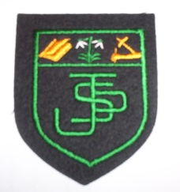
What we are learning about:
Maths and Numeracy    During this term we will be following the Glasgow Counts planners and developing our understanding of whole and decimal numbers, multiplication and division, fractions and time. We will be developing different strategies to calculate an answer through number talks. We will also use our learning in different contexts such as through outdoor learning. |  | Literacy  In reading we are developing our reading skills through our novel Street Child; we will be developing our understanding through a variety of comprehension tasks linked to our books.  In writing we are creating narrative stories through plot, character, structure, setting and theme.  We will be learning to transfer our spelling knowledge in our reading and writing.
Health and Wellbeing
For Health and Wellbeing, the children will be following the Emotion works programme and exploring strategies that they can use in a variety of scenarios. In PE the children will be developing skills in netball.
Religious Education
For RE this term we will be focussing on the importance of Advent and preparing for the birth of Jesus.

 | Things to remember…  Healthy Snacks and Packed lunches  PE—Our PE days are Monday and Wednesday and (No jewellery)
Our Topic…  This term, Primary 6 are learning all about Scotland! We’ll be exploring the geography of our country by using maps and digital tools to identify mountains, lochs, rivers, valleys, and cities. We’ll also be celebrating our culture and heritage by learning some Scots language, creating a detailed skyline artwork of a Scottish city and exploring traditional Scottish food. |  |  |  | 
Homework
Homework will be uploaded onto showbie. This can either be completed on showbie or a jotter given to your child to complete tasks. We would ask that pictures are then taken and uploaded.

Yours sincerely,
Mrs Keelan

