 | Teacher – Mrs Bennett  Primary P4/5  Term2 Newsletter |  | 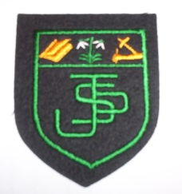
What we are learning about:
Maths & Numeracy    We are exploring place value, numbers and quantities. We will transfer this knowledge into adding, subtracting, multiplication and division. P5 will begin to compare fractions and P4 will order fractions. In Maths the children will be focusing on shape, area and equations. |  | Literacy  In reading, we are focusing on strengthening our strategies using the Big Cat reading books alongside our class novel. We will build our understanding through a range of comprehension activities connected to these texts. In writing, we are working on instruction pieces, giving clear steps in order. We are also learning how to apply our spelling knowledge within both reading and writing through the North Lanarkshire Literacy approach.  Writing:
Health and Wellbeing
We are exploring healthy foods, food groups and the nutritional benefits of certain foods. We will continue with the emotion works programme, discussing emotion words, regulation strategies and behaviours.
In P.E we will have a gymnastics block where children will understand the use of space, increase their flexibility and give feedback on their own shape/posture and that of others. Our Determined to dance workshop will continue until the end of November.
Religious Education
Children will examine the role of the Holy Spirit and will research a Scottish charity. We will look at the Wise Men within the nativity story and the symbolism of the wreath and crib.

#

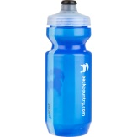   | Things to remember…  Healthy Snacks and Packed lunches  PE—Our PE days are Tuesday and Thursday (No jewellery)
Our Topic…Our topic for this term is Famous Scots. If you have anything at home that could help with this (e.g. posters created, pictures) please send them in for our display.  Among our learning will be Scottish inventors and how their discoveries have impacted the world. The children will have the opportunity to research famous Scots and summarise their findings. |  |  |  | 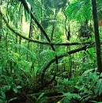
Homework
Homework will be uploaded onto showbie. This can either be completed on showbie or a jotter given to your child to complete tasks. We would ask that pictures are then taken and uploaded.

