 | Mrs Halliday  Primary 1  Term 2 Newsletter |  | 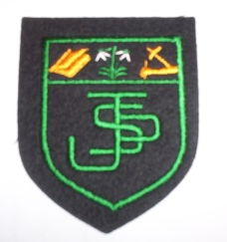
What we are learning about:
Maths & Numeracy  - Say alternate numbers (to at least 30)  - Recognise and read +, - and = symbols  - Organise and sort objects in different ways  - Exploring measure   |  | Literacy  Reading: We will be continuing to develop reading skills through learning sounds and attempting to blend the sounds, in order to read words. We will be looking at non-fiction books and using these to find information.  Writing: We will continue to develop our writing skills through looking words we can use in instructions and explanations. As well as how adding images can add to our writing
Health and Wellbeing
We will be keeping active through our P.E. sessions this term by participating in dance and gymnastics. We will be looking at ways we stay healthy and preparing and tasting different Scottish foods.
Religious Education
This term we will be looking at the seasons of Advent and taking part respectfully in the Mass.

 | Things to remember…  Healthy Snacks and Packed lunches  PE—Our PE days are Tuesday and Thursday (No jewellery)
Our Topic…  Our topic for this term is Scotland – The Wee Scottish Caterpillar. We will be looking at different foods grown and produced in Scotland as well as looking at the lifecycle of a butterfly and minibeasts and we will create some art related to Scottish foods. |  |  |  | 
Homework
Homework will be given out on a Monday and can be returned any day of the week. Pictures of the class working throughout the week will be posted on a Friday to share our learning with you.

Yours sincerely,
Mrs Halliday

