St Francis Primary School Curriculum Information for Parents/Carers
Term 3 January 2026
Literacy and English  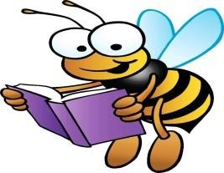 | In Literacy this term, pupils will continue to build strong reading, writing and language skills across a range of activities. In spelling, we will carry on working through the Phonics International units to develop accuracy and confidence. Our reading lessons will focus on continuing Parvana’s Journey, alongside developing digital literacy and comprehension skills, helping pupils think carefully about what they read online and in texts. In writing, pupils will use the Talk for Writing programme to plan and create explanation and description texts, learning how to structure their ideas clearly. Grammar lessons will support this work by helping pupils vary sentence structure, length and type, use the present tense, apply time connectives (such as then and next), causal connectives (such as because and so), generalisers, and make provisional statements, all to improve clarity and detail in their writing.
Numeracy and Maths   | This term, pupils will continue to develop their understanding of fractions, decimal fractions and percentages, identifying the links between them. They will practise simplifying and finding equivalent fractions, work out fractions and percentages of an amount, and use the four number operations when working with fractions. Key number skills such as long multiplication and long division will be revised, and pupils will be introduced to squared and cubed numbers through practical problem-solving activities.  In maths, pupils will apply their learning across a range of contexts. They will learn to use the formula for speed, distance and time, and develop measuring skills by finding lengths and heights within the school environment. Pupils will calculate the perimeter of shapes and learn how to find the area of quadrilaterals and different types of triangles, as well as the volume of cubes. Pupils will also begin learning about chance and uncertainty, describing how likely events are to occur.
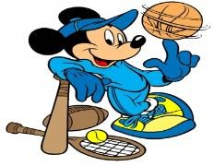  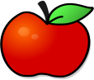  Health and Wellbeing  /PE | This term, children will explore a wide range of careers, learn why people work, and discover the skills and qualifications needed for different jobs. They will identify their own strengths and interests, complete self-assessments, and understand how their skills will be applied in school and future work. Pupils will investigate local jobs, categorise careers into sectors like STEM, creative, and service, and build key employability skills such as teamwork, communication, problem-solving, and creativity through practical activities. They will research specific careers, plan pathways from school to work, take part in enterprise projects, and reflect on their learning and personal growth. We will also be taking part in the ‘I Can Do Anything’ Conference in March.  In P.E., children will develop their basketball skills through a variety of fun and challenging activities. They will learn the rules of basketball, practice passing, dribbling, shooting, and defending, and take part in team games to develop coordination, teamwork, and strategic thinking. Children will also have opportunities to improve their game awareness and understand the importance of fair play and communication on the court. Primary 7b (Mrs Balloch’s class) will be starting swimming at the end of January. More information to follow.  Children should wear their P.E. kit on their designated days:  - P6/7 – Wednesday and Thursday  - P7a – Wednesday/Thursday  - P7b – Monday and Wednesday (Wednesday will change to Thursday (swimming) W/C 26.1.26 until the end of Term 3)  (For swimming – please note: remember to bring a swim hat, towel, swim kit, and 20p for a locker. Goggles are optional)
Religious Education  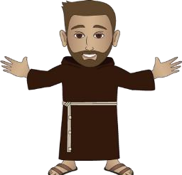 | This term, children will be preparing for the Sacrament of Confirmation, which will take place on Tuesday 3rd March at 7pm in Holy Cross Parish. Through their learning, children will reflect on times when Jesus faced difficult decisions, recognising that He experienced worry and anguish just as humans do, and understanding that God can help us when we are troubled or unsure. We will explore the unique relationship between Jesus and His Father, learn that prayer can support us when making difficult choices, and develop an understanding of temptation, particularly during Lent. Children will also learn about international Christian pilgrimage sites, revisit the symbols and rituals of Confirmation, take part in the Stations of the Cross, and engage in discussions about Leonardo da Vinci’s The Last Supper, developing a strong understanding of this important event in Jesus’ life.
Sciences  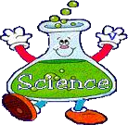 | This term, in Science, we will explore genetics and plant reproduction. We will learn that inherited traits, like eye colour or height, are passed on through genes, while other traits, like favourite colour or language, are not. We will discover that every living organism has a unique DNA fingerprint. In plants, we will learn how pollination and fertilisation lead to seeds and fruit, and how seeds germinate with water, oxygen, warmth, and a food store. Through hands-on activities, we will develop a practical understanding of how traits are inherited and how new plants grow.

Technologies   | This term, linking to our IDL topics, children will extend and enhance their knowledge of digital technologies. They will learn to collect and analyse ideas and relevant information, and organise their findings in clear and effective ways. This will allow them to develop important skills in research, problem-solving, and presenting information creatively using digital tools.

  Expressive Arts  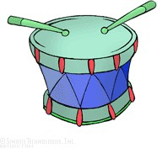  Music/ Drama/ Art/ Dance | Music: This term, we will take part in the Celtic Connections Learning Programme, who will be delivering exciting music workshops.  Drama, Art and Dance will be integrated into our interdisciplinary learning. Please see below.
Modern Languages  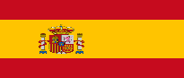 | Modern languages will be integrated into our interdisciplinary learning.
Interdisciplinary Learning  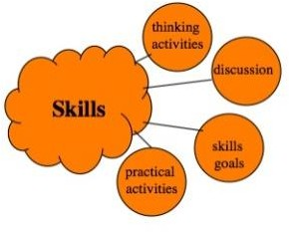 | This term, prior to our trip to Valencia, we will be exploring Spain as part of our interdisciplinary learning. We will learn where Spain is located within Europe and the wider world, identify its key physical features such as major cities, rivers, mountains, and coastlines, and understand how its climate and geography influence daily life, tourism, and lifestyles. We will also discover Spanish culture, traditions, festivals, and famous figures in sport, art, and culture, while comparing life in Spain with life in Scotland. Children will have opportunities to use basic Spanish phrases in simple spoken exchanges, such as greetings, numbers, and everyday expressions, helping to build confidence in using another language. They will also apply and develop creative skills through art, drama, music, and design by exploring Spanish themes and traditions, including creating artwork inspired by traditional Spanish tile patterns. These creative experiences will encourage imagination, collaboration, and a deeper understanding of Spanish culture. Through these activities, children will work collaboratively, communicate their ideas, and reflect on what they have learned about another country and culture.

