St Francis Primary School Curriculum Information for Parents/Carers
Primary 6 – Term 3 – January 2026 – April 2026
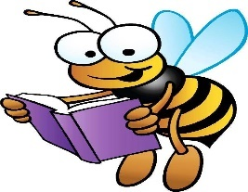  Literacy and English | In Literacy, we will focus on the following areas. In reading, they will finish reading their class novel, exploring the themes and characters in depth. They will also engage in comparing and contrasting activities, analysing similarities and differences between characters, settings, or events. Pupils will create open-ended questions to encourage deeper thinking and discussion.  In writing, pupils will use the Talk for Writing approach to help structure their writing, focussing on both fiction and non-fiction. They will also be writing reports, learning how to present information clearly and logically, and persuasive writing, where they will develop skills to convince an audience of their point of view.  In spelling, pupils will continue with the Phonics International programme, reinforcing their understanding of phonics and improving their spelling accuracy.
Numeracy and Maths  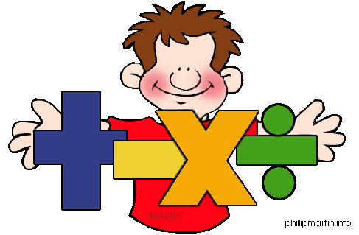 | In Numeracy, we will be learning to read, write, and order decimal fractions with up to two decimal places and position them on a number line. We will explore number sequences, identify equivalent fractions (including tenths and hundredths), and compare and order fractions. Additionally, we will add and subtract fractions and decimals, multiply fractions and mixed numbers by whole numbers, and calculate fractions of quantities. We will also learn to understand percentages, convert fractions to percentages, and write decimal numbers as fractions.  In Maths, pupils will be developing important financial skills, such as managing money, comparing costs from different retailers, and deciding what they can afford to buy. We will explore the use of bank cards, learning about the costs, benefits, and risks involved, and understand the importance of budgeting. We will also use the terms profit and loss in buying and selling activities, carrying out simple calculations. Additionally, we will investigate how data is presented across a variety of media, interpret information, and recognise when data might be misleading. Through surveys and investigations, we will gather, organise, and communicate data effectively, using an extended range of tables, charts, diagrams, and graphs, with the support of technology.
    Health and Wellbeing /PE | In Health and Wellbeing, pupils will explore positive emotions, identify their strengths, and reflect on what makes them feel good. Children will learn about role models, discuss how role models can influence behaviour, and present what they admire about their chosen role model in a creative format. As part of substance misuse education, pupils will practise saying no to peer pressure, use positive communication strategies, and create posters to raise awareness of healthy choices. They will also explore safe decision-making and create collages showcasing positive lifestyle alternatives, such as hobbies and spending time with family. In PE, pupils will be developing their badminton skills through a range of activities. We will learn the rules and safety of the game, practice coordination and teamwork, and apply offensive and defensive strategies in small-sided games. Pupils will also focus on improving flexibility, strength, technique, control, and balance as they refine their skills in competitive game situations. By the end of the term, they will reflect on their progress and apply all the skills learned in a full match setting.  P6a – Tuesday and Friday.  P6b – Tuesday and Friday.  Children should wear their PE kit to school on PE days/no jewellery.
Religious Education  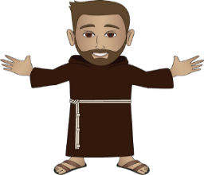 | During Religious Education lessons, we will explore the gifts of wisdom and fortitude in line with our Pope Francis Faith Award. We will deepen our understanding of Jesus as a teacher and explore the meaning of ‘The Lord’s Prayer.’ During Lent, we will be learning about the importance of Alms-Giving and Fasting in the Catholic faith, writing our own prayers of intercession, and participate in the Stations of the Cross to reflect on Christ’s suffering. We will be exploring the difference between a disciple and an apostle, learning to recount how the first disciples were chosen, and understand how we are all called to be disciples of Jesus. Additionally, we will also be learning about the significance of the Paschal Candle and how the Church works for justice and peace.
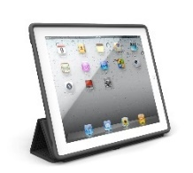  Technologies | In Technologies, pupils will design and create their own sports brand logo, learning about the importance of eye-catching designs. They will explain their ideas, discuss solutions to the design brief, and share examples of effective sportswear logos. Pupils will write a short description of their logo, explaining their choice of graphics, text, and colours. Using iPads and digital tools, they will enhance their designs by adding text and shapes, developing their creativity and technology skills throughout the process.
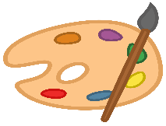  Expressive Arts  Music/ Drama/ Art/ Dance  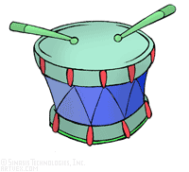 | In Expressive Arts, pupils will be exploring a range of creative activities across art, drama, and music. In art, we will be learning to use materials effectively, such as creating different shades with paints and designing tessellating patterns inspired by Escher and Islamic art. We will also be studying the styles of Charles McGhee and Jen Aryani, experimenting with techniques to create textured landscapes and relief sculptures, and presenting their work to the class. In drama, we are developing characterisation skills by writing character profiles, designing costumes or props, and experimenting with vocal techniques and movements to sustain roles during activities in line with our class novel. In music, we will be listening to Scottish music and identifying instruments, sharing our thoughts and feelings, and creating our own emotive pieces using GarageBand.
Modern Languages     | In Modern Languages (Spanish and French), pupils will revise essential vocabulary and phrases like numbers, colours, and greetings. They will learn how to introduce themselves, ask and answer basic questions, and describe their feelings. Pupils will also explore the names of body parts and learn to describe hair and eye colour. We will also learn how to describe different weather conditions, such as sunny, rainy, or windy. Finally, pupils will explore Easter traditions, learning about how Easter is celebrated in French and Spanish-speaking countries, including customs, foods, and activities associated with the holiday.
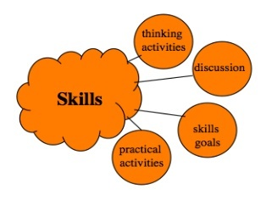  Interdisciplinary Learning | This term, pupils will explore sustainable practices by creating timelines, researching eco-friendly transport, and debating the most practical methods. They will research sustainable practices in the past and compare past and present lifestyles through research.  Pupils will also research sustainability sites, like Whitelee Windfarm and create upcycled pieces of Art as well as create awareness posters. In science, they will experiment with ice melting rates and learn about the water cycle, creating diagrams and reports on their findings. These activities will deepen pupils’ understanding of sustainability and the environment.

