St Francis Primary School Curriculum Information for Parents/Carers
Primary 3
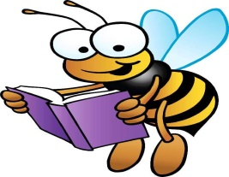  Literacy and English | This term Primary 3 will continue to develop their knowledge of phonics and spelling patterns using the Phonics International programme. They will be encouraged to use these patterns to read with increasing fluency and expression. In reading they will explore prediction, use context clues to clarify words and continue to answer a range of questions about a text. They will be encouraged to read for enjoyment and will have an opportunity to give a short talk about their favourite book. In writing, they will study the non-fiction genres of report writing and persuasive writing. They will also develop fiction writing skills through the structure of a short story, focusing on beginnings and endings.
Numeracy and Maths  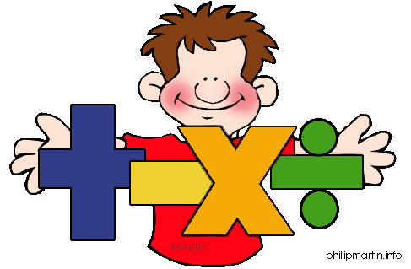 | In numeracy, the children will learn to multiply and divide by 2, 3, 4, 5 and 10. They will be introduced to these concepts through grouping and sharing, using practical materials and pictures. They will also work with fractions, recognising equal parts, comparing simple fractions and finding parts of a set or quantity.  In mathematics, Primary 3 will develop their skills in data handling, collecting and recording information using tally marks and bar graphs. They will strengthen their understanding of time using both analogue and digital clocks.
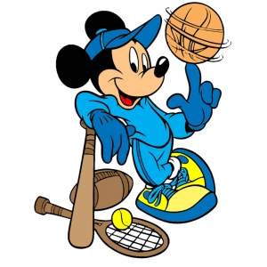  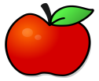  Health and Wellbeing /PE | In Health and Wellbeing this term, the children will use the PATHs programme to explore friendship groups and will learn about different ways to resolve conflict. They will also explore healthy living and will develop an understanding about a balanced diet and the importance of exercise. In P.E. our themes this term are fitness and ball skills. Please remember that Primary 3 have gym on the following days:  P3a - Monday and Friday*  P3b – Wednesday and Thursday  *(Outdoor session – please dress accordingly)  Please ensure that your child has a yellow or white polo-shirt, dark shorts/leggings or jogging trousers and a pair of gym shoes/trainers on these days. All jewellery should be removed.
  Religious Education | This term the children will learn about the themes of free will, forgiveness, Lent and Easter. Some of our children will also be prepared for the Sacrament of Reconciliation. During Laudato Si week, the children will learn about SCIAF and they will take part in fundraising events during Lent.
Technologies  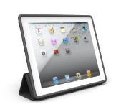 | In I.C.T. the children will continue to have opportunities to use the smartboard across their learning. Children will also use iPads to support their learning and will be taught how to use the internet safely for some simple research tasks.

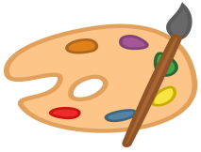  Expressive Arts  Music/ Drama/ Art  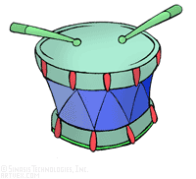 | Music:  The children will have opportunities to explore a range of traditional Scottish music.  Drama:  This term, the children will further develop the use of facial expressions, body language and voice to portray different scenarios linked to their class novel, their RERC lessons and their PATHs programme.  Art:  In art this term children will explore using colour and pattern to create their own tartan. They will use Rabbie Burns as a focus to develop their line drawing skills. They will also design silhouette pictures using a range of media and will use different materials to create some 3D flower pictures.
Modern Languages  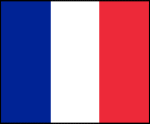 | Children will continue to practise basic phrases and greetings in French. They will continue to develop their confidence in responding in French during class time, using the language of commands and instructions. They will learn the French names for colours and use these in everyday tasks.
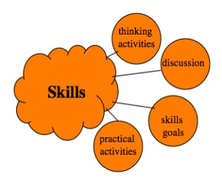  Interdisciplinary Learning | Our topic this term will be ‘Living Things’ which will be developed through Literacy, Expressive Arts, and Science. Children will learn about the characteristics of living things, as well as explore life cycles and food chains. Much of this learning will be linked to their class novel, The Owl who was Afraid of the Dark. They will research the RSPB and find out how they help to look after and protect birds.

