St Francis Primary School Curriculum Information for Parents/Carers
Primary 1

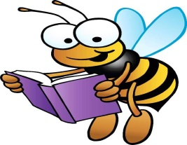  Literacy and English | This term in our reading lessons we will focus on the reading skills of sequencing with a focus on beginning, middle and end of a story. Using Phonics International we will continue to build on our knowledge of phonics by exploring more digraphs e.g ai, oa. We will continue to blend and segment three letter words such as wet and we encourage you to practice this at home. We will use our knowledge of phonics to continue building and writing simple sentences.
Numeracy and Maths  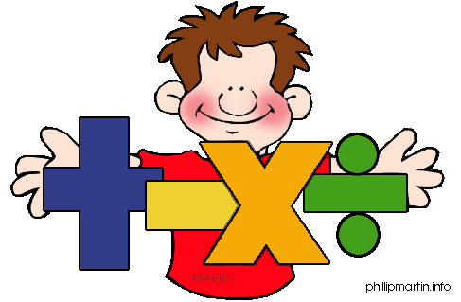 | This term in numeracy and maths we will continue to explore numbers 0-20 and explore number bonds to 10 and 20. We will continue to use concrete and pictorial strategies such as cubes or a number line. We will begin to explore time focusing on o’clock and half past using both analogue and digital clocks. We will introduce the concept of subtraction using a range of strategies.
Health and Wellbeing /PE  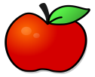   | In Health and Wellbeing, we will learn about resilience and how to show resilience in all areas of life. We will learn about the importance of celebrating others and their achievements. As part of Health and Wellbeing we will be learning about the importance of healthy eating, and we will discover what makes you healthy or unhealthy.  Primary 1a- Monday  Primary 1b- Thursday  Primary 2/1- Tuesday  All jewellery should be removed.  Primary 1 will have tennis at the Gorbals leisure centre from 19th Feb to 12th March  This will take place on Thursdays  1a will go on the following dates 19th and 26th Feb  1b will go on the following dates 5th and 12th March  Primary 2/1 will have dance coached coming into school to teach them  P2/1 will have dance coaches starting 21st Jan until 10th March
  Religious Education | This term the children will be learning about Creation, we will explore how God made the world and everything in it. We will also learn about the love that God has for us and how we can show that love to others. We will then learn about Easter and explore the meaning and purpose of Lent.
IDL   | This term for IDL our topics are Toys and On The Farm. Looking through the lens of Toys we will be investigating energy sources and how they work and were developed. We will explore old vs new toys, how toys are made, and we will even design our very own toy. We will also be exploring our Topic On The Farm. We will be learning about living and non-living things. We will then look at where our food comes from and how it is processed from farm to plate. We will look at the role of a farmer and how they care for different animals. Through Art we will create different farm animals using a range of materials and create our very own farm display.
Expressive Arts  Music/ Drama/ Art  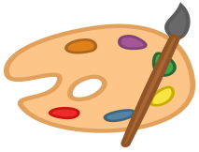  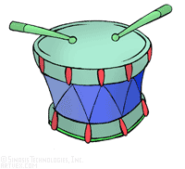 | Music:  We will continue to participate in lessons with our CREATE tutor Mrs. Rodger and Mr. Dunn and we will learn about beat and rhythm. We will also learn a range of new songs with both teachers.  Art:  In Art we will continue to explore a range of famous artist and their work such as Andy Warhol. We will also explore the use of different materials and how they can be used to create the effects of different farm animals. We will also create art pieces to celebrate occasions such as Burns Night and Valentines.  Drama:  Pupils will explore hot seating and will use stories to focus on a range of different characters.
Modern Languages   | In languages this term we will continue to build on our understanding of numbers, colours and greetings. We will also begin to explore weather.

