St Francis Primary School Curriculum Information for Parents/Carers

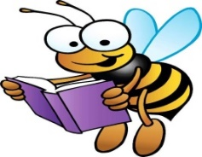  Literacy and English | This term Primary 5a and 5b will be continuing to revise, recognise and write sounds using Phonics International. Our writing focuses this term are a fear story and instruction writing through Talk for Writing. The children will practise using ellipsis, –ing sentence starters, compound sentences, and will begin to write more complex sentences. We will also look at how to use –ed endings to show the past tense when writing about things that have already happened.  We will also be continuing to work on their class novel “How to Train you Dragon” on a variety of comprehension type questions such literal, inferential and evaluative based.
Numeracy and Maths  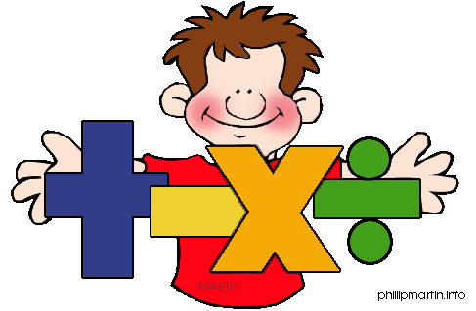 | In term 3, the children will be learning about - fractions, exploring fractions of a quantity, tenths and the link between fractions, decimals and percentages. We will also be focussing on word problems using the four operations. They will learn to work out missing numbers using symbols and use simple rules to create and describe number patters.  Within Maths, the children will explore time, measurement and volume.
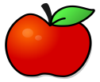  Health and Wellbeing /PE  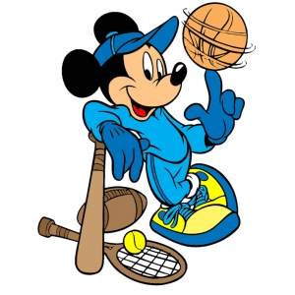 | In Health and Wellbeing this term children will continue progress in PATHS, relating these to real-life situations and with a focus on making good decisions and being responsible. We are also continuing to explore healthy eating and will be looking at the importance of oral hygiene.  In P.E. the children will be focusing on Dance, Gymnastics and Hurling, which will be delivered by coaches. Please ensure that your child wears the correct PE kit, brightly coloured items/football kits and non-school uniform items are not permitted. All jewellery should be removed.
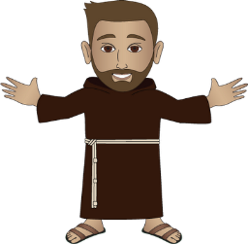  Religious Education | In RE, children will be learning about Moses and the Ten Commandments, Prophets and Kings, and Abraham. From February 18th, we will be learning about the Season of Lent.  Children are always encouraged to share their faith with others in the class.
Sciences  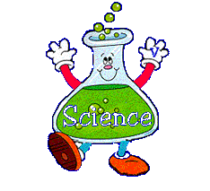 | This term the children will be learning about electricity and waves. They will be learning about sound vibrations and how they are carried through air, water and other medias.

Technologies  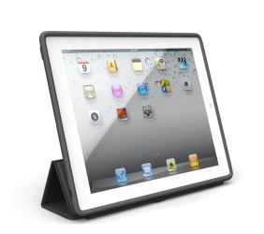 | In technologies this term the children will continue to have the opportunity to use the iPad across their learning. We will be focusing on how to use search engines appropriately. We will also be learning about digital footprints and how to keep safe on the internet. We will be tying this into Safer Internet Day which is on the 10^{th of} February.
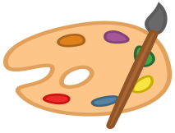  Expressive Arts  Music/ Drama/ Art/ Dance  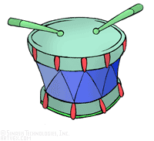 | Dance  In PE we are exploring Dance. We will be learning different dances, moves and styles, such as Scottish dancing. We will also have opportunities to create our own dances, showcasing our creativity.  Art  In Art, we will be exploring different techniques for line drawings. We will also be creating an animation through digital art and exploring and using the sketchbook app.
Modern Languages   | In French, we will be learning to identify colours, classroom objects, weather, seasons, months, commands and digital time. We will continue to revise our learning throughout the term through conversation, songs, quizzes and games.  The children will be exploring frenchgames.net online to reinforce and extend their French vocabulary.
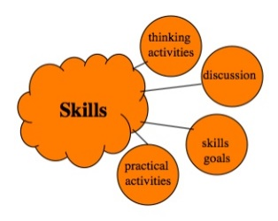  Interdisciplinary Learning | In term 3, our IDL topic will be Engineering. We will be learning about what engineering is and exploring different types of engineering. We will be learning about how wind turbines and solar panels effect the environment and have the chance to create a wind turbine using recycled materials.  The children will be taking part in online stem BGE lessons.

